There are 3 routes in the game.
In v0.55 you can reach the beginning of each route.

- Asahi’s cuck route.

- Peek / Close the door
- Make her a compliment.
- Tell him to fuck off.
- My hands / Stairs.
- Let her go and leave it on her shoulders.
- Accept Hiroto’s feelings.
Reasoning: You were kind and attentive to mom, and you made her feel guilty for not pressuring her. In turn, she didn't give in to Hiroto right away.
- Hitomi’s slave route.

- Peek / Close the door
- Tell her that you are not embarrassed to be around her.

OR

- Peek / Close the door
- Make her a compliment.
- Tell him to fuck off.
- My hands / Stairs.
- Push it.
Reasoning: There could be various variations, but there was something missing that made her fall completely under Hiroto's spell.
Having 2+ horny level makes Asahi extra horny over Mom.
- ??? route

- Peek / Close the door
- Make her a compliment.
- Tell him to fuck off.
- Fire extinguisher on the wall.
- The fire extinguisher in your face.

Slave route walkthrough.
There are two parameters that play a major role in the slave route: 1. Asahi's attraction to Mom. 2. Hitomi's resistance to slutification.
In version 0.55 you can get different lines or even scenes depending on these parameters.
1. If you choose the "Peek" and "Push it" options before getting on the Slave route, Asahi will begin to show more interest in Hitomi (attraction level). Currently, it results in a few different scenes such as jerking off to the moans, some additional dialogue and different endings.

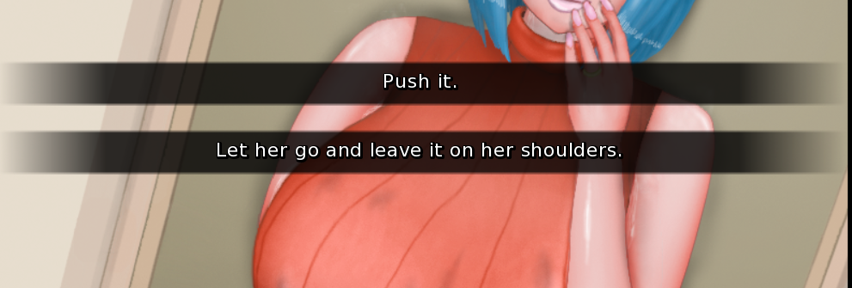

2. Hitomi's resistance to slutification parameter has a key role, at this point you need to score 2 of the 3 available resistance points.
- [Butt plug] Selecting "Yes" 2 times will help you to find your mother's butt plug, which in turn will lead to Asahi admitting to her that he went through her stuff, which in turn will make her feel uncomfortable about her secret because her own son appears to be honest with her. + 1 point to resistance.

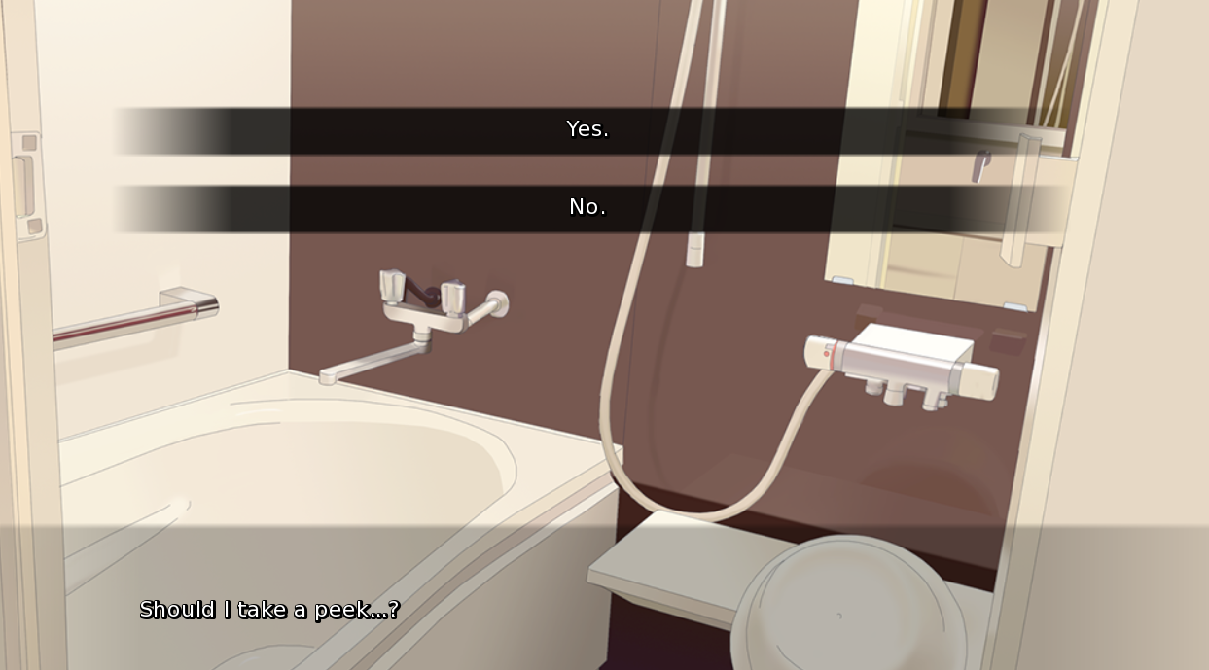
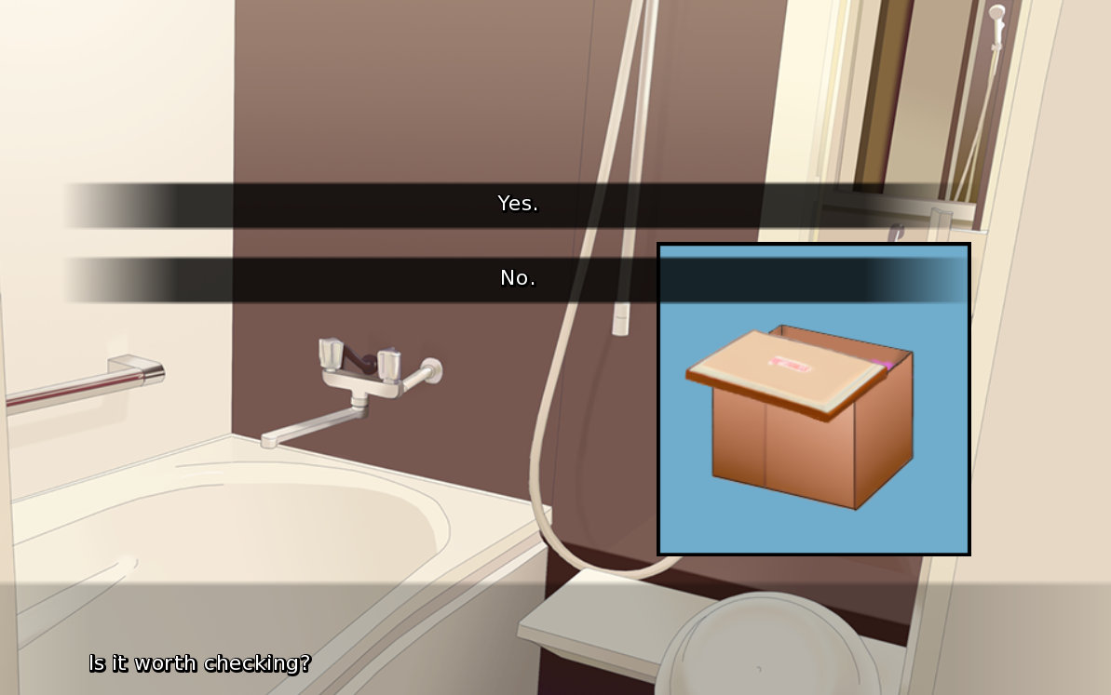

- [Cum kiss] In this case, by refusing to kiss Asahi ("No"), Hitomi goes against Hiroto's command and does not smear her son with his bully's cum. + 1 point to resistance.
From this point on, you can already hear Hitomi's lines of doubt about what she is doing.
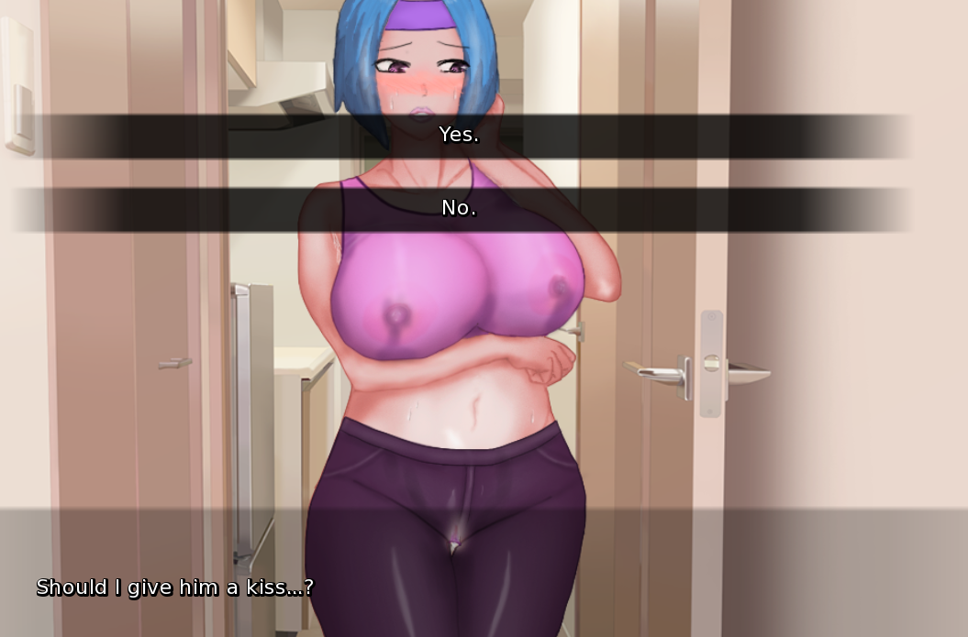
- [Cum drinking] In this scene, Hitomi can find a voice of reason within herself that drinking a mug of male cum is a little too much. Choosing the second option will give you + 1 point to the resistance.
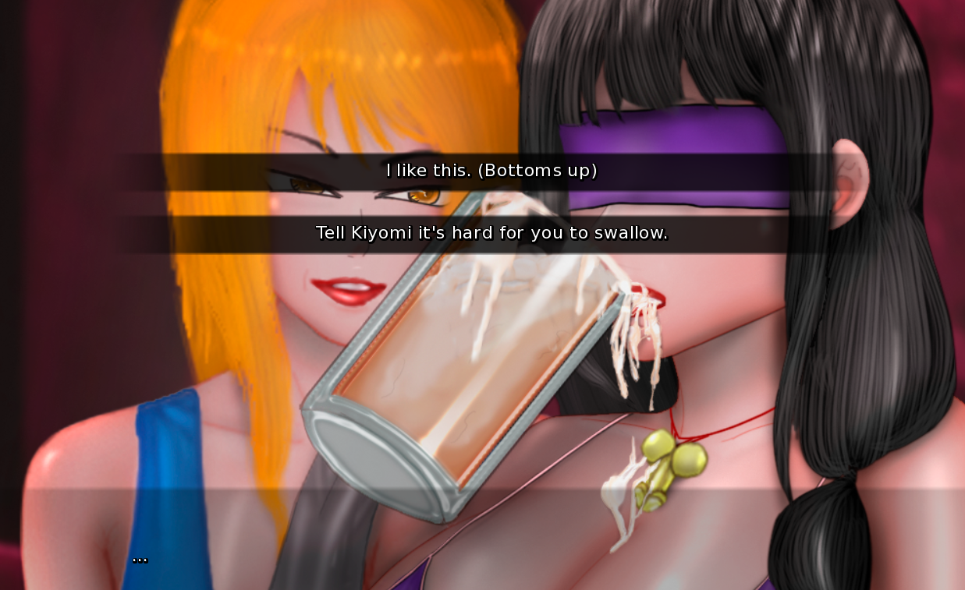
If you manage to earn at least 2 out of 3 points, you'll unlock a series of different scenes (Additional mini CG)(mostly from the point when Asahi is leaving the club (v0.55)). Such level of resistance will further lead to 2 sub routes. In 0.55 you will get the first ending that way. Ending 1A is with high Asahi's attraction to Mom mentioned here in this document (see paragraph 1). Ending 1B with low Asahi's attraction to Mom. Also, this way you can get the BBC route by convincing Mom to return to the club.
However, if you have less than 2 points, you'll be redirected to the main “degradation route”. High Asahi's attraction to Mom will lead you to the NTR ending. Low Asahi's attraction to Mom will lead you to the Corruption ending.

FLOWCHARTS
