LAWYER’S ASSISTANT
COMMISSION STORY
BY CHALDEACHANGE
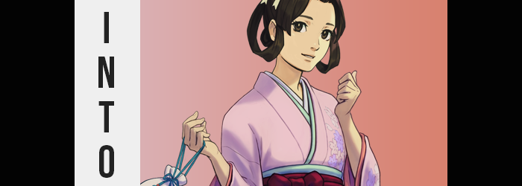

It was Christmas eve, and everything seemed to be in place for the holidays on the part of Joseph. Gifts? Wrapped. Food? Obtained. Family time, at least for the evening? Complete. If it hadn’t only been eight o’clock in the evening, he might have gone right to bed so that he could wake up for Christmas morning – not that it held quite the same magic once you reached adulthood.

But it most certainly was only eight in the evening, which meant there was plenty of time for the young man to burn before he even considered turning in, for better or worse. That meant there was time to fit in a little bit of gaming, perhaps? Opening up Steam on his computer, eyes scooched up and down his game list to pick out something to enjoy. But upon doing so, he caught sight of something strange.

“Huh? Why does The Great Ace Attorney need to update? I’m pretty sure all of the DLC was in the main release. Maybe it’s just a bugfix?” For a visual novel / courtroom drama series like Ace Attorney though, he couldn’t exactly imagine there were many bugs to iron out even after the fact. Still, the update didn’t seem that large and he had nothing else to update, so he clicked that update button, nonetheless. After all, he wasn’t expecting anything life changing to occur. He had no reason to think that way.

Well… Sometimes life had surprises of the likes you could never expect.

Joseph had turned away from his computer just a moment to double check that all of his gifts were wrapped, only for a sensation akin to his chair being pulled out from beneath him to lead into what he expected to be a spill upon his hard floor. That wasn’t what he landed on though. In fact, by the time his ass had hit the ground, he was not even in his room any longer. At least not the bedroom he was familiar with.

Not only was it barely lit – and by an oil lamp of all things at the end of 2021 – but from the creaky floorboards to the futon in the corner, to the Victorian-style dresser and nightside table… Just what was the plan when this room had been designed? What was with the mix of Western and Japanese furniture and items? In a way, it kind of reminded Joseph of—
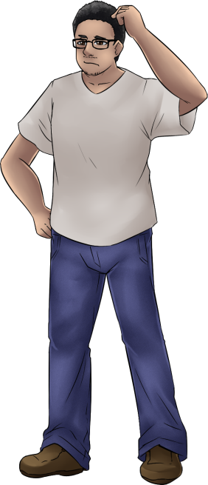
“That couldn’t be, right? Did I fall asleep? I’m dreaming? That makes the most sense, I think.” It reminded him of the setting of The Great Ace Attorney, actually. But he had just been in his bedroom – there was no chance that he just suddenly been teleported to another place, much less within a video game! That was such a silly, nonsensical thing to think!

If only he’d noticed the true cause of the falling he’d been subjected to. That his computer monitor had somehow, magically, slurped him up and dropped him into this space. It certainly would have seemed far less impossible then, would it not have? Instead it was just much easier to dismiss his current predicament as an impossibility.

With a sigh, he picked himself up onto his feet again. He could see more of the room now, like a pretty, pink kimono hung up on a nearby wall. “The design of this looks a little like Susato’s, doesn’t it? I really must be asleep.” Susato Mikotoba was a character in The Great Ace Attorney. A Japanese teenager and the assistant to the main character, she was something of a keen legal mind despite working in Britain after growing up in Japan. But what was this voice calling out from within the depths of Joseph’s psyche. “That kimono is… mine?”

He understood full well the absurdity of what he was saying. After all, he had never worn a kimono in his life – much less one that was clearly designed for a woman. And one that he could only assume had been created for the express purpose of being worn as cosplay as that, since it belonged to a character in the game he had gone to play before this very realistic ‘dream’.

He couldn’t shake the idea that it belonged to him though, and perhaps it was because that, in the back of his mind, he was denying the truth of this because it ‘belonged to a woman’, but something about his body began to appear… askew. Not exactly in a negative way, but the manner in which the light from the oil lamp tickled his skin gave off the impression of said skin being much smoother than normal. At the same time the tone of his skin appeared to lighten from its usual olive tone, not quite turning pink, but certainly paler with a slightly yellow skew.

“Is it just me, or did the kimono get higher up?”, he wondered aloud ever so briefly. Joseph didn’t exactly think about who he was posing that question to, but it was one posed, nonetheless. It wasn’t until he felt his pants slips from his hips that he was given a clear answer, and certainly not by another party. “Hey!?”

He didn’t manage to catch those pants before both they and the boxers hit the floor. The combination of these two losses most certainly should have exposed what dangled between his legs without any mosaic blur to speak of, but much to his surprise they remained covered… by the base of a shirt that typically sat squarely at his hips. It didn’t take him very long to put two and two together by this juncture. It was fairly obvious what he had not only succumbed to, but was continuing to succumb to.

“I’m shrinking!?” While he did yell, he didn’t really shout. It was more of a hushed scream that displayed a conscious decision not to make a ruckus for his neighbors – or at the very least a subconscious desire to do just that. His assessment wasn’t exactly wrong though, that was exactly what was happening. His figure was dwindling perhaps not at an alarming rate, but he was definitely becoming much more petite than he had once been.

It afflicted every facet of his body all at once, taking his stocky figure and seeing it rewritten into something both lither and gentler by contrast. Whether it was the slight excess of body fat thinning out, or the muscle tone he possessed lessening everything (aside from his arms, but even then it seemed less pronounced), the fact that the shape of his body had become much trimmer was absolutely undeniable.

Perhaps ‘daintier’ was a better word for it though, because it was reflected all over his body. Fingers exemplified it just as keenly as anywhere else, with digits now slender and sporting fingers that were manicured, yet speckles of dirty were suggestive of the idea that perhaps his lifestyle wasn’t as clean as the modern experience. The same could be said of his feet, which had crunched into themselves and, despite manicured nails, sported signs that modern footcare products were not available.

Having collapsed all of the way down to a meager five feet in height after once standing at an imposing six feet, it was through the grace of his shirt, now utterly huge, that he was covered at all. Fair fingers tugged at the cloth as he expressed his disbelief. “This can’t be happening! Why did I get so small? And so thin? My skin’s not supposed to be this color…” He almost had to wonder if he’d consumed something bizarre for his dream to take such an uncanny turn.

Though it was becoming uncannier and uncannier with each passing moment, things seemed. If not for the shirt in the way, it would have been easier to see the full extend of what had transpired regarding the design of Joseph’s body, but even he had not noticed these things, to be fair. Whether it was how his hips appeared to protrude a little farther than they had before, or how shoulders were leaner. A look at his tummy would have revealed that, while flat, it sported several moles that hadn’t existed there as well.

And his face? Well, it was becoming significantly harder to see him as a masculine individual aesthetically. Those features softened and rounded. Lips became swollen and plump, widened eyes more expressive, and his nose rounder. Yet for the time being his face did not seem to skew towards any racial changes like the color of his skin had in the onset. He did, on the other hand, look much younger. As if he had regressed back into his teens. His glasses, unable to remain on the bridge of his nose, fell to the floor. But he didn’t need them anymore. “I can see?”

Joseph lifted one arm to observe it, and then the next. “I can’t believe it… I look— SOUND like a woman.” Those hands eventually came up to cup his face, conscious of the fact that one wrong move would see even his shirt spill off his shoulder. But is there any issue with being naked in my room? With that thought in mind, he eventually removed it so that he was as bare as a newborn babe. It wasn’t until after he’d done so that he realized. “Wait! There it is again!”

Why were these thoughts occurring? Then again, why was any of this occurring? The sweeter pitch of his voice did a bang-up job of eliciting the impression that he was a frail and innocent girl, but he hardly possessed the equipment… for a time. Hands were ultimately moved away from his body in surprise, for he could feel the flesh in certain parts of his body inflating, and it would have been in poor manners to touch himself when it happened.

“So it is my destiny to become a woman?” Joseph’s vernacular sounded much less casual and much more proper, which was surprising considering the sight he was now being treated to. The flesh around his hips had jiggled to life, both his thighs and rear becoming supple and full, while not growing overly so. If anything it was round enough to better create the impression that he was a woman.

Not that he really needed much more proof with what happened between bloated thighs. His cock stiffened for just a moment before it became flacid once more, its length shortening even more-so than normal until it slipped inside of her. Her balls followed suit, and when all was said and done there was little more than a woman’s slit peppered by a bush above that was crudely shaved – another sign of the times.

After shuddering in slight from her changed sex, the woman watched her nipples bloat until they were several coin sizes larger, and fat pooled beneath them to see a once flat bosom expand into a pair of perky, if not small breasts. At best they were solid B’s, jiggling a little with her unusually calm breathing. Not enough to catch attention, but in London there were other facets of her aesthetic that would do it anyways.

“I suppose that kimono would fit me now. Was that the point of this? Does that mean that this is actually… that I’m actually…?” She didn’t quite want to say it, but as she prattled on there were signs that what she suspected was, in fact, true. Her proper English found a strange accent gradually peppered throughout to indicate she was not a native speaker, and mentally she had begun to think in Japanese.

Reflected upon her face, the eyes that had been so big and wide in their femininity before soon narrowed into more almond-like shapes. Even their colors dulled to a hazelnut, and her cheeks rounded even more than before so that her jaw had a very curved slant. She bit her lower lip, a lip that had flattened slightly thanks to her racial redistribution. Any British person would turn their heads at the sight of a traditional, Japanese beauty, and so there was no need for her to have an incredible figure of any sort.

All that remained of her previous life was her hair, and even that was short-lived. Locks lengthened and spilled down to her shoulders, becoming silkier but also portraying an oiliness that wouldn’t have been common in the modern era thanks to the shampoos of current day. With the color of her hairs just a touch lighter than her previous one, it wasn’t so small of a change that anyone would question her identity. She was the spitting image of who she had suspected she was becoming. Of a woman within her video game.

And right on queue her mind felt full. Like it had begun to overflow with factoids about both the British and Japanese legal systems. Not the modern ones, mind you, but of the systems in place at the turn of the 1900s. The very era that it was outside of her window.

“I do not understand. There must not be any legal precedent for abduction and… the changing of one’s body?” While fluent enough in English, she was no longer as fluent as she had been. Her words were communicated with an accent that bore British flair but also came with the difficulties one faced with a second language. It took more time to piece together what she wished to say, and at times there were better words for what she wished to say that just did not come to mind.
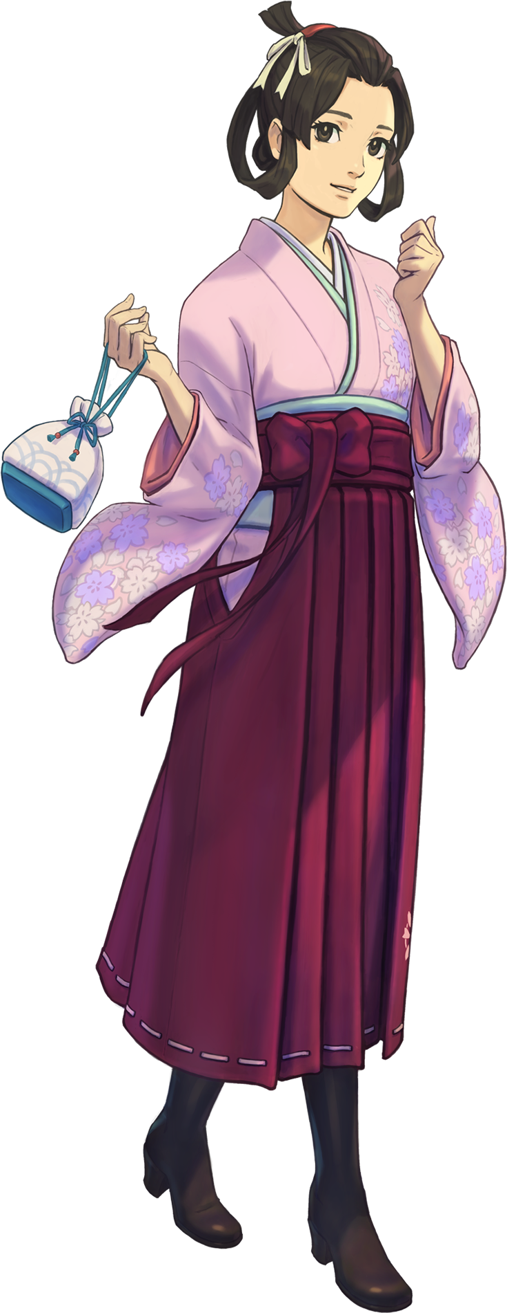
Such was the situation that the newly reborn Susato Mikotoba faced. On one hand, everything about her body in its current state felt foreign. She had been a man not very long ago, after all. But it also felt just as familiar. From the mole on the side of her breast, to the papercuts upon her fair digits, there was a story to each and every blemish upon her fragile form. And she could recall each and every story that had led to each and every marking. Her ego was a blended product of two different lives, but from her flesh and mannerisms it was clear that one was more dominant than the other.

Even now, brown eyes flickered to and fro between the kimono on the wall (one she could recall hanging there), and the clothing of a man from the future that had fallen to the floor beneath her. Even if she explained her situation to someone of this era, would they believe her? “No… I suppose it would be in my best interest to have these burned. Not even my dear friend Mr. Naruhodo would believe such a tale, I’m sure.” Her closest ally, a fellow Japanese that had come to Britain to learn of its legal system. He was staying just beyond the door to her room, in fact, as the two of them occupied the attic of Herlock Sholmes’ abode.

So hurriedly she picked up all of the clothes and stuffed them into a suitcase for the time being. It was elaborate, but it did not take her much longer to stuff her body into the kimono either, or to do her hair. It all felt so natural, like she had always lived this way. Which left Susato in quite the predicament in the end. She could not tell anyone, so how might she return home to the world she had come from? Was there a means? Did she want to?

“I wonder if perhaps it might be best to simply live as Susato Mikotoba from now on? But that would simply be living as ‘myself’ as I am now? With no means of returning, perhaps this is for the best after all?” Peering out her frozen window, she could see fresh snow falling down upon the streets of London.

At least it appeared to still be Christmas here as well!

