NEKO UPGRADE
JANUARY 2022 REQUEST STORY
BY CHALDEACHANGE
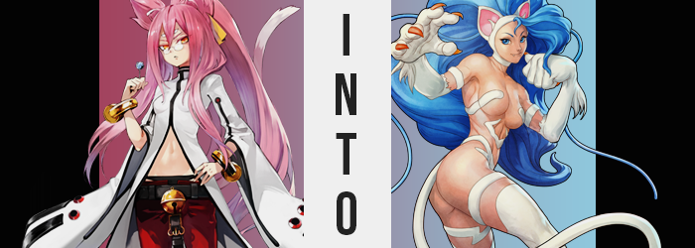

Kokonoe A. Mercury had been working on a secret project.

Well, okay. To be fair there were few projects in Sector 7 that weren’t a secret. That was kind of its whole shtick being a secret organization that stood against the Librarium and all. But this one was a little more personal than most. As of late it had become harder and harder to keep Azrael pinned down within his shackles. He would escape, be recaptured sometime later, and then once again imprisoned. It would have been a system that worked if not for all of the damage he caused in the first place.

With her lab so close to his holding cell then, Kokonoe wondered: what if she devised a way to make it easier to deal with him herself? If he could not be bound with shackles or weaponry, then why not appease the very thing the criminal sought: a worthy opponent? It was a difficult project to pull off because Azrael hardly had any interest in Tager anymore, and Kokonoe? While a master of technology and magic herself, she lacked what he sorely desired. To clash with an opponent that was worthy of his strength, fighting with their own body.

“And naturally, that description does not apply to me. At least not like this.” The whirring of a machine within Kokonoe’s lab slowly silenced itself, and with a HISS a steel panel in front of the feline woman opened to reveal the cause of its utilization in the first place. A lollipop. One that didn’t look all that unlike the ones that the genius was constantly shoving into her mouth. “This will do, I suppose. I’ve run the calculations a number of times, and the effects should be temporary.”


Melded into the sugar of the treat that she plucked was a serum by her design. One that was meant to simply increase the physical capabilities of all who consumed it for a temporary period of time. The theory was that if she were to partake in such a treat, that the Grimalkin could bestow herself with a comparable, if not superior strength to that of Azrael. That meant he could easily be subdued on the frontlines, and that he would be much less of a headache for Sector 7 overall.

Even if it meant sacrificing her own time to do it.

“All that’s left is the testing phase, but I don’t imagine there will be any complications.” Kokonoe was so meticulous that she never doubted creations of her own design. She wasn’t hailed as a genius for no good reason, and such talent was expected of a woman running an organization like Sector 7 practically all by herself. And so, without any further delay, she popped that lollipop into her mouth.

Sweet, sugary goodness blessed her tongue. “Huh. I wonder if it was a mistake to make these look and taste the same as my regular ones?” This was a question that was most likely best asked before she had started their production, but… “Ah well, if I mark them it should be fine.” Just so long as no one else tried to snack upon them. Kokonoe wasn’t even certain that it was working initially anyways. “No changes demonstrated after sucking on it for thirty seconds.”

There had been a bit of a delay in its effects activating though, as enough of it needed to accumulate within her body. Once that amount had been amassed, well… Kokonoe’s body began to burn. “I suppose… this is to be expected…” The Grimalkin winced and lurched forward, for her body felt like it had suddenly lit aflame. Perhaps to characterize it as her entire body might have been a little disingenuous though. Considering the intended effects of the serum in the first place, the actual cause of the burning was her muscles.

She could feel the heat forcing them to rise like dough in an oven, with arms and legs and everything in between promptly forcing skin to tighten around them as mass bulged. Twig-like limbs were quick to demonstrate their new power aesthetically, and the development of a six pack of abs saw the depth of her bellybutton practically double from that which she was accustomed to seeing. An unfortunate drawback came about regarding her chest though, for her already lackluster showing of bosom looked even smaller with proper pectorals wedged beneath them.

“A little grotesque, but this falls within my parameters. At this strength I should be able to lift this.” Rather than gawk at herself or how tight her pants and coat now felt, she instead walked over to a steel cube that was larger than herself – an object she’d had created to test any power she received from the serum. As Kokonoe expected, she was able to lift the whole thing with a single hand. “These results are promisi— Whoa there!”

Prompt in dropping the cube, it wasn’t a lack of strength that had pushed her attention away from her experiment, but the feeling of one of her nipples slipping out from under her jacket. It was plenty alarming, and a little confusing. And she couldn’t really make much sense of it until she’d had both of her hands free. What she had found, though? “What the hell?” Well, her jacket hadn’t slid off her chest… It was much more like her chest had outgrown her jacket.

Both breasts had swelled while her experiment was being conducted, forcing the zipper that kept her pawed jacket open just above her bellybutton to lift even higher. Tits, swelling from tiny handfuls to fully blown melons, were then afforded the opportunity to escape, with Kokonoe not initially noting their weight because of how strong she had become. Now that she was aware, curiosity had gotten the better of the scientist and she was squeezing soft flesh and the pink, swollen nipples that extended from them.

“How peculiar. Did the serum augment my estrogen levels as well? That would be an oversight on my part.” She took a mental note of it to jot down later, and once she’d had her fill of weighing them with her hands she finally let them go. It wasn’t like she’d ever agonized over her figure before. She was better than that.

Kokonoe did, however, find herself pushing her glasses up the bridge of her nose once again as a feeling of tightness returned, this time beneath her waist. “Belt…” There was no shortage of exasperation in her voice as, with her new strength, she tore the thick belt right off her pants with a single pull. She’d have to replace it but, hell, her whole closet was just the same outfit over and over again. Efficiency!

She didn’t even stop with the belt and tore the red pants themselves right off, leaving only her pink thong to cover her nether region. Based on what had happened with her chest, she was fairly certain that these steps were necessary. Her hips had already widened dramatically, and while the heat of her muscles swelling had long since faded, there was a kinder warmth gathered in the flesh around her loins.

It manifested in the form of a soft thickness that graces her ass and thighs, allowing everything to make proper use of the space left by those wider hips of hers. Skin was stretched tautly around ass cheeks that became tender and bouncy, jutting out a good sex inches past the initial arch of her back, and those thighs of hers became just as abundant in mass. This fattier weight did a good job of disguising the muscle that lurked within, likewise providing a very sensual presentation. “And that’s about what I expected, yup!”

“…Yup?”

While attempting to pick her thong from the deepest depths of her ass crack, the Grimalkin was left to ponder where that strange burst of energy had come from, ultimately shrugging as her strength snapped the already tense waistband, forcing her to expose her loins to the vacant laboratory’s cool air. It wasn’t like her to sound enthusiastic, much less cheerful.

“Maybe things are more dire than I expected! Wha-!? What’s with all of this energy!?” She soon found that she couldn’t stop herself, blurting everything she wanted to say out with an infectious cheer. At the very least it served as an ample distraction for what was to come.

Looking at the fur of Kokonoe’s ears and tails, well there was very clearly something wrong there. It was all supposed to be just as pink as her hair was, and yet at the tips there was an unnecessary amount of white, as if her fur had been dusted by freshly fallen snow. This matter only worsened, and before long all of the fur upon her body was painted in this same color, while midst her hair?

A playful bright blue teased its appearance. A color much too gaudy for the feline woman to accept typically, it wasted little time in consuming her whole mane and, not even satisfied with the changed color alone, saw the length and bulk of it swell so that her hairdo was beyond ample. It looked like something you might see in an 80s or 90s fashion magazine, with bangs just as big, blue, and puffy as what now fell down to her huge ass.

Blue teased both her eyebrows and her eyes, which in turn appeared to grow several inches bigger so that they were more expressive. This wasn’t all of the change that graced her face though, and glasses dropped from a nose that simultaneously grew more angular and smaller. Despite losing them though, her vision did not change. With her beauty renewed, she practically looked the part of a model when factoring in her new body type.

“I can’t control this energy! What is this!? I need to put it in my notes…! Er… What notes!? What was I talking about!?” The woman was practically shouting everything now, and her words were being communicated through plumper lips that unintentionally revealed beast-like fangs. All in all, she was becoming a little more beastly. Even though at some point her second tail of white had seemingly mended with the first, leaving only one appendage.

But white fur was growing all across her skin. A great deal of her was left nude, but her arms and legs received the bulk of it – trading out her regular hands and feet for sets that swelled and grew, becoming incredibly thick and rough despite the softness of the fur that coated them. With pink claws fashioned from the nails that had once tipped them, each limb was headed off with a big old paw that carried the brunt of her raw power and made her an even more formidable foe.

While she had been repressing the impulse for a while now, as the fur wrapped around her head and neck, as well as banding in stripes across her bosom and loins, it finally escaped. A sound that made sense for her current appearance, but one that Kokonoe would never have been caught dead saying before. “Meow!?” Were she still herself, the sound of a cat would never, ever, in a million years have crossed her lips. She would have sooner been dead. But as she was, who she used to be no longer mattered whatsoever.

“Huh? What was I… doing?” From her perspective, Felicia had plenty of reason to be confused. She was in an unfamiliar prison of steel with scraps of clothing that did not fit her clinging to rippling muscle with complete disregard for her figure. How had she ended up in this place? Teleportation? Being a Darkstalker, such methods weren’t unheard of even if she did base her life in the human realm. … Was that all true, though? It somehow felt… off.

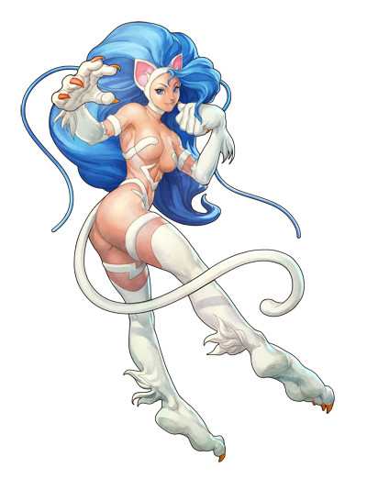
The sound of what she assumed to be an explosion nearby caught the catwoman off guard, and even she couldn’t subdue the squeak of surprise that called out from her sensual lips. More than that? She could feel something approaching, and that provoked her into finally tearing off the remaining scraps of cloth that clung to fur and flesh. “MEOW!”

It wasn’t all that intimidated, but she let out a catlike cry as a man burst through the nearby door, his huge hands interlocking with her oversized paws. His strength was incredible! Enough to force her to dig claws into the ground to hold her position. “FINALLY! This shithole has delivered me a worthy opponent!” With dust clearing, the woman could make out the visage of a behemoth of a man. What was going on here!? Perhaps it didn’t matter.

“If you’re looking for a fight, buster? I’m gonna give it to ya!”

…Hopefully no one got a hold of the other 100 lollipops that were currently in print? Else the results would have been…

Nya-tastrophic!

