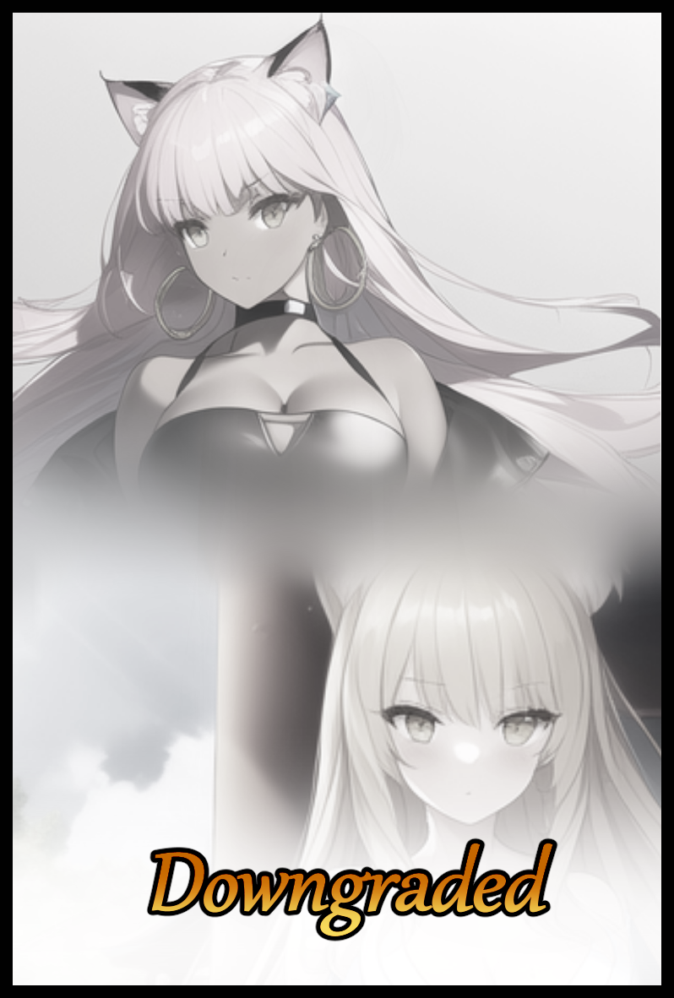

A bright flash stuns the blonde maiden, jerking her neck upward in an instinctual response to the stunning flash shooting her right in the eyes after exhaustion and mental degradation had left her reflexes tardy, too slow to register the glimmer of a camera lens sliding in from beneath, too inept to shut her eyes before stunning light had left her temporarily blinded and even more dazed than she already was, wanting nothing more than to tend to the nauseating ache assaulting her entire body…or better yet, for someone to free her from the invisible bonds that kept her frozen right where she stood…selfish thoughts that hadn't been floating around inside her head a few minutes ago in place of the concern she held for her followers and the many guests, tourists or otherwise, that were just as imperiled as she was at the unsuspecting hands of the peppy feline woman bouncing her weight from foot to foot with a beaming smile on her face at the sight of her golden captive, excited ears and leering eyes privy to things she wasn’t as an airy laugh precedes a taunting line, masked with the same jovial air her body language seemed to radiate in stark contrast to the dark heart lying beneath that innocent shell…

"Tehee~ Sorry for the flash but I thought you could use a wake up call! Looked like you were about to fall asleep for a second there! Whatcha think of my photo taking skills? Pretty cool ain’t it? Doesn’t it capture every last bit of your majesty and grace…my Lady~?”
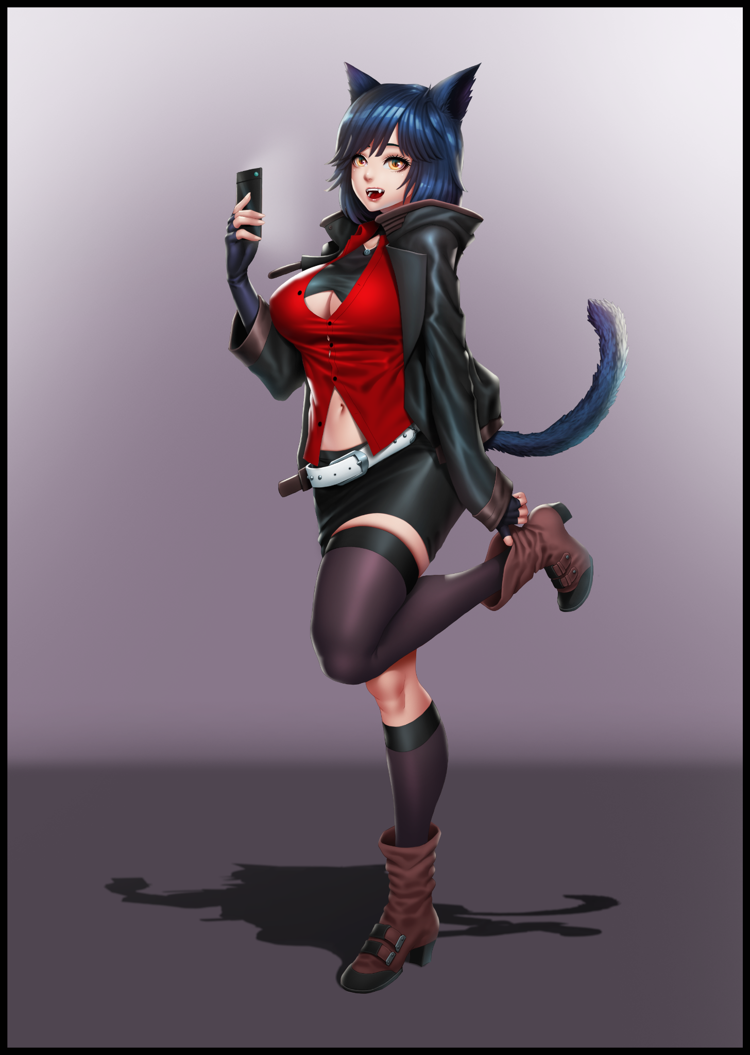
Hideous, it was an ugly picture capturing a singular moment of her ongoing defeat, the defilement of majesty and grace as a bolt of pure magenta energy shoots forth from her captor’s hands, crossing the distance between them in a millisecond to engulf her body, sending a flurry of erotic sensations surging through every single nerve to stimulate her erogenous zones, pushing them to the limit in an act that floods her system with adrenaline, a push that gives her the bare minimum to muster the strength to clench her outstretched hand as yet another mind shattering orgasm rocks her to the core. An irresistible explosion of bliss in her core that shatters the face of her defiant poise just like it had many times before…except this time there came the pitter pattering sounds of liquid splashing against the floorboard below as the absorbent fabric that once hugged her body beneath vanished robes fades away. A shameless display that only served as fuel for the mocking words hurled at her by the remorseless feline as yet another camera flash fills the dimly lit halls of the honden, cementing the dishonorable display for time immemorial behind the screen of that accursed phone of hers.

“Oh dear…you might wanna get someone to clean that up for ya. You do have someone to call for, right?”

Reaching out for aid was impossible for she knew there was no escaping the fate that awaited her as she struggles to compose herself, panting heavily from the recent exertion placed on her severely weakened form. Trapped by the very system she had created to empower those who sought her aid and vice versa, gaining power through the faith and prayer offered to her in return. Humble offerings that had been steadily fading in number for every time she failed to prevent herself from reaching climax. A foreign sensation to the pure spirit until now, where she had experienced it so many times in a row now to the point where it just couldn’t be stopped, her body acting against her mind to indulge itself in the alien, sinful bliss that were the pleasures of the flesh despite the negative effects showing clear on her body as the neatly trimmed nails that adorned her hands begin to lengthen with subtle cracks and ticks, gaining an added layer of polish as glossy pink spreads itself over the dexterous digits in tune to the creeping wave of khaki emerging from the corner of her eyes, spreading out from leathery sleeves to subsume what little remains of her original beige hide.

A torturous erasure of one’s identity masquerading under the guise of an unwinnable game forced upon her by the sudden arrival of a threat she had overestimated her abilities to handle on her own, one that had spent the last unknowable millenia amassing power, a myth made flesh before her eyes in the form of a gloating cat girl…someone that should have been her inferior…in theory at least.

‘では、どのように...どのように彼女は成長し、あのように...強力になったのでしょうか？’
(So how…how did she grow to become so…so powerful?)

This was not how she had expected the events of the evening to play out, far from it when she had awoken to a serene morning. Not a single sign of the metaphorical storm that had ravaged her home and it’s people so thoroughly in the present, thus failing the charge expected of her as one of Japan’s many powerful yokai, a being closely related to the Kami of yore at the height of their power and one of many that called themselves Kitsune; spirits that had the appearance of foxes with the ability to assume the bipedal form of the fairer sex with which they would use to walk amongst mankind at large without worry as they would partake in their usual hobbies of spreading misfortune through malevolent acts before mellowing out with a sense of duty and responsibility instilled with old age and immense power, a rare moment that often times came as late as a couple thousand years into their long lived lives.

Except Rumi and a few others like her were not average Kitsune, belonging instead to a unified group that had many dealings with other supernatural entities both local and foreign. But the group's famed power did not come without cost, and in Rumi's case, her duty had been a rather simple (and oddly suspicious) one in comparison to her vulpine kin. A standard duty she had seen other Kitsune tend to, both young and old; taking on the role of overseer for one of Japan's many surviving shrines…with one major exception.

The heart of Shinto shrines normally served to house specific Kami for the humans to tend to and venerate with all their faith and a popular hotspot for both spirits and yokai alike to linger around and leech from the abundant spiritual energies that saturated such places…save for a handful that is, one of which would be the new home for Rumi to secure and amass power from, serving as the latest stand in 'Kami' and the receiver of the people's faith after the last one had left a supreme Tenko…a state only a few Kitsune could ever hope to achieve…a time consuming process and simple to achieve without the cost of wasting away a thousand or so years as pesky, immature children yet to see the world through the wizened eyes of their elders. And thanks to their signature talents of illusory mystique, the fleeting humans would be none the wiser for all time, happily assuming their services were in the name of their gods, none the wiser to their simple existences as cogs in the machine…a cold mindset Rumi had come to shed shortly after a year of receiving the people's prayers and faith, adopting a fondness for the many shrine maidens who tended to the place in her stead, with one amongst their number receiving a modicum of her undivided attention while the vast majority in the form of the many patrons who would visit on a daily basis to receive her 'blessings' were more or less relegated to the back of her mind as simple faces that came and went without anything noteworthy to take away from, deriving satisfaction from receiving their praise for helping them with their woes.

What should've been a job had instead become an enjoyable life. A Kitsune of Rumi’s age would've been busy thinking up a stunning prank on some unlucky soul, but here she was a year in, sporting a third tail and a veritable list of experiences with the humans that had made her the matured lady she was today…

…Before it all came apart when a frosty gale had blown in from the north opposing the front of the rustic shrine when the time came for the evening to roll around, stirring up leaves and whipping the branches of tall trees, making them flail in a manner reminiscent of maddened men riled into a frenzy. Arms swaying while stiff bodies twisted to the unnatural whims of an external force…and at the very top of the circular hill that served to prop up the divine home to a false goddess stands Rumi herself, a proud figure with vigilant eyes of amber peering into the distance after being drawn toward the perimeter by the sudden appear, unfazed by the onset of darkness wrought by the fading sun cresting over the horizon as it’s brilliant flare dies away, leaving the blessed land and their inhabitants to face the unknown by themselves. A prospect that didn't excite the tri-tailed Kitsune by a margin…but a challenge she would nonetheless come to accept, confident in her ability to handle threats of any magnitude…but not so those of the ordinary humans who were still around, now more than ever when the crowds would be at their busiest. Meaning a greater number of casualties if the coming omen was reckless enough to reveal itself before the citizens of Japan at large…a grave violation of the treaty that served to protect both sides.


The Kitsune was no stranger to conflict and petty squabbles wrought by disagreement and strife, but that had been with the humans, a 'lower' life form she could easily placate to be brutally honest. Whatever the eerie breeze was warning her about was anything but human, another of her supernatural kin, something she hadn't thought possible after the age old accord to keep the peace between both sides had been agreed upon years ago in a bygone era where managing yokai and vengeful wraiths were more than just simple horror stories to keep children in bed. An unspoken law that served to protect the people of Japan by obscuring the supernatural world from them, a law all yokai knew to abide by. So to go against it willingly would be like signing their own death warrants…unthinkable…

Turning to head back into the shrine, Rumi’s first order of business had been to prepare the shrine’s caretakers for the coming incursion, and the only way she knew was to meet with the head Miko and the only one amongst the shrine's caretaker's to have ever had the chance to view the 'Kami' spoken of in the tales told by her forebears. Taking great pride in that fact from the renewed vigor and enthusiasm she put into her work as the one responsible for maintaining her goddess' shrine…a facade Rumi had hopes to break in the future once her ascent to true maturity was achieved with the manifestation of every Kitsune's ambition; the ninth tail, coated in lustrous sheets of pale gold and shimmering silver. A signature trait of the Tenko and a daydream that would serve as a tiny bit of reassurance on this tumultuous evening as the invisible Kitsune drifts by the many tourists and locals lingering around the main pathway leading toward the honden, the shrine's main building and one of the few closed off to the public at all times, sensing the head Miko’s presence flitting to and fro within the confines of the hallowed structure.

“るみさん？何かが-”
(Miss Rumi? Is something the-)


Barely a second after phasing through the doors of the honden, the Kitsune would unknowingly have a few seconds left to glimpse the sight of her human friend as she remembered her for one final time once a sudden disturbance in the air washes over the oblivious maiden, cutting her off mid-sentence and rooting Rumi to the spot as the intense wave of magic energy cascading forth from Mio’s burgeoning body overwhelms her senses, an incredible display of corruptive power that leaves the fox stunned and helpless to lend her aid to the head Miko as her cherished garments burn and distort amidst an instantaneous darkening of the skin and a growth spurt that rapidly ages the spritely youth into a buxom lady with a perverse figure, complete with massive breasts pushing hard against the repurposed fabric of a pristine kosode, now a woefully small tank top that leaves a firm navel exposed alongside long, slender arms bulging with muscle and meat that fills in to eradicate Mio’s once petite body. An unstoppable defilement of purity as inert nubs swell to erect mounds atop milk laden teats, shifting her weight from foot to foot as plain sandals harden into fashionable heels under the influence of malignant magenta that adds even more height to the maturing female once fattened thighs and toned calves finalize themselves. Their curvaceous silhouette clearly defined by the incredible squeeze of leather jeans that had since replaced the flowery hibakama the bygone shrine maiden once wore, temporarily halting her sudden metamorphosis with an explosion of obscuring, two-toned hair that falls all the way down to the floor, framing the hourglass figure of the altered woman alongside a side swept fringe that hangs over the still intact face of Mio as pleading eyes turn toward her goddess for help. Almost as if the one responsible served to toy with both women’s heartstrings by delaying the inevitable…
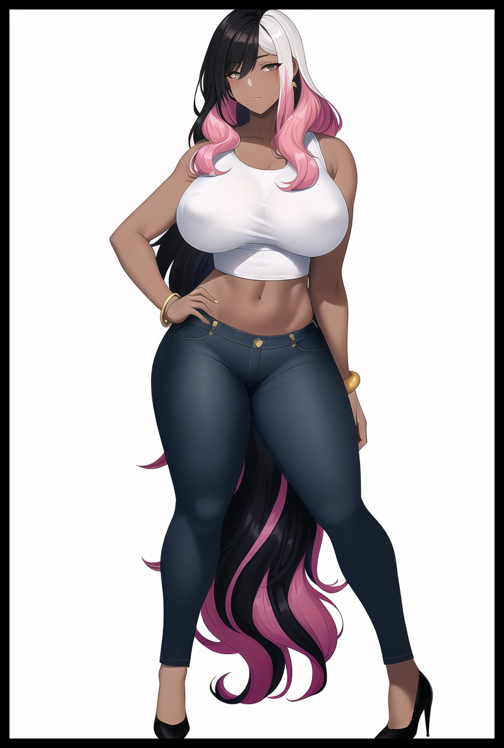
“るみさん...”
(M-Miss Rumi…)

The Kitsune’s reply would leave an open mouth as a wasted croak as the one step she takes in an attempt to save her cherished shrine maiden ends in the complete erasure of Mio, helpless to stop the careless swipe that distorts the girl’s face to match that of her older body, losing any recognizable features as the visage of a twenty four year old Japanese woman morphs into the sensual face of a foreign wench wearing an expression that looked like she couldn’t be bothered as fearful eyes narrowed into dismissive slits while an already tantalizing body fattens even further, gaining heft between spread legs while an already impressive mane curls into an extravagant flair, coloring itself in shades of neapolitan to complete the Miko’s downfall, replaced by a beautiful foreigner who didn’t seem to mind her compromising attire as a manicured hand plants itself over virile hips, cocking her neck with a cold look she never would have given Rumi before redirecting her appalled gaze at the surroundings she herself had played a part in maintaining.

“The heck is this dump even…hey chica, you seen the Boss around? I think she’s run off again..”

Reaching out in an effort to peer into Mio’s essence while brushing aside the panic wrought by hearing that husky mature voice in place of a sweet, airy one. Rumi attempts to resonate with a significant portion of her own power she had lent to the shrine maiden, thinking to use it as an internal ‘bomb’ of sorts to purify the Miko, only to have it backfire on her once the anchor she had sought to use fires back in response. An unexpected retaliatory strike that hits the vulnerable Kitsune right in the chest to send a familiar pulse throughout her body that rings closer to home than Rumi had expected as she comes to a freezing halt, hand outstretched, legs apart, spasming tails locked in place as a sign of the immense internal struggle brewing within to try and break free…this was Kitsune magic, an unmistakable assumption Rumi was more than certain of after having had the misfortune to be on the receiving end of such spells in her youth.

“Figured it out huh? Unfortunately, you’re still a tad bit off from being spot on…though you can thank your inner circle buddies for that…”

Hearing the nonchalant voice dripping with a subtle tinge of sarcastic spite belonging to the evil whose arrival had been foretold by the night winds echoing out from directly behind the bastardized form of Mio had been the first ‘step’ in the downward spiral Rumi was still in the midst of falling through as her addled mind connects the recent past with the ongoing events playing out before her very eyes as the cat girl standing before her very eyes had crept out from directly behind her former friend, laying eager hands on her body without express permission. An infuriating sight made worse when the corrupted maiden spurs her advances further by grinding her buxom form against the salacious digits roaming over her swollen breasts and pendulous hips, giggling like a dumb ditz with her face twisted into an expression of utter delight…and even though it had been twisted just like the rest of her body, there still remained faint traces that made the Kitsune writhe in protest at the sight of her Miko’s eyes, glassy and hazed over peering back at her, enraptured by the touch of someone else that wasn’t her…

Rumi could understand little of the foreign tongue spoken by the many tourists who visited her shrine. But amongst all of them, English was something she had a more or less stable enough background behind to know the meaning behind certain words. And from what the vile feline had said in response to her thoughts, she too would be able to understand the meaning and anger behind her demands to let her friend go.

“Oh my, someone’s mad…I’m sorry hun, but you aren’t getting the picture. I’m not here for any of you…well, sort of. I’m just out to make a lil fun while I take back what’s rightfully mine! I’m not the type to waste any time so let’s hop to it! Oh…and by the way, I don't think Mio’s gonna cut it anymore, not a name that would fit Big Momma over here…eh, you’ll think of something…”

The only reply from ‘Mio’ would be a fading sigh in the wind as all autonomy leaves the curvaceous woman once the catgirl’s dexterous hands finally fall back to her sides, leaving the Spanish woman to stand silently by the side like a life-like mannequin, gray eyes sapped of emotion with the only signs of life being the steady rise and fall of a heavy bosom and the feverish blush painted over her pretty face while fat lips remained slightly open beneath half lidded eyes burning a thousand yard stare into the wall on Rumi’s left, the imperiled Kitsune still clinging to the vain hopes of rescue for her friend before a snap of the finger heralds an unearthly crack that splits the air like thunder, causing the entire structure to tremble and Rumi's distracted mind to snap back to focus, glaring in shock at the whimsical feline for the feat she had performed with terrifying ease, all while the muted sounds of heightened murmuring from the crowd outside bleeds through the walls, clueless to the gravity of the situation they had all been drawn into at the whims of the uncaring being staring Rumi down with mocking glee in her own domain.

"Well? Let's get started shall we?"

The paralyzed Kitsune didn't need a visual check to realize the shrine and everyone within had been plucked from Japan and dumped within a spatial bubble in an entirely foreign land altogether. A 'belly of the beast' scenario to set the stage for this game of hers where everyone, from human to yokai, was fair game; the final push on a slippery rung that would send Rumi falling on an ongoing descent she had long since realized there was no escape from. Her confidence to defend her domain and the humans frequenting it upon sensing this unrivaled intruder misplaced.

According to the bubbly feline, all Rumi needed to do to qualify a win was to last against a single 'session'. What that meant at the time had been a mystery to the Kitsune, assuming it to have been a confrontational challenge or a battle of the wits as yokai usually favored. And if she won, the peppy stranger had promised to return the shrine to its former place in Japan and to leave them alone…but not before restoring Mio to her former self. A demand that amuses her to a certain extent if the wry smile over her youthful visage was evidence enough.

"Heh~? Just Mio? What about everyone else? For a 'Kami', you're awfully tunnel visioned…oh…right, you totally can't sense a thing. Here, front row seats to the jolly good time going on outside!"

Another snappy gesture of the hand, and a spherical tear in space hovering over the trio would reveal a bird's eye view of the shrine. Everyone seemed to be shaken but dismissive of the brief dimensional disturbance, going back to whatever it was they were doing as tourists chatted amongst each other while the Miko tended to their duties…except the background looked…wrong…as if a shifting barrier of disturbed air had been conjured in the space surrounding the shrine all the way down to the foot of the steps at the base of the hill. But that was the least alarming thing the Kitsune had instantly taken notice of in the real time vision.

It was subtle, but the disturbance was gradually beginning to intrude upon the shrine, and in a manner similar to what had befallen her friend, random members of the crowd were being altered at a rapid pace, vanishing them in plumes of magenta energy that leaves them in completely unrecognizable forms similar to Mio's current 'daring' appearance…and the worst part was, no one seemed to realize what was going on. Not even her dutiful Miko when their own numbers began to fall to the insidious energies creeping forth from the invisible shroud surrounding them all, distorting whatever they touched from the shrine itself to the people within.

Age old wood, carefully maintained and restored over the years becomes cement reinforced by rebar and modern materials. Cobblestone pathways melt before shimmering into polished marble flooring lined with built in lighting systems and other such implements hidden by velvety carpets while an open view of the night sky is concealed by the emergence of a high ceiling interspersed by support struts and hanging wires. Transforming the serene shrine into an enclosed space that was starting to look alot like the debauched dens baseless humans would frequent to indulge in the pleasures of the flesh. And in line with the environmental changes, it would only make sense then that the people follow suit as well…

Horrified and helpless to do anything, Rumi could only watch as tourists became scantily clad waitresses while Miko were corrupted where they stood into attractive women of foreign descent, following after their fallen head as some took on the role of cheap escorts clinging to the broad shoulders of what few men remained untouched by the invisible magic while others like the young girl manning the gift shop are given more 'important' roles as her youthful form bloats and distorts over the course of a second until a sultry bartender had taken her place, whispering sweet words and empty promises to the man she handed a martini to instead of the handmade charm she had been holding onto.

"Still wanna make your dear Mio the sole exception? It's not too late to make changes, y'know?"

Rumi's fate had been sealed long before her hasty agreement to save the home she had been charged with protecting alongside all the unwitting innocents caught in the crossfire, for nothing could prepare her for the overwhelming, metaphorical kick to the stomach that was a forcibly induced orgasm that instantly whites out her mind once her bold declaration of acceptance devolves midway through into a guttural groan while her frozen form spasms in maddened bliss amidst her opponent's wicked cackling as half closed, teary eyes draw upward at the vision amidst her wracking laughter.

"Ahah! Y-You weren't the least bit ready were you? Better take it seriously though m'lady, you're losing people faster by the second for every time you screw up from here on out~"

It was a dishonorable tactic…but also one Rumi could find some measure of respect for one willing to resort to anything if it meant victory. And in her opponent's case, a complete lack of morals seemed to lean the odds greatly in her favor through the underhanded technique she was using by channeling her own energies through the pre-established link Rumi herself had created in a bid to ensure something like this could never happen in the first place.

Against any normal foe, her ingenious plan would've worked fine. But against the catgirl, whose prowess in the arts of Kitsune magic and beyond far exceeded her own, Rumi was helpless to stop the intrusive insertion of miasma into her network and the cause for the overwhelming sensations that would send her into a maddened frenzy everytime she did so…and whenever she failed to hold herself back from the irresistible throes of orgasm, minute changes would begin to creep over her disgraced form as pale skin is painted over with a glistening khaki hue while ornate robes grow heavy once silk morphs and hardens into dark, glossy leather in stark contrast to the pure whites and gentle blues of her original clothing. All while a blonde curtain glowing with a divine energy steadily loses its light before stiffening into a drab mane of hair maintained by high quality shampoo and conditioning, spurring the onset of neon pink that creeps forth from the root, whittling away at pin prick ears as they broaden into shortened stumps akin to the ones sported by her catgirl opponent as vulpine extensions cross the species barrier towards feline descent…changes racked up in succession like a growing snowball rolling down the hill for every slip up as the fading Kitsune's score in this unwinnable game continues to drop.

She wanted desperately to stop herself from succumbing, especially with the knowledge that holding out for just one ‘session’ would guarantee victory. But Rumi, in human terms, was simply too naive a virgin to even hope for such a thing. With her innocent love for Mio being the closest thing the Kitsune had ever felt to a bodily emotion, nothing could prepare her for the ruthless onslaught of pure eroticism laid upon her by the catgirl, flicking fingers to summon bolts of electrifying energy to stimulate every last nerve center in her body to transform the Kitsune’s very being into an erogenous zone, her mind barely able to handle two orgasms before the back breaking strain of five more made themselves known…and for each howling moan or quaking cry, more of the shrine would vanish under the growing structure of a nightclub repurposing her Miko and the tourists to populate it’s neon lit dance floors and posh seat. An inevitable fate Rumi would soon succumb to as her physical form falls to the feline’s magic.

A lean derrière bloats into a pliable bubble butt. Modest breasts inflate into enticing melons squeezed tight by a revealing latex sling top formed from repurposed cloth, emphasizing buoyant girth from the amazing cleavage formed by the two jiggling teats squished together in a suffocating prison. Drawing attention away from slender arms mostly hidden beneath the baggy sleeves of a crumpled leather jacket drawn from the rest of the upper portions of Rumi's soiled and ravaged kimono as the remnants shift lower, leaving a heated navel on show while coiling like dark snakes around freshly widened hips leading down to plump thighs and toned calves tapering off into waifish feet secured by boots to replace outdated geta sandals connected nicely to the shimmering, skintight leggings that were the final piece of the puzzle to form a more 'modern' outfit…a scandalous one the humiliated Kitsune wanted nothing more than to rid herself of as her haggard mind catches up to present events once more, staring down the catgirl whose beaming smile of faux innocence had yet to fade from that reprehensible face of hers. Blurry eyes barely able to register the silhouette of Mio's warped self standing idly to her left, playing the role of a silent doll as her cursed form comes under assault by the bored monstress' idle hands yet again…except this time, Rumi no longer felt jealous or angry…looking instead to question the stranger on why she had even done thing in the first place. Nor did she seem concerned with the deeper voice formed by thicker lips speaking in perfect, if shaky English instead of soft spoken Japanese…

"W-Why…"

"Huh? Did ya say something? Wanna call it quits right here?"

By now, most of the shrine and its inhabitants had already been changed by the perverse magic that once saturated the air. By integrating the disjointed shrine into its new location as the interior of a seedy nightclub somewhere in the far flung lands of North America, there was no longer any need to sustain the dimensional bubble keeping its trapped inhabitants blissfully ignorant, not when each and every last one of them had become alcohol addled partygoers, drugged up dancers (most of whom had once been Miko performing a ritual dance turned sensual and erotic with the twisting of their forms and the ground they stood on into scantily clad Latina hookers gyrating their bodies on raised platforms and high reaching poles) and daring escorts. A high concentration of which were very promiscuous females to match the desecrated nest of sin and vice they had been forcibly integrated into beneath their notice as the equally wasted Rumi watches the last tourist fall to it's touch, sensing something off far too late to do anything as the hand reaching for a phone in his back pocket instead begins to unravel black lace panties beneath a rapidly grown miniskirt for her fellow gal pals to finger a dripping pussy without care for the vanished manhood that once hung there…and thanks to the still intact link connecting her to most of the afflicted, Rumi could feel everything they felt down to the letter…and it all served to drive her towards that lax, hedonistic lifestyle they all partook in as the irksome feeling of leather brushing against skin becomes pleasurable while the woefully tight sensation of rubber waxing skin spurs wanton thoughts simmering within the Kitsune’s mind into a yearning flame that had overtaken the righteous anger and distrust for the catgirl she could no longer muster.

Rumi’s shared power, the bonds she had established had been turned against her. The energy stored up overtime for her ascendance to godhood about to be sapped dry, cemented by the unraveling of her tails ever since the gradual deformation of her body as each one had started to curl inward like a crooked finger, tightening with every passing moment before fusing with another, looking less like fluffy appendages and more like a matte smooth bundle of flaky skin. Bubbling and shifting in an organic manner unbefitting of the (formerly) majestic image expected of yokai like the Kitsune…because Rumi no longer was one.

With the final droplets of her essence sucked dry, the roiling mass extending from a neat little cutout above her leggings becomes a smooth, lanky tail. Coated in a short layer of smooth raven black fur divorced from glorious gold and looking nothing like the paintbrush-esque plumes signature to foxes and more like the flexible, stable length of a cat’s tail to match the ears that had replaced the vulpine ones atop her head. Leaving her as an undeniable cat girl just like the more able one staring her down…except unlike her, she truly was as weak as any other member of the cowardly race of yokai. A shadow of her former self.

"Why…do this?"

"Ahh…well…I hate to keep reminding myself of that particularly nasty bit of history but…screw it, it's the least I can do for ya, losing side and all…long story short; I’m just here to collect…no hard feelings and all, you have what I want; Kitsune energy…and I don’t very much care what happens to who I have to take it from, I’m a couple thousand years past that…but, I’m not totally heartless, so here, let me make it easier for you…"

“N-No! W-What’re you…ugh!”

Crossing the distance between them in the blink of an eye, the catgirl zips over toward Rumi in a flash of magenta, grabbing ahold of her forehead before twisting her neck up so her eyes were directed skyward to view the honden itself fall prey to the superior being’s power as the spacious chamber compacts itself into a living room sized space complete with large couches, a table laid out with alcoholic drinks and a work space fit for a corporate agent devoted to their work in place of the ornate statue that paid homage to a former self long about to be erased for good once sparks of miasma begin to shoot out of the gaps between the catgirl’s hand and Rumi’s scalp from a final surge of that corruptive bliss being directed straight into the newborn feline’s brain in an inescapable attempt to scour her very being of who she once was; rewriting loyalties while personal relations were hotwired, dumping the ‘useless’ memories of a millenia long lived Kitsune in favor of a much shorter series of events that painted the catgirl…no, Philia, in a better light to the refurbished soul standing limp in the center of the uplifted room built to oversee the majority of the nightclub like the command center to a spaceship as the sounds of thumping beats blasted by speakers easily pierces the walls of the newly formed room and the last addition to the nightclub. Leaving the victorious feline standing before her conquest with a wry smile on her face, leering eyes scanning the nameless feline’s voluptuous form all wrapped up in tight clothing just like her former attendant…

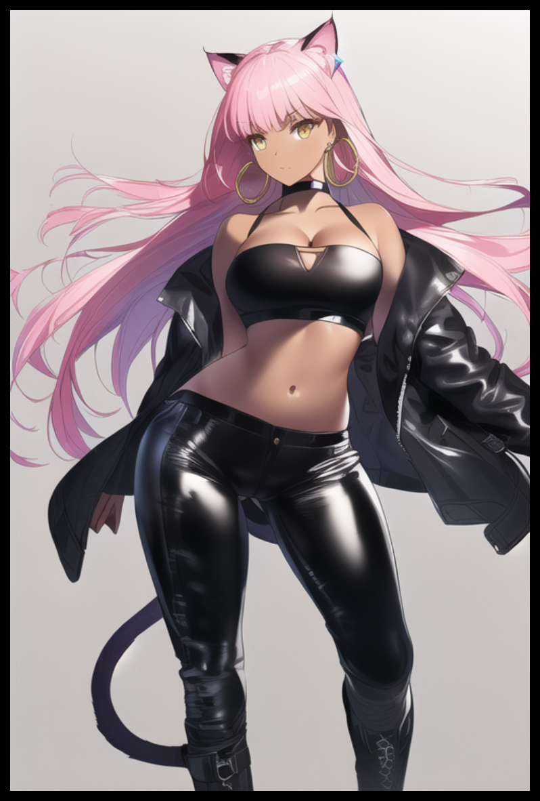
With the final addition of a banded choker tightening itself around a dainty neck, the newly molded woman rouses from her slumber as the light of intelligence slowly flows back into her glassy amber eyes, the only things that hinted to her former status as a Kitsune and a mark for Philia to remember her by as she takes a step back to allow her creation some space to breathe and stretch, taking on a more provocative and confident pose far removed from the elegance and humble reservation of Rumi’s.

“lo siento jefe…did I miss anything? Feels like I just…took a nap or something…a real long nap…”

“Oh it’s fine Mali…speaking of, you in particular…are looking real fine tonight~”

“Jódeme~ You do mean what I think you’re sayin’, right?”

In place of Rumi’s youth where the circle had uplifted her inferior existence to their level in exchange for her services. Mali could only remember being a simple cat scraping by each day in a dark alleyway somewhere in the streets of an American city where crime and vice was at an all time high. And in the midst of all that turmoil where animals like herself were treated like stress toys for the humans to vent on, Philia’s timely intervention and proceeding notice of her had been the first steps of many on her ascent to power. By turning her from animal to intelligent cat girl spirit, Mali had been able to secure a high place masquerading in human society as the proprietress of one of the country’s most popular nightclubs to waste away one’s riches in for a good time. Amassing followers that numbered by the dozen in the week after her Mistress had vanished and then eventually a hundred by the time the first month was over. Seeking to build her empire in an effort to show Philia the fruits of her decision to save her that day when she would someday return…and now here she was, standing before her own two eyes after so many years…blissfully unaware of how her ‘owner’ had fabricated it all in the span of a few seconds.

“Of course…evidently, you’ve been a busy girl…and I like busy girls~”

“Ahyan~ M-Mistress…not in front of the others…Lucia? Puedes irte. Tómate un descanso o algo, ¿de acuerdo? Te llamaré cuando te necesite de nuevo.”
(Lucia? You can go. Have a break or something, alright? I'll call when I need you again)

Similarly brought up to speed and snapped out of her hypnotic stupor, the motherly Lucia acknowledges her boss’ orders with a not so subtle blush on her cheeks and a nod of the head as she heads out the door, careful not to make a sound as Mali’s personal bodyguard and stress relief leaves the heated ‘couple’ alone. Locked in a highly insinuating position with one of Philia’s hands dug under the front of her partner’s leggings while the other crooks inward to cop a smooth feel of creamy tits beneath her suffocating top, adoring the swollen sensation of erect nipples tenting the rubber while fingered gash down under let’s loose its umpteenth load of the night all over Philia’s hands, eager to form another puddle in place of the one that had been cleaned up in a jiffy once the old floorboards of the honden had been thoroughly erased from existence…

“Hired help? I don’t mind a threesome y’know?”

“Let Lucia go…she’s had enough of me for a lifetime…tonight, I just want it to be you and me…solo~”

“Mmm…now that’s something I think I’ve heard before.”

“Oh really? Where from?”

“Eh, it’s nothing…just a stupid fox…”

With a final shove and a subtle sigh escaping moist lips, the two cat girls would waste not a second more as they immediately get right into the thick of it; conjoining bodies together as soft skin melds while opposing layers of supple flesh rub against the other. Fusing beads of sweat that beads cocoa and vanilla hide as Mali and Phillia begin to make out in earnest…the former, in false love for her new Mistress…the latter, gleefully awaiting the day she would regain the strength and splendor stolen by her supposed kin…content with her progress for tonight after the consumption of Rumi’s ‘ill-gotten’ gains and Mali’s scrumptious body…

THE END

Image Sources

Image 1 provided by Sigrun (Commission for OC featured in the story)

Other images generated by NovelAI

