STAYCARE DELIGHTS
CH6: BUZZ OFF
BY CHALDEACHANGE
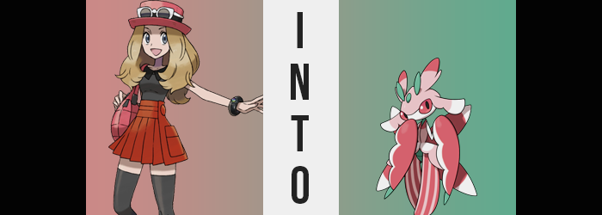

“Mmph!? Mmph! MMPH!?”

The reigning Champion of the Kalos region, Serena, had seen better days. All the girl had thought she had been doing that morning had been using the new free Pokémon Daycare that had been set up in her hometown of Vaniville Town. She had been staying with her mother for a few days, and had more than a few friends in her boxes that she needed to train up – and so she had figured: why not?

But things had taken a surprising turn when she had arrived at the building that morning to find it open, but seemingly unoccupied. No one was staffing the front, and there certainly weren’t any Pokémon out in the attached field. “Hello?” And so, concerned that there was some sort of emergency, the girl had crept deeper into the building all on her own. She’d passed a strange, white room and had come to an open door through which she could hear voices.

“Why isn’t the pedestal functioning!? Don’t tell me we need to contact Team Galactic HQ!?” There was a woman yelling inside, and through the crack of the door? Serena could see a woman dressed like a receptionist alongside a man with blue hair… dressed in a strange uniform.

Serena repeated something that had stood out to her under her breath. “Team Galactic?” She’d heard of them. A team that apparently had been active in the Sinnoh region but had long since disbanded – but this woman’s words appeared to suggest the contrary. Was that the uniform the man was wearing? “Maybe I should— AH!?” Get help? That had been the plan, but the girl had suddenly been struck in the back of the head, and all had faded to darkness.

“How’d yer snooping go? Well, won’t matter for long.” When the girl had come to, she had been bound and gagged. Her head had been throbbing and yet that hadn’t even been the worst of her problems, because no sooner than she had awoken? The man who had presumably knocked unconscious had dragged her into the white room she had passed. At least he had untied her hands, but he had still thrown her into the room and closed the door behind her.

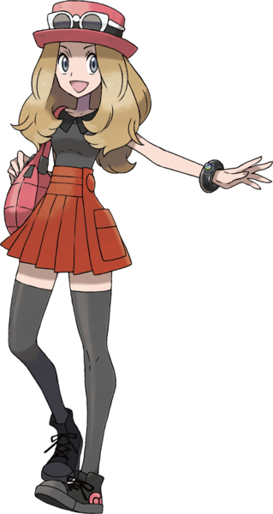
It took her a moment, but Serena eventually managed to undo the gag before lunging at the door. “Hey! Let me out of here!” Panicked, it had taken her a moment to remember her Pokémon. Yet even if she had wanted to use them, it seemed her pink bag hadn’t been brought in with her. The door wasn’t budging either, and she had finally realized the most important thing of all. “Wait, they took my hat!”

That probably should have been lower on her list of priorities.

Particularly as the pedestal in the room’s center came to life, casting a pastel pink glow through the room that caught the girl’s attention. Evidently they had fixed it during the time she had been knocked unconscious, not that the girl knew what it did. But she quickly learned of one effect after turning around. “H-Huh!? I can’t move!” But it was oh so much worse than that.

And it didn’t exactly take very long for the girl to realize that. “Whoa!?” Had she been able to throw her hands out to the sides, Serena most certainly would have. Because she perceived a strange imbalance in her body, and from her perspective it was as if she had begun to fall. After screaming with surprise though? She realized she wasn’t actually falling, yet why was her point of view dropping? And had the room always been this large?

It wasn’t until the girl felt her skirt slip from her hips and her accessories begin to slide off her arms and legs that the reality of the situation finally clicked. “SERENA’S GETTING SMALLER!?” Wait, why had she referred to herself in the third person there? Compared to the realization that had dawned on her, it apparently wasn’t all that important. But she certainly wasn’t incorrect. Her body had been shrinking in a proportional manner, meaning that rather than her body becoming more child-sized, she retained her build as she shrank. By the time she had realized she was just under the three foot mark, and her hat and top ere the only pieces of clothing still on her.

Thankfully she had shrunk so much that the shirt was acting as a dress, but because her shoulders were narrower too? It seemed like the slightest movement would force it to slide off her shoulders.

“What? What!? WHAT!? How is this possible!? Serena must be so tiny!” In terms of things that could be the culprit, the glowing pedestal was the only thing that came to mind. Had Team Galactic composed a device that shrunk people!? Yet it unfortunately wasn’t as simple as that. The three, leafy green nubs that seemed to sprout atop her head were a testament to that.

The growths were varied in size, with two farther back being about five inches long, while a smaller nub in the middle and slightly forward was only about two inches in length. They lifted her hat, which inevitably fell off. “…My Lur-hat!” Squeaking that exclamation was all she could do though, at least as long as she was incapable of examining her own body.

But the balance of her skull was soon compromised further by four additional growths split between two pairs. Two jutted out from behind the green antennae about seven of so inches while slightly lifted. Unlike the earlier, green growths however, these were largely pastel pink aside from the darker pink tips. Otherwise, the other pair not only extended above her ears but consumed them, leaving two tiny holes for hearing beneath pastel pink fins of sorts that were tipped with white. While they were softly colored? These growths were oddly firm to the touch.

Firmer than human skin, at least.

And this hardened coating wasn’t isolated to these new growths alone. All of Serena’s skin had hardened to a similar strength, smoothness, and sheen; the color varied depending on the part of the girl’s body that was affected, however. The pastel pink from her new growths crept into her forehead and nose, and the bottom half of her face was left white. Her neck and groin, on the other hand? They both adopted the same green as her antennae while the former thinned and the latter bulged in slight, almost taking on a segmented, rounded look as her genitals were smoothed away into obscurity.

“Lurat’s happantising!?” It was becoming increasingly difficult for her to speak with a human tongue, but she could definitely tell that something was up with her skin. It felt all stiff like she’d put on too much cream or something, but that wasn’t the case at all. Take her torso, for example. The skin largely hardened into a dark pink beneath the neck, but in tandem her torso narrowed significantly and any mammalian traces were stolen, meaning she lacked both nipples and breasts. But from the base of her torso? A paler pink emerged, fanning out into additional skin that was supported almost like a skirt – despite the fact that it was part of her body. Down the center of all this? A line engraved itself, almost making it seem like her torso was a shirt.

Serena’s legs on the other hand? They almost appeared swollen as stripes of dark and pale pink ran vertically down her skin. This hardened flesh fanned out, making her legs appear bigger than they were while consuming her knees. But ultimately it made it look like she had extremely loose fitting pants on. What became of her feet, though? They were not affected by pink, but instead green. Toes merged together and both of her feet shrunk until they were naut but little claws beneath her ‘pants’.

A similar change affected her hands, not that the girl could see them as they hung at her sides. Fingers all merged into green claws, and yet… something more substantial followed. Her palms did not become one with the claw, and instead? They began to inflate in size as dark pink covered their backs, and white her palms. Yet they became bigger and bigger, weight growing with their size. Tops rounded, curved downward and lengthened – ultimately resembling scythe-like appendages with flower petal-like undersides. They were attached to her arms, but those arms had been bleached white and turned stick thin.

By this point the trainer was having a hard time opening her mouth to speak at all and her head felt even heavier than it had with its new growths. That was none too surprising considering Serena’s head itself was now swelling, practically doubling in size so that it took on a shape resembling an egg laying on its side. Her eyes bulged in the process, each moving slightly to the side of this ‘egg’ as irises and sclera united in a dark pink color, and pupils became larger. Her difficulty speaking was because her mouth wasn’t quite what it had been, and unless she opened the small slit to make noise? “Lurantis!?” It was basically invisible.

All of her hair retracted so that she was completely bald, but her new body looked very strange with hair anyways, so perhaps it wasn’t a loss? The girl could feel her ability to move returning. The weight of her scythe hands, the imbalance from her big head – it all had her stumbling. But balance was eventually restored by four red appendages that sprouted from her thin back, each tipped white and resembling wings as they tore through the back of her shirt.

One more flash of light from the pedestal eviscerated Serena’s clothing anyways, and once it had? Now that her body wasn’t smothered with cloth, an impossibly pleasant floral scent began to waft throughout the room. The girl herself was the source.

The green antennae atop Serena’s head twitched, the girl’s mind broiled in confusion as a sickle-shaped arm was raised to her tiny mouth as if to cover it like a sleeve – no doubt a mannerism that she had developed thanks to her new position as a Lurantis. Lurantis was a Grass-type Pokémon that looked more like a Bug-type. One with beautiful coloration and the sweet fragrance of a flower that drifted from its body.

“Lurantis…” She could speak only her species name, but she was trying to express her shock. If anything the girl was fortunate that her two-foot tall body was still humanoid in a sense, but everything else about it felt so forward. Was this what the man had meant? She certainly couldn’t tell anyone what she had seen if she wasn’t speaking the human language.

At the very least, she thought, she still had her sense of self. She could feel something more instinctual gnawing at the back of her mind, like the desire to make sure that her colors continued to flourish with proper grooming. But she could overcome them for now. So long as she didn’t allow herself to be distracted by, for example… that male Breloom in the corner of the room. “Lurantis!?” When had he appeared? And why was his fragrance so sweet and intoxicating?

It almost made her want to give herself to him…

