**Chapter 7**

**Shit Rolls Downhill**

**“LET’S GO ASSHOLE!”** Alanna shouted as she walked six feet ahead of Jake. He could not even stand up straight from the excruciating pain his stomach was under! It felt like he was being ripped open with hot knives from the inside out! With each step he could feel the leftover waste from his mother and sister sloshing around inside of his stomach!

After the morning rush, Jake spent hours laying on the bathroom floor and holding onto the toilet! He had never been so sick in his entire life! Both of his mother and sisters feces came exploding from his mouth between wet bouts of diarrhea from his own ass! He had no idea how, but at some point he dragged himself to the shower and turned on the water! Jake passed out and woke up on the shower floor with feces running from his lips. Jake scrubbed and cleaned for over an hour, but there was no soap on this planet that could remove the odor from his skin! He would need to use chemicals, rubbing alcohol, none of which he had! After his shower, he waited with water dripping off him before Alanna yelled…

“Get dressed shit for brains! We are going to the library!”



Jake looked up from his feet and to his younger sister walking ahead of him. Her ass looked amazing in her jeans, each cheek so thick and plump! Usually Jake hated the look of womens asses in denim, but god damn, Alanna fucking wore the shit of those jeans! Jake only realized his thoughts when his dick began pressing against his pants. He quickly readjusted himself as Alanna entered the public library letting the door slam behind her. Jake followed with his head tilted down and facing the floor. He felt pathetic walking behind his younger spoiled sister, he was thankful though for the fact that the library was almost completely empty!

“I don’t even know why I need to take the Sat’s” Alanna mumbled to herself as she turned down one of the aisle of books.

“We should just send you to work every day, something minimum wage, hard labor, then I could relax all day like the Princess I am” Alanna shot a smile of her shoulder to Jake as she began laughing. Jake blushed as she turned back to the rows of books and began scanning them for the one she needed.

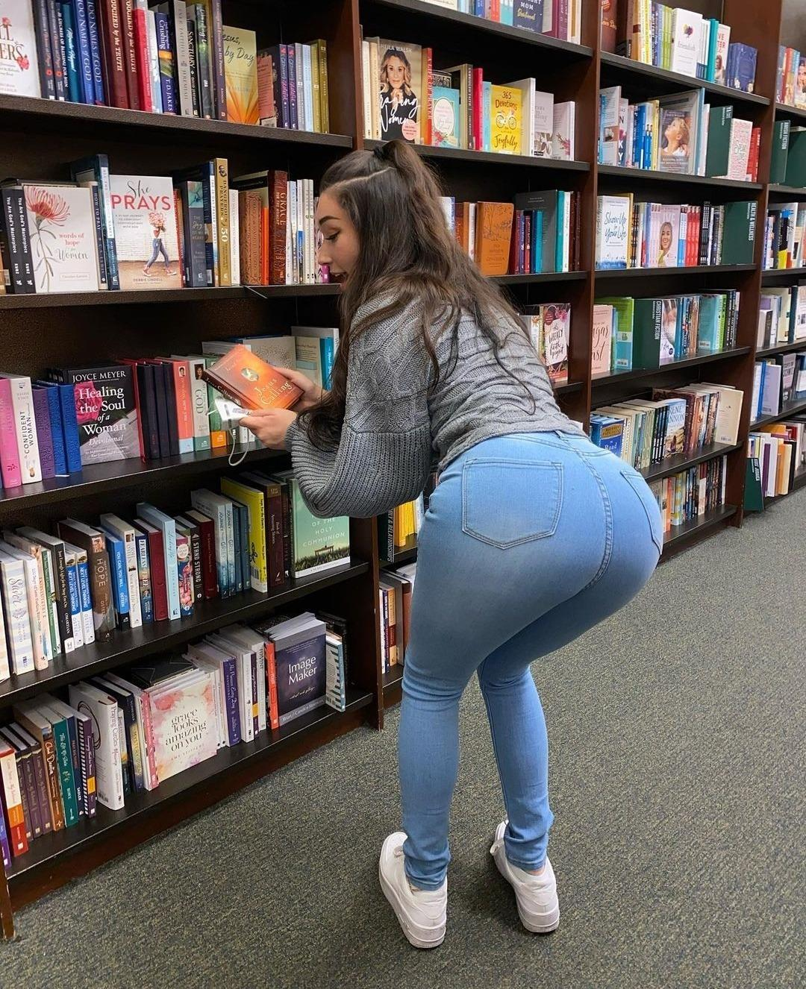

Alanna spotted a book she needed as she bent over, arching her back and sticking out her ass! Each cheek bubbled out and put pressure on the jeans making them look like they were about to rip right open! Jake could feel his pants getting tighter as he reached down to adjust himself again. His mouth began to water as he watched her ass sway back and forth, he wanted to get down on his hands and knees, he wanted to crawl up behind her, he wanted… to sniff his sister's ass!

Alanna looked over her shoulder at Jake as she pulled a book off of the shelf! She looked back and forth down the library aisle as she spotted two college aged women at the far end. Both of them had corona masks on and were discussing amongst themselves.

“On your knees! Don’t make me ask twice” Alanna smiled and snapped her fingers and pushed her big ass out a bit further, wiggling it back and forth!

Jake looked at the two women, they caught him staring before he looked away and blushed! Alanna was still waiting and Jake knew making her wait would only make things worse. His face began to burn a bright red as he got to his knees on the carpeted floor. Alanna’s ass was so much bigger when he was on his knees! Each cheek was so thick and round, the fibres of the denim looked like they were about to explode! Slowly Jake crawled forward, he could see the two young women watching from the corner of his eyes.

He was a few inches away from Alanna’s crack and he could already smell the subtle fresh odor of shit! It was earthy and very strong, his nose twitched as he picked up the eye watering scent. Alanna watched over her shoulder as Jake pushed his nose to the center seam of her denim ass crack and took a long deep sniff, long enough for both women to hear! There was an audible gasp from one of the women before Jake felt Alanna’s anus push outwards.

**BBBBBBBBBBBBBBBBBBBBBBBFRRRRRRRRRRRRTTTT**

Jake closed his eyes as the brutal explosion of gas blew past his face! He could feel her thick anus pushing through the denim jeans as the odor invaded his nose! Both women began laughing hysterically just as it hit his lungs making him choke uncontrollably! Jake burned bright red as he kissed across Alanna’s big ass cheeks! She reached back and **PUSHED HARD** as Jake threw his arms down so not to fall. Seconds later, Alanna’s big ass landed on his back. It took him a second to realize what was happening as his head spun from her thick gas, but she was using him… as a seat…

“Why don’t you take a picture? It will last longer!” Alanna commented to the women watching as she leaned to the left and let a short raspy fart loose on Jake’s back.

**BBBBBBBBBBBBBBBBBBFRRTTT**

“Oh fuck, that stinks!” Alanna laughed as she fanned her nose and bounced a bit on Jake’s back. Alanna was not fat, but she was not skinny either. With all her weight concentrated in one place, it felt like his spine was going to snap! Jake’s lungs were still burning from the fumes as he choked and gasped! The fart was so hot and fresh, worse than her morning gas, way worse!

“Mom made pancakes for breakfast, and they always give me a stomach ache!  
Alanna commented as she pushed off Jake’s back and bent over to scan the book shelf again. The one in her hand she dropped to the floor recklessly as she was done with it.

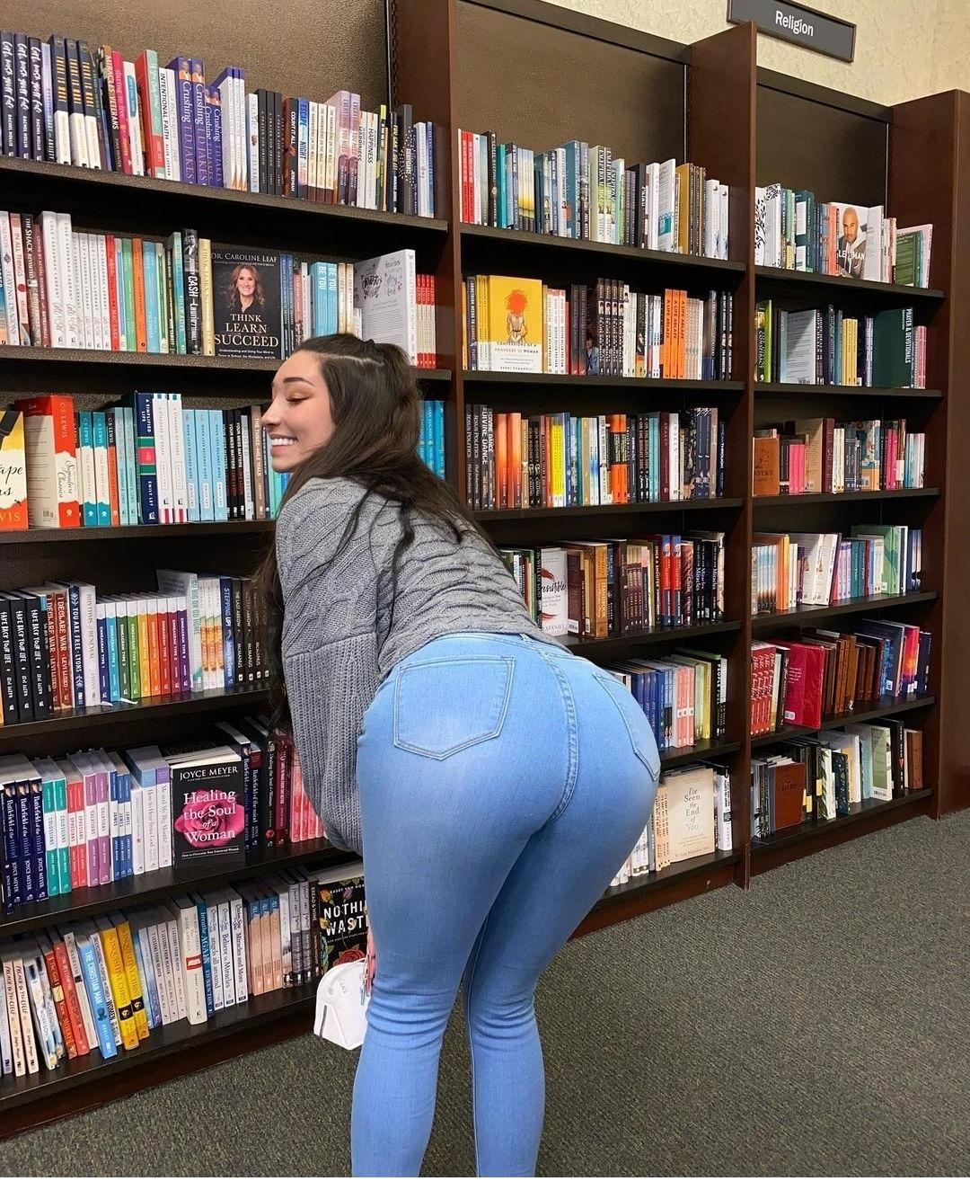

Jake reached for the book she had dropped so he could place it back on the shelf, he hated leaving work for other people. His face was less than an inch from her big fat ass when a bubbly shart popped in his face!

**BBBBBBBBFBppdpppppprpttttt**

Jake looked up with water eyes as he choked and gagged on the sharp odor! Alanna was smiling and looking down at him.

“Sorry! That one slipped out! Oooo wow!” Alanna began laughing as she plugged her nose and fanned behind her butt gently to animate the odor!

“Take this book, and this one!” Alanna threw some heavy books behind her to Jake without aiming whatsoever! The first book hit his chest hard and the second nearly knocked him in the face! He caught them both and choked as she shook her butt back and forth letting the gas air out! Because of how thick and tight the denim was, the gas clung to her cheeks for much longer than normal pants or leggings.

Jake could feel his dick pressing against the heavy textbooks in his lap as Alanna jiggled her ass back and forth in his face! He was still sick to his stomach from this morning, but he couldn’t help thinking about what her next offering was going to be like. Would it be hard and chunky? Soft and runny? Spicy and eye watering? His heart began to race as Jake shook his head, breaking himself from the chain of thoughts. He could feel his hard dick pressing through his pants and against the bottom of the text books in his lap.

“Sorry excuse me” Jake looked up and leaned back as a beautiful young woman passed between him and Alanna



She looked back and flashed Jake a quick smile as she walked down the aisle to the end and slowly turned the corner, her eyes scanning the book shelves. Jake looked down her back from her golden locks to her thin waist and **EXPLOSIVE ASS**! Her cheeks were so thick that they devoured her leggings! Each bubbly globe bounced back and forth, crashing into one another and sending ripples down her chunky thighs! Jake could practically see himself dissapearing between those asscheeks! They would completely cover his head like nothing!

“Don’t even think about it shit for brains! You can barely finish what me and Mum give you, and now you're dreaming of eating other womens crap? Ugh, you're gonna make me puke!” Alanna said while putting a finger to her mouth in an animated grossed out fashion.

Jake blushed as Alanna turned back to the bookshelf and tossed him another textbook. Maybe she was right, maybe he did want to be that woman's toilet. The longer this went one, the further he mentally devolved. He turned back to Alanna, his eyes glued to her thick ass cheeks! He lenaed into her asscrack and pushed his nose to the seam taking a deep long sniff! Jake could amost smell his sisters anus beneathe the denim fabric! Her anus puckered and pushed outwards as Alanna reached back and pushed on his head!

“Ugh! Get off of me!” Alanna shoved him, sending Jake flying back and hitting the opposite bookshelf!

“You're such a pig! Can’t get enough shit!” Alanna grimaced as she tossed another heavy book to Jake.

Alanna began walking to the next aisle and then the next as she scanned the rows of books for the ones she needs. Jake followed her with his arms full of heavy textbooks. Alanna searched in silence before looking back at him with a scowl.

“Make yourself useful and go find a women's bathroom, I can already tell when I need to go there won’t be a lot of downtime, if you catch my drift” Alanna rubbed her stomach and made an upset painful baby face while pouting.

“Yes Alanna” Jake replied as he began walking away…

**“PRINCESS!”** Alanna shouted… Jake turned to her with confusion…

“What?” He asked…

“From now on, refer to me as princess” she said while turning back to the bookshelf and not waiting for a response.

Jake walked around the library, it took him only a few minutes to find the public bathrooms. They were in the back western corner of the building. One thing Jake noticed as he walked around, was that there were no men there, except for himself of course. Each row had young women in it looking for academic books, no guys at all as far as he could see! Jake had heard recently in a news report that women had been dominating the academic fields recently, while most men filled entry level and part time jobs. Jake had noticed when he was at college there were way more women than men, almost on a ⅕ ratio. Were things really this bad?

Jake walked around for a bit before Alanna spotted him and snapped her fingers calling him over. Jake walked to her quickly as she found a small empty table to sit at and study! Alanna opened her laptop and sat down placing her purse and belongings on the other empty seat, Jake took the hint and began getting to his knees on the floor. He had barely touched the carpet when Alanna snapped her fingers and pointed across the library.

“Go outside to the Starbucks next door and grab me a frappuccino! Extra whip cream” Alanna demanded with a strict and spoiled tone.

Jake groaned as he pushed his sore body to his feet and began walking away…

**“AND DROP THE ATTITUDE!”** Alanna shouted to his back, Jake didn’t turn or answer her.

He left the library and reached the front doors of the coffee shop while reaching into his pocket and feeling his wallet with his fingers. He was almost broke and prayed that he would have enough left to get the coffee, if he came back empty handed, he had no idea the punishment and torture his sister would inflict. The line was almost empty, so he reached the front cashier quickly.

“Welcome to Starbucks, what may I get for you today?” a cheerful young woman asked…

“Uhmm a frappuccino, Medium, thanks” Jake ordered politely as he presented his debit card. He pushed it into the card reader and began praying with closed eyes, please go through, please go through, Jake said over and over in his head.

The machine beeped with the approved sign as the woman ripped off his receipt and handed it to him. Jake breathed a sigh of relief as he stepped aside and looked at the debit card receipt. He still had $3.85 in his account, maybe he could get a small snack for himself? Jake’s eyes scanned the glass counter, the other side of it was filled with cookies and sandwiches and little treats! He had not had food for so long, his mouth began watering just looking at the different foods!

“Ugh! I am so sorry! Let me try my other card!” Jake looked up and saw the **MASSIVE BOOTY** blonde blushing and looking through her purse frantically. Her big ass cheeks jiggled like Jello as she bounced up and down emptying her purse on the counter! She let out a sigh and then began apologizing to the cashier!

“I am so sorry! I think I left my other wallet at home! I uhmmm” she blushed and began putting her belongings back into her purse.

“I got it” Jake smiled as he leaned in and offered his debit card…

“Oh… uhmm are you sure?” The blonde asked with a smile as she began blushing…

“Of course, it’s fine, How much is your bill?” Jake asked…

“3.85, I can pay you back, if you give me your email, I can paypal you!” She began explaining as Jake held his hands out and smiled!

“It’s okay, it’s my pleasure” Jake paid for the coffee as his stomach rumbled with hunger.

“My name’s Sonya” she said while holding out her hand.

“I’m Ja…

“Oh hold on a second!” Sonya interrupted him as she held up her finger to his face and pulled out her cellphone, she began speaking loudly and very obnoxiously laughing right in Jake’s face!”

“Hello, oh hey ashley! **OMG, REALLY? HAHAHA** that’s **HILARIOUS!** Yea i am just at the library, getting a drink! **OH MY GOD, DID SHE ACTUALLY?**” Sonya continued her conversation as Jake stood there waiting. The woman behind the counter handed Sonya her coffee, she grabbed it and walked away without even glancing back at Jake. he watched as she walked around the corner and back towards the library.

“Jay? Jay? Jay?” The woman behind the counter said over and over until Jake turned to her.

“Your Frappuccino” she pushed the drink across the counter to him and smiled…

“Thank you” he replied before taking the drink and leaving.

Jake got back inside the library and placed Alanna’s drink on the table before kneeling beside her seat. She picked it up and took a sip before returning to her book and muttering…

“You took long enough”

Jake was about to reply as she leaned up off the wooden seat with her ass facing his direction. There was a slight wet vibration sound before her fart turned to a full blown hurricane of shit fumes!

**vvvvvvvvvffffffffffvvBBBBVFFRRTTTTTTTTTTTTTTTTTTTTTTTTTTTTTTTTTTTTTTT**

Jake’s eyes began to fill with tears as he leaned over and gagged hard! Her gas was so thick, it was like he was sucking on one of her turds! The flavor filled the dry library air surrounding them both as Alanna burst into a fit of coughing and choking! Clearly she hadn’t anticipated the odor to be so strong!

**“OH MY GOD, DO YOUR FUCKING JOB”** Alanna screamed to Jake. Before he could reply, a Librarian appeared and shushed both of them very loudly and obnoxiously.

Jake watches as the old librarian walked away, as she turned the corner, Alanna grabbed the back of his shirt and **FORCED HIS FACE** into her ass crack! The odor of her gas was stuck to the fabric of her jeans, It felt like his face was being smeared through her raw wet panties! He could only imagine the disaster that was her thong right now!

Jake sniffed in and out, gasping and sucking the gas through her jeans as Alanna choked! He could taste the spicy fresh shit in his throat as her anus puckered under her jeans! It was clear now why she had him find the bathroom preemptively.

“This is such bullshit, why should I have to work for a living!” Alanna muttered to herself while sipping her drink and flipping the page of her textbook. Jake looked up to her just as she leaned off her wooden chair and let another warm gaseous blast loose in Jake’s direction.

**BBBBbbbbfrrrrtttttttttttttttttttttttttt**

“I mean, it’s not like I'm not gonna find some simpleton to take care of me, why should I even go through the motions of trying with school? Its so stupid and pointless!” Alanna complained while using her hands to waft the odor from her ass and towards Jake’s face.

“Maybe mum was just…

**SMACK!**

Jake saw stars for a moment as a blinding light filled his eyes! He fell to the floor as his cheek and side of his face began throbbing in horrible burning pain! The last thing he saw was Alanna standing above him with her hand back and a cruel grin on her face.

**“YOU SPEAK WHEN SPOKEN TO SHIT FOR BRAINS!”** Alanna screamed at the top of her lungs, her high pitched voice cracking a bit from how shrill she was!

Jake was still on the library floor holding the side of his face and crying in pain when the elderly librarian arrived! She had a scowl on her face as she peered at Alanna.

“This is your **LAST WARNING!** One more outburst and you're banned!” The librarian said with a raised voice, it was clear she was angry.

“It’s fine, I am just going to use your bathrooms and then we will be on our way! **COME NOW**” Alanna grabbed her laptop and put it in her bag before grabbing the back of Jake’s shirt like it was a dog collar. She began dragging him across the library as countless women watched with hushed laughter and giggling!

Jake’s face was less than an inch from Alanna’s fat bubbly ass cheeks and he could smell the odor of her stale gas trapped in the fabric of her jeans! Each ass cheek jiggled as she walked, her powerful steps echoing on the tile floor leading to the ladies bathrooms. The inside of Jake’s stomach began to gurgle and rumble as he prepared himself for what was about to come.

**“HURRY! I NEED TO GO ASS FACE!”** Alanna shouted as she kicked Jake in his ass ushering him into the women's bathroom on his hands and knees!

Jake grimaced as he placed his hand into a large wet spot on the tiled floor with Alanna aggressively hitting him from behind! Instantly Luckily the restroom was empty, Jake did not know if he could handle the embarrassment of someone seeing his sister use his mouth.

**“GET IN THE STALL, QUICK! I'M ABOUT TO SHIT MY PANTS LOSER!**” Alanna pulled open the farthest stall, it was meant for handicapped so there was extra space! Jake had no time to react as she grabbed his shirt collar and threw him against the porcelain bowl! Jake's head cracked hard against the bowl as he reached back, rubbing his skull from the instant throbbing pain.

Alanna was panting and breathing deeply as she sucked in her stomach and unbuttoned her skintight jeans! Jake watched, his eyes wide and locked onto her fat cheeks as she pulled down the tight denim, her fat cheeks popping out and wiggling back and forth. She bent down to work the jeans down her thighs, her big ass got even bigger as her cheeks spread slightly. Jake could already smell the foul sweaty odor of fresh shit, it was so strong that it filled the entire stall.

**BBBBBBBBBBBBBBBBBBBBBBBBBBBBBBBBBBBBBBFRRRRRRRRRRRRTTTTT**

Jake felt his entire inside churning as the horrible gas whipped past his face! It smelled so bitter and thick with the odor of fresh shit. Alanna began choking as she raised her legs one at a time in a marching fashion forcing her tight jeans down her legs. Her big ass jiggled with each step as Jake choked behind her!

“Don’t you dare make a mess, I’m not about to walk around with shit running down my legs! **UNDERSTAND??”** Alanna asked while looking back over her shoulder and walking backwards towards Jake. her ass cheeks were so big and pale, the seams from her jeans had been imprinted onto her cheeks because of how long she was sitting!

“Yes Alanna…” Jake replied with his voice trembling…

**“YES WHAT?”** Alanna shouted…

“Yes princess! Jake cried out realizing his mistake!

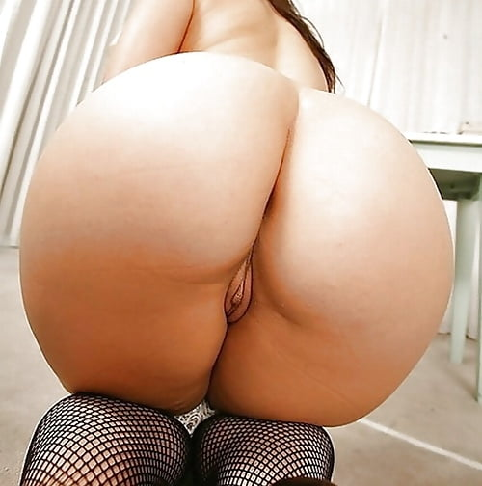

In less than a millisecond, Alanna’s bum came **CRASHING DOWN** onto Jake’s face! He felt his sister's weight as her fat cheeks smooshed to his features, it felt like his head was going to explode! She wiggled back and forth, his face sliding easily into the deep darkness of her ass crack, the smell was so overpowering and atrocious, it burned his nose from just the tiniest whiff! Each cheek spread over the sides of his cheeks as she sat heavily letting her sticky greasy asshole cover his mouth!

There was no warning, no gas, not even the slightest bubble! Her anus spread open wide as a torrent of mushy wet feces came SPILLING out! Jake’s eyes went so wide that he feared they may pop from his skull, all while Alanna tilted her head back moaning in relief! Her shit was so mushy, just solid enough to retain some sort of structure as it was blasted down his throat! He tried to swallow but that only slowed things down as he choked sending feces spraying from his nose!

Alanna grunted and pushed, he was so full, his cheeks stuffed to the limit but she did not care! He felt her anus pucker as it blasted out another mouthful followed by another and another of her milky soft shit! It began spilling over the sides of his cheeks as he reached up and grabbed the sides of Alanna’s ass cheeks! His fingers sunk into her ass fat as she knocked his hands away and groaned!

“Don’t fucking touch me! Your hands were on the floor! **THEIR FILTHY!”** Alanna shouted as she let loose a monster fart!

**BBBBBBBBBBBBBBBBBBBBBBBBBBBBBBBBBBBBBBBBBBFFFFFFFFFFFFFFFFFFPSPPFBBFSPPPppsprtttttt**

Jake wanted to cry as her gas blew his cheeks out and launched a massive load of wet shit directly down his throat! It was the size of a massive sausage and went down in one giant piece! He cried out into her asshole as it slid down leaving skid marks on his insides before landing in his mess of a stomach!

“Seriously! I have no idea how you eat this stuff!” Alanna commented as she grunted and pushed letting more wet shit loose! Jake wanted to cry as she filled his mouth again with the watery bitter feces! How much shit was inside of her? What the fuck! She was such a tiny little thing, how was this even possible! Jake cried in his head!

Alanna leaned forward, her anus smeared up and down over Jake’s nose coating it in fresh feces before she sunk back down onto his shit covered mouth! Jake was actually getting dizzy from the sheer amount of fumes he was inhaling! Alanna pushed and grunted as her anus puckered in his mouth! It was still dripping sticky shit, but not in massive loads. Suddenly Alanna sat straight and looked over her shoulder nervously to Jake’s watery eyes. Someone else had just entered the bathroom.

The bathroom door creaked as it opened and closed. A pair of footsteps moved across the bathroom before entering a stall.

“Ugh, gross” she commented before checking the next stall…

“Oh my god, does no one clean this place?” she commented out loud before approaching the stall Alanna and Jake were in.

Knock knock…

“Excuse me, I’m sorry, but the other stalls are disgusting, Are you going to be long? I am having a bit of an emergency!” she said in a soft sweet voice with a hint of panic and desperation.

“Actually, I am just finished” Alanna smiled as she looked over her shoulder to Jake.