He’ So Cute
Inspired by a Captioned Image by Tiffany
By Maryanne Peters

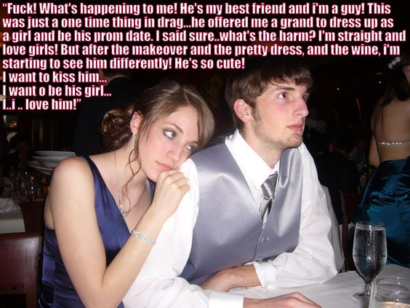

He’s so serious - I knew that he wasn’t joking. I knew he had the money. It is nothing to him. He is already making money from his share trading business while we are still in high school. To him $1,000 is small change.

“Look I am not about wasting time looking for a girl to take to the prom.” That is what he said. “Time is the one thing that you can’t make more of. Better to take somebody I know, so I guess that’s you. It’s just that you have to be a girl for the night because I am straight. So please, be a pretty one.”

He’s so precise – I had to make sure that I was as attractive as possible, and he always says quality starts at the core. That means getting myself in the right space and getting my body smooth and clear before dressing it up. It means hair extensions rather than a wig. It means plucked eyebrows and eyelash lifting and tinting and accepting that I might not pass as a boy for a while.

“That is what I am talking about!” That is what he said. I mean he looked good in the silver waistcoat and tie under the dark suit, but I looked fabulous in blue.

He’s so gentlemanly. I think that if you are treated like a woman then you feel like a woman. I really can’t explain it. I think that you have to experience it to understand. I mean you can copy the ways girls do things, but that is just like acting. But when some guy in real life opens and car door for you or pushes in your chair as you tuck in your skirts, then you suddenly become a woman. He is that kind of guy – attentive to his girl – a gentleman to his lady.

He’s so strong. The way he moved me around the dancefloor for the formal numbers, it was like I was as light as a feather. I suppose it made me feel that he was a man, and I was … something else. Not less than him, but not manly either.

He’s so good looking. I had never noticed it before. He has a strong nose and a good chin, and a mop of hair that had me wanting to run my fingers through it. And he smells so good. I mean even under the aftershave there is the smell of a man that should not excite me, but it does.

“I can’t believe how beautiful you look,” he told me. “And there seems to be a new sparkle in you, like you are really coming alive. Have you been hiding something from me all these years?”

He is so smart. Have I been hiding? Is this the real me? Am I in love with my best friend? Is he in love with me? Can I be his girl? Oh, I want to be … soooo much.

The End

A Bet is a Bet  Inspired by a Cap by Tiffany  By Maryanne Peters  We were football fans who supported different teams, so sometimes that makes it hard to be friends. We were always arguing about which team was better so any bet on the big game had to be something of real value that both of us would find it hard to give up. So, what do football fans with no money put the highest value on? Their masculinity, that’s what. | 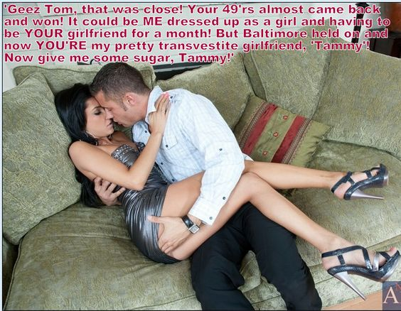

The fact is that I would have made a lousy woman, so it was just as well that Baltimore held on. And I always knew that Tom would look good in a dress. The truth is that, although it sounds weird, I had dreamt about him dressed as a woman. In fact, I prayed for my team to win harder than I ever had before. I wanted so much to meet Tammy, and maybe convince her to stay.

It was not the thought of having to parade around a guy in drag that had me nervous in the closing stages. I could have laughed that off and explained the bet. No, it was the risk that Tammy might never come into existence – into my life. I mean, nobody would blame him for trying to wriggle out of it – maybe accusing me of being a creep for wanting him to go through with it.

But he said – “A bet is a bet.” So I offered to fund the makeover, jut to make sure he would not embarrass either of us. When he turned up at my door with those hair extensions and those killer legs beneath a dress that looked painted on, I was smitten.

“Well? Are you going to invite me in?” Even the voice was different, like a husky woman’s tone – the sound of a seductress. “I am dressed to go out. Your choice, I think. So are we going out? Are you going to take me to a nice cocktail bar? Or somewhere with a dancefloor?”

We ended up making out on my couch, and shortly after that I ended up inside my new girlfriend.

“You won fair and square,” she said. “A bet is a bet.”

And the taste of a win is sweet indeed.

The End

On Malta  Inspired by a Captioned Image by Tiffany  By Maryanne Peters  Where do you hide? I got as far as Malta on a small boat from Pozallo which barely survived the 40 mile journey. Malta is a small island in the Mediterranean Sea that close to the south coast of Sicily where the Boss and his “Family” were based.  Malta is its own country, but as it turned out the Government there be easily bought. Only one international airport and tightly controlled seaport. You need a passport to get out, and that means being identified as Luigi Termoli, “the Rat”, and being dead.  No more small boats. Going anyway other than Sicily is 160 miles by sea. I was not up for that. The wat I figured it my only hope was to hide out in Malta, and because I knew nobody who could give me shelter, that meant hiding out in plain sight with a disguise second to none. | 

It turns out that Malta is famous for a few things, and just one of those is its transgender community, something that I found out by accident. I was in a desperate state, and something desperations spawns some crazy ideas. Maybe this was one of those. But what better disguise that a change of gender. Not only did I become invisible, but I immediately found myself surrounded by supportive friends, all of whom understood that leaving my past identity behind was so very normal.

It is just that, as I learned, transfolk don’t do things by halves. They expected me to follow their lead and get on with transition.

“You have the added advantage that with a face like yours you could be pretty,” they were all agreed. “So don’t insult us by being less beautiful than you can be.”

Before I knew it I was transformed into Maria, plucked and shaved, with hair extensions and semi-permanent makeup, and with hormone shots and deportment classes every week. And all of this was in English, which was my language, despite the Italian heritage that had brought me to Sicily. Malta is an ex-British country and English is an official language.

I found a place to live, rooming with another transwoman. She even found me work in a beauty salon doing manicures, although I still had my stash to live on. It seemed like a suitable cover. I learned a few words of Maltese and bluffed that I knew more when there were strangers about, especially those I could hear speaking Italian.

Everything seemed to be going well. Anybody looking for Luigi was going to be out of luck.

I was out with the girls at an outdoor restaurant one evening when I saw Lorenzo Marino looking at me from across the street. Here was somebody that I knew, and Italian American like me, just over to do business and shortly going home. He knew Luigi well, and seemed to have recognized me. I did my best to ignore him. I resisted the temptation to duck for cover as that would clearly mark me out. I figured that my disguise was so good I could talk my way out of it.

Anyway, he disappeared after a while so I thought I was in the clear. But as it turned out he had found a place where he could watch me without being seen, and he followed me back to my place without me even noticing. That was where the confrontation took place.

As described, I started by insisting that I was Maria and had no idea who Luigi Termoli was. I even said – “I am not insulted. Lots of Maltese girls have heavy features, but I can assure you, I am not a man.”

I even had enough flesh on my chest and the right bra for a very convincing cleavage, and I made a point of showing it to him. But he was not convinced.

“It is that nose of yours, Lou,” he said. “I always though that it was too pretty to be on a man’s face. It looks perfect on you now.”

I groveled. What person wouldn’t? What person, man or woman, would not beg for their life. It is just dressed as I was, and flooded with female hormones, I burst into tears.

Instead of laughing and making the call to the Boss, he put an arm around me.

“I saw you with your friends tonight, even before you noticed me,” he said. “Now I understand you. Running away has given you the chance to become the woman you really are.”

It seemed like a glimmer of hope. I nodded furiously, and wiped away my tears. My makeup remained perfect.

“So you are not going to tell them that you found me?” I was still simpering in my practiced girl voice.

“On one condition,” he said. “If you will agree to be my girlfriend, Maria, then we can both go home and forget Sicily. We can fly to London with you as my companion and then back to New York from there.”

I was not really in a position to set any conditions of my own. It turns out that he was happy with my nose, and as for the sex change, well when you fall in love with a heterosexual man you have to make sacrifices.

The End

Employee  Inspired by a Tiffany Caption  By Maryanne Peters  Why can’t I have anything I want? I have enough money. I wanted him from the moment I saw him. It was just that I cannot appear gay, so he will need to make some changes. But it just s happens there was somebody who could help.  Quite why he had got married was hard to understand. He seemed to me to gay. Not gay like me, but gay like the boys (I am sorry to say it) I quite like. Effeminate, some call them, or sissies. I just call them pretty. That’s the way I like them.  I like them to keep a bit of man – something for me to tug on when having sex, and that look in the eye that only a man can have when he is being fucked, but otherwise he must look like a woman. | 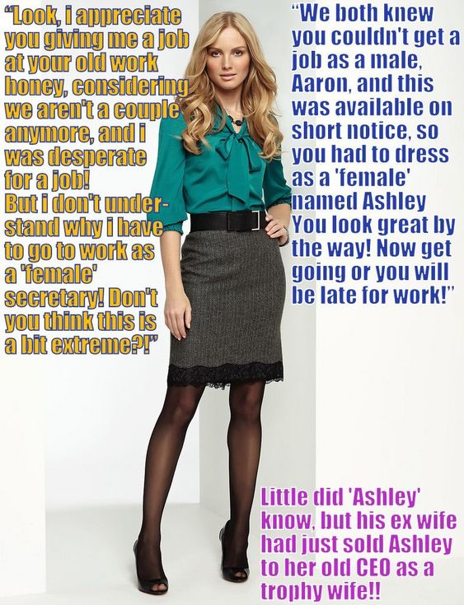

I have appearances to keep up. I am the CEO of a major company. It is just that with all the gold-digging women that might want to throw themselves at me, none could give me what I wanted. I wanted him, but rendered feminine, and with that hint of anger at being feminized that makes the sex truly great.

In Hannah I found the perfect accomplice. She had just taken a job out of state and separated from her husband – the one I secretly adored. She told me that he was out of a job and that he appeared to be un-employable. She was a good enough person to want to see him secure when she left.

Although I keep my urges secret, she had been close to me as my secretary and she was leaving town anyway, so I told her about my feeling for her man. She was a good enough person to see that I was genuine, and so she started to think of how she could look after both of the men that she was leaving behind.

“I think that you have seen through Aaron,” she said. “The truth is that he is a cross-dresser and he has fantasized about sex with men – he has told me as much. What you need is a secretary and then perhaps a wife. So let’s see if we can persuade Aaron to adopt his feminine persona in working hours.”

So you see, it is not really that Hannah sold me her ex-husband. Of course I paid for everything, and I paid Hannah for her trouble. She had to persuade him that if he was prepared to dress as a woman he could take over her job as my secretary despite him being short on the required skills. She had to get him to the salon and help get him prepared to appear so completely female that nobody would guess that Ashley was anything less than 100% female. She had to explain to Aaron that this was a favor by me to both of them, because that was the kind of guy I was.

Of course, Ashley was grateful. She was also appreciative of all the little things I did for her, and how I treated her so completely as a woman despite knowing her secret. She grew into womanhood so completely that I became certain that she did not cast it off when she went home at night, but I needed to know. I found an excuse to call in to her apartment late one night.

There she stood in a peignoir robe with her extended hair in curlers. I could not restrain myself, and (as it turned out) she was ready to receive me. It was a night of passion.

Of course, when a man is in a relationship with a woman, or anybody for that matter, it is not appropriate that she remain an employee – not long term anyway. Ashley moved in to my place but properly insisted that I propose before she resigned.

We are finalizing her divorce from Hannah before we plan the wedding, but for sure Hannah will be her maid of honor.

The End

Dinner Date  Inspired by a Tiffany Captioned Image  By Maryanne Peters  She took this photo of me, groping his cock through his jeans while his tongue was deep in my mouth. I have to say that when I saw it, I was shocked, and even scared what she would do, but then I found myself thinking about that kiss! I just want to be back in his arms. So who am I now?  What I was - or I thought I was – was a regular guy, with Sandra as my girlfriend. I suppose that I always knew that something was not right between us, but I never knew that it was this.  She said that it was some sociology thing she was doing – something about gender roles. She begged me to help her out, and I rarely say no. | 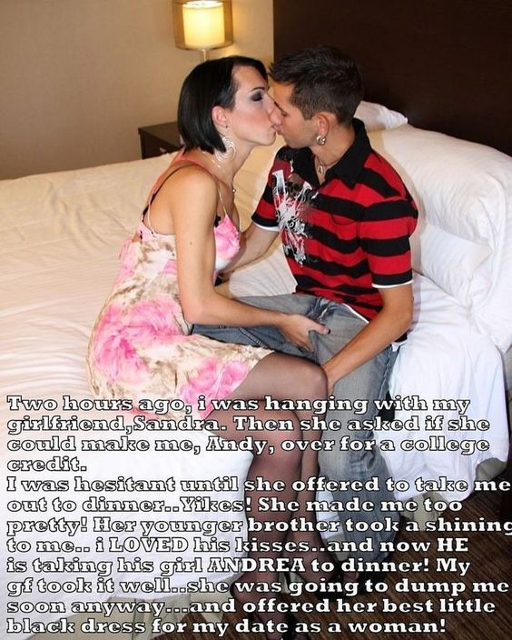

What surprised me was just how easy it proved to strip away my manhood – just wash and style my hair and thin my eyebrows, then shave down my body. I liked the way I looked. I found myself doing some looks and moves in front of the mirror. It was like from somewhere deep inside me I knew what to do – like finding the inner woman in me.

Then she said that this sociology paper was about interaction, so she had arranged for us to go out to dinner with two guys – her with somebody from her class and me with her younger brother, and he was on his way over.

I was up for it. God knows I was ready for a good meal. I had lost a lot of weight since starting college.

So, back to the photo. I just have no idea how it got to this point. I mean, he turned up and told me that he thought that I was really beautiful. He said stuff about how I must be a woman deep down because nobody could look and act the way I did without that being my “core”. Instead of laughing I was blushing and getting confused.

I am not even sure why we went into my bedroom. We just ended up there. When Sandra sneaked in and took the photo, we were tongue wrestling and I was groping his cock, just to check that he was getting aroused … which strangely, was what I wanted.

I never saw the paper she handed in. Apparently it was something about repressed or latent transgender inclinations, whatever that is. I don’t care about that and neither does her brother. We are a couple now, and Sandra is okay with that. She says that she is not a lesbian, whatever that means.

We laugh about the image now. He says that it proves that attraction is immediate and powerful and that no small anatomical problem can stand in the way of true love.

Who could not love a guy who says shit like that?

The End

