HONKAI STAR RAIL: TROPE CITY
FINAL CH: THE TRICKSTER
BY CHALDEACHANGE
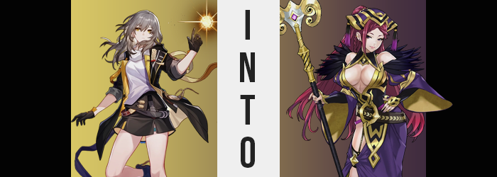

“That’s weird. I wondered if Himeko had maybe gone ahead, but…”

The Trailblazer, Stelle, had been having a very weird evening. It should have been one worthy of celebrating, what with the plans of the IPC on Jarilo-VI thwarted and peace having returned to Belobog once more. At the very least Bronya had been thankful for their help. Things had seemed relatively normal from Stelle’s perspective aside from an unusual moment in the middle of the day when her phone had gotten very hot for some reason. Did it need to go in for repair?

But after speaking with Bronya, Himeko had asked her where the powder room was and had ultimately taken off. Nothing wrong there, right? She probably just had to go ‘number one’ or something like that. The trash-enjoying Trailblazer had decided to wait around for her so that they could head back to the hotel together. But ten minutes had become thirty and she hadn’t come back. What’s more? When she had gone to check the bathroom in question? Himeko hadn’t been there.

Since she wasn’t returning any texts, the next possible explanation was that Himeko had slipped out when she wasn’t paying attention and had gone back to the hotel ahead of her. But when she’d finally arrived at their room? Not only was Himeko still unaccounted for, but March didn’t seem to be around either. “Did they go out to dinner without me? Kinda mean…” That didn’t really sound like it was in-character for them at all though, did it?

At that moment, however, something was beginning to happen in her pocket. Her phone had finally served its purpose for the ‘virus’ that Silver Wolf had set loose, and now there was no longer a need for its owner to remain in this world. Stelle didn’t even get to step out of the hotel room before a flash of bright light consumed her and the room was left entirely vacant aside from an echo of the “Huh?” she had managed to ask before disappearing.

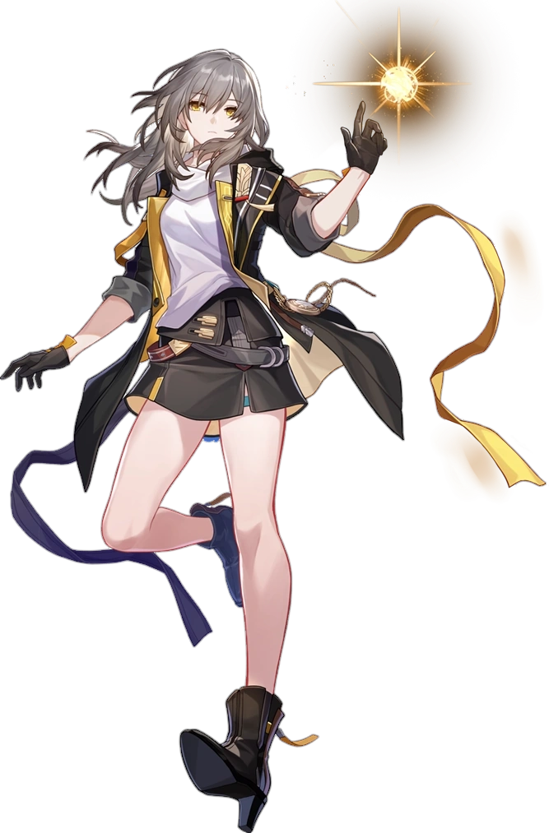
The next thing Stelle knew? She was standing in a forest of rolling hills and huge trees, fallen leaves padding the ground below her. “What… just happened? Was I teleported?” The very idea of being warped felt ridiculous, but the Trailblazer was the least credible of all people to remark on what should or shouldn’t have been possible. She was a living being with a Stellaron at her core after all. “So this must be a different planet…?”

She didn’t really need to ask that. If she’d still been on Jarilo-VI then everything would have been frozen over. The air was cool since it seemed to be early morning, but it certainly wasn’t as cold as a frostbitten planet like the one Belobog existed on. “So what am I doing here? I feel like I was supposed… to be doing something?” That in itself was unusual. Her main priority should have been returning to the Express somehow!

But in the end? Her thoughts ended up being pointed elsewhere. Downward, in fact. “…What’s going on here?” Because she was in the middle of a forest and didn’t know for sure if anyone else was around she didn’t want to lift up her shirt to see. But her breasts felt a little swollen? Not in an achy way, but they felt oddly full. “M-Milk!?” The strangest explanation imaginable came to mind. But of course that wasn’t it at all. She wasn’t about to lactate!

Although that wasn’t to say it hadn’t even seemed that way for a second. Stelle’s golden eyes went wide as she could make out her nipples pushing up against the underside of her shirt. “T-Too big!?” They definitely seemed to be larger than she recalled. Gloved hands reached up to grab her chest and the woman immediately became aware of the truth that it wasn’t just her nipples that were growing. There was much more heft to her breasts and her skin was stretching around them. It didn’t take long from that point on before they bloated into supple orbs that gradually lifted up the base of her white shirt to show off her tummy while the front of the shirt was pushed forward.

“Th-This is…! …My usual size? No, wait…?” Anyone with half a brain could have acknowledged that this wasn’t Stelle’s original cup size. They had to be G-cups or more! And yet the Trailblazer herself seemed a little hung up on how big her tits should have been according to her own memories. “Mm, no. My tits are usually large, aren’t they? And of course my ass…” Her voice hadn’t changed, at least not yet, but the way she was speaking… she was putting too much emphasis on lewder terminology. There was a seductive coo to how she was enunciating too.

In the end she hadn’t even been wrong about her ass. It didn’t draw her attention like her hefty bosom had, but the blue panties underneath her skirt were stretching and digging into but the plush shapes of her lush cheeks and the edges of her hips. Because all of these regions were linked and expanding because of each other. Her ass bloated into a peach shape, which in turn widened her hips, which in turn? Saw added weight flow into her thighs, which took on a softer, rounder sheen comparatively. But because she wasn’t wearing pants? This was all a lot less obvious to feel.

“Hm…” The Trailblazer hummed to herself after looking at a nearby tree. Had it grown taller suddenly? Perhaps it was just a trick of her imagination? Naturally the forest wasn’t getting bigger, but that didn’t mean there wasn’t an explanation for that momentary thought she’d had. The woman’s body had been shrinking, at least a little. She was supposed to be 5’8”, yet once her hourglass figure had filled in she had dipped down to 5’4” – which definitely didn’t make that bombastic figure seem any less excessive. It did give her some extra room in her shirt for those tits though!

Stelle bit her lower lip. It wasn’t a nervous habit that she possessed, but that wasn’t to say it wasn’t one that the woman she was becoming did. “I feel like I’m forgetting something. Something important.” Now her voice sounded different. A little deeper in a way that complimented just how much more intentionally seductive it sounded. But even then, the lip she was biting was part of the problem. Lips had been inflating, appearing practically bee stung by the time they had grown both fuller in size and pinker in color.

Lips that somehow appeared even larger than they actually were. Not that this was their fault, at least not as much as it was the fault of their surroundings. The woman’s face had actually compressed its size. Not significantly, but it was shorter and narrower, allowing the features upon it to stand out easier. This included a more sharply shaped nose, as well as eyes that had narrowed and, oddly enough, sported purple irises as the golds flickered away.

She didn’t look like Stelle anymore. She looked like an entirely different woman who was older in age, probably in her early thirties rather than seeming like she was in her twenties. The heft to her huge bosom would have proven that if they’d been bare; they weren’t as perky as they would have been if she had been about ten years younger.

All that really remained of her old self seconds later, visually at least, was her messy, silver hair. But even then that wouldn’t last long. The roots of her mane had already begun to darken. Not to black or to brown, but to a relatively dull reddish purple that severely contrasted the original coloring. The color traveled to the tips of her hair, straightening and thinning anything it touched… but also dramatically drawing out its length once the tips were touched. Hair cascaded down past her hips when all was said and done, and her bangs were brushed to either side so you could see her forehead.


Subconsciously? The woman was unaware that anything had changed, just like all the others. And much like them? She was privy to a shift in costume in just the blink of an eye. Now wearing a long, purple robe with an open chest to show off the size and shapes of her inner tits and an open right side so that her thigh was laid bare. It had a fuzzy collar that opened around her shoulders, gold trim everywhere, and a matching headdress that pulled her lengthened locks into a high ponytail in the back. She looked the part of a witch and, honestly?

It was a part she now enjoyed playing as well.

“What I was doing? Oh, of course~! Sometimes its good to rise up early and spy on the Order of Heroes.” The question of what she had been in the forest to do was something that had haunted the woman throughout her transformation, yet it was now a question that Loki felt like she could quite easily answer. As a Trickster Goddess she didn’t exactly have any real loyalty to anyone, and so despite her being a version of herself summoned by the Order, her willingness to work with them only extended so far.

She summoned her staff and used it to help herself traverse the terrain. With her tits so exposed and with little binding them in place, perhaps it was only natural that they’d jiggle and sway with each step. Not that Loki herself seemed to mind all that much. Her tits were an asset when it came to manipulating people, and at times it was humorous to watch others overreact to them. “Ugh, maybe I should at least accept their invitation to house in the capital.” Because living out in the forest where she couldn’t as easily be spied on made it a real pain in the ass to get back into town.

But was that worth the prying eyes? She would likely get away with less. Either way, it was an unusual fate for a woman who had possessed the potential to become a great hero in another world. Reduced to play the part of a recurring villain, and one bound to her foes at that. “Ah well. One must deal with the cards they’re doubt or something like that.”

Loki would make her moves one way or another.

