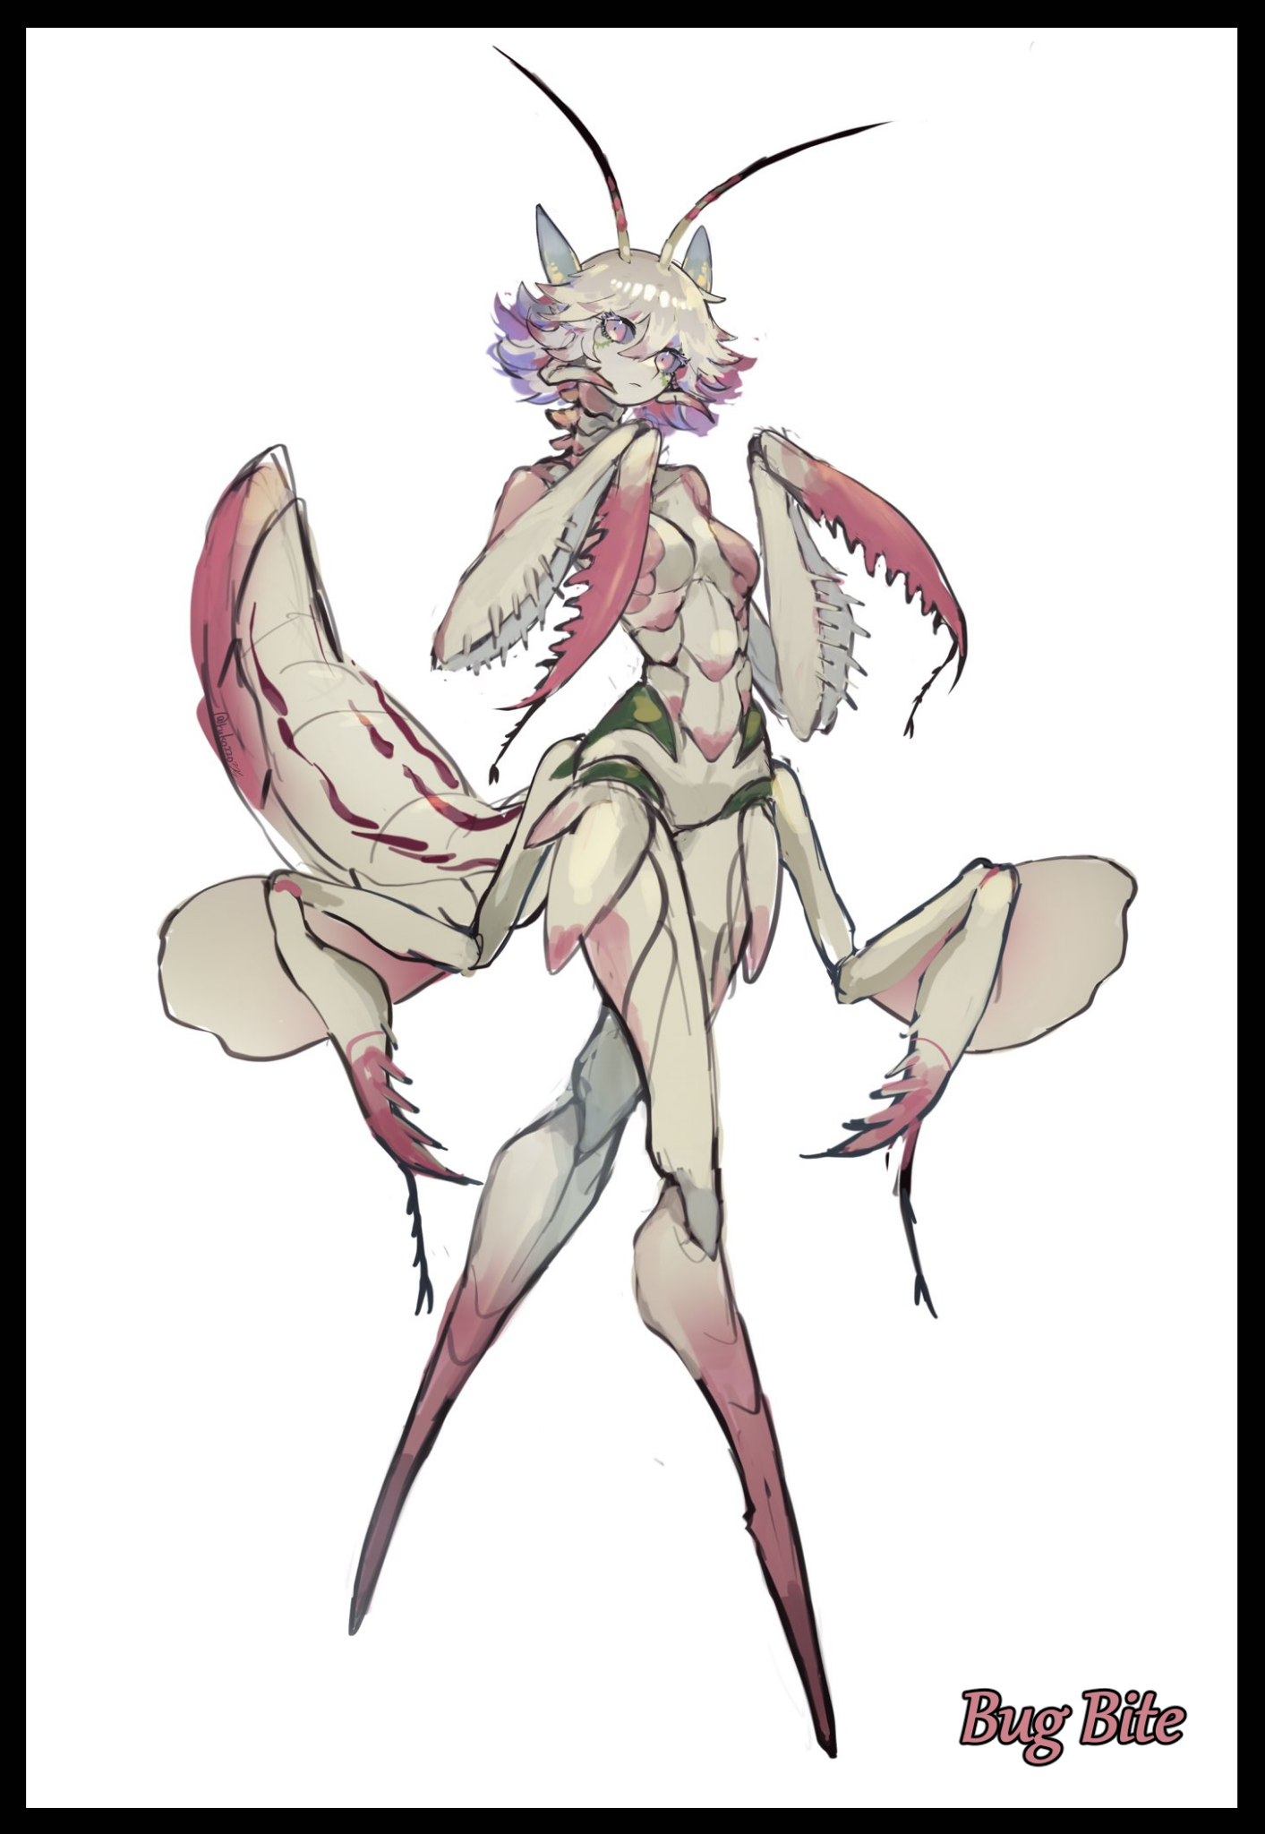

When mankind first dreamt about making contact with intelligent life beyond the borders of our solar system as far back as the antiquated years where notable philosophers like Aristotle made their mark in History. The concept had been based in spirituality; the idea that enlightened men or chosen souls were taken to other 'worlds' that existed inside our current one. From there it evolved into more plausible theories pushing the idea that other forms of life similar to native fauna including humans could potentially be found on other celestial bodies across the vast stretches of infinite space. Etcetera etcetera…

But after going so long without anything happening for centuries, the idea of higher beings out there in the void soon devolved from a serious topic into one that served as the bedrock for jokes and sci-fi media. Besides the entertainment value it's given us in the form of amazing shows, games and books, it's also served to show just how desensitized the world has become towards the potential danger of little green men from outer space discovering the blue ball in the middle of nowhere we call home.

What happened to all the uproar about attempting to contact alien life on the off chance we call up the wrong folk in a bad part of the galactic neighborhood? Against lasers, energy shields and other advanced technologies we wouldn't even be able to fathom, bullets and nukes won't do much when the big bad eventually comes knocking on our door after hearing our call…

So when alien life finally did show its ugly head in the early 60's of the 21st century when an alien spacecraft descended upon the American space station sending out a constant call into deep space. The majority of course, bent the knee. Welcoming our new 'friends' from another galaxy, all too eager to get cozy with them in the hopes of being the first to receive advanced technologies in a bid to get ahead of other nations.

Surprisingly enough, the aliens seemed to have enough of a grasp over politics between nations run by men who followed different ideologies to know better than to hand a 'welcome gift bag' over to the first human they saw sucking up to them. And whoever the poor sap was probably wasted his dignity and pride when said feet were triple jointed, carapace clad limbs connected to a segmented torso. I still remember the first time they showed themselves on TV when I was still just a kid, it was like an insectoid human clad in silver armor, no icky hairs or anything like that though. Besides the multiple limbs, big eyes and a sturdy pair of wings, they looked more or less alright. And if the interviews were to be believed, our new buddies were 'peaceful and forward thinking'...

I don't know how or why they did it, but over the years since first contact, the Sectoids (ridiculous I know but thank the eggheads working with the higher ups for getting those poor bugs into agreeing that was a suitable name) began to piece the disparate nations of Earth together, insisting, pretty much through force and threats, that becoming one was better than being apart. Rivalries and bad blood be damned.

That was simply the first sign that maybe meeting aliens wasn't going to be the sunshine and rainbow field trip the general public was expecting it to be. Within days, major governments across the world gave in to the Sectoid's demands for unification. One would think the shifting of all borders would wreak havoc across the world but it…surprisingly didn't take that long for the world to conform to the new state of affairs wrought about by our winged buddies. I bet when they were signing that document on live TV, they must've been cursing the men and women who even proposed the deep space signal station in the first place. Sure, there was some resistance here and there, but when the Sectoid's advanced shielding and weapon nullification systems came into play, the naysayers were instantly nodding their heads to the tune of a single world power.

So now here we are, a couple years forward in time and Earth's still in pretty good shape. We've got environmental cleaner stations in low orbit cleaning up any speck of pollutants, resources aplenty thanks to new innovations partly contributed by Sectoid minds and world peace was secured…but at what cost, you might ask?

Surprisingly, not much at all. Demonstrations by 'dissidents' were allowed as long as they didn't get out of hand and free speech was still a very much cherished thing in the physical and digital realms…that is if course, considering you were a part of lucky middle to upper class citizen with a wage and that you had a squeaky clean record, since crime of any sort was punishable through incarceration within one of the many Sectoid installations that had taken root across the world near major population centers and elsewhere across larger landmasses. On paper, they were supposedly institutions where Sectoid representatives lived, worked and oversaw their relations with us Earthlings. But as I write this, I'm starting to think of them as testing facilities for whatever the hell they've got brewing in the back rooms before pumping them out for mass production to use in that recent new criminal system they've got going…and boy did they not skimp out on the details regarding what they did to the unfortunate souls caught before they started testing this new thing of theirs.

It might sound ironic if I don't sound too pleased with the Sectoids running the show. I mean, I live in a modest apartment flat, I own a neat little business running an electronics repair shop a good distance down the block and the money I get from it's more than enough to pay the bills…I literally eat out of their lap.

But it's what they do to those they deem an outsider to the system that gets to me. Even as a kid, I didn't quite like the look of those beady eyed bugs as they walked out on the world stage to address us like a king would their loyal subjects. And years later, that didn't change much at all…especially after what they did to Mirza a few weeks ago before the announcement about their new ‘public service’ rolled out to the masses.

Unlike me, Mirza wasn't a lucky kid growing up. No education, no work experience whatsoever, no connections to depend upon. I didn't even know the man until a few weeks ago when I found him collapsed outside my door, dressed in rags and smelling worse than the sewage on a bad day. Of course, me being the charitable person I consider myself to be, I brought him inside, let him use the bath and gave him a new change of clothes…but not before bandaging the strange injury in his left leg that looked like someone had got him right in the ankle with a two pronged blade of some sort. Then we had a little chat over some dinner…none of that artificial stuff from the dollar store but the real meat and rice we used to have all those years ago before the Sectoid's came knocking.

That was how I came to know the guy, telling me all about his troubled years as a homeless man up until recent events where he'd been running from something he wasn't supposed to have seen, said he got hit on the leg by something but still managed to keep running. Until eventually he landed right at my door…

The tale stank, but even then I offered to let him work at my place for a generous cut as long as he pulled his weight around the place. Even though his vocabulary wasn't the best, he was still good company to have and once he got the grime and rags off along with a nice hair cut, the man looked good, ready and fit for the job.

A few days passed after that but there still hadn't been a response by local authorities or their Sectoid bosses so I assumed either Mirza had gotten away with whatever it was that got a homeless man like him tangled with the likes of them or they just didn't see the worth in capturing him…a rare occurrence considering they almost always seemed to recapture escaped convicts within half an hour at most.

Maybe I should've noticed the signs when Mirza started taking breaks more and more, but there was something the man was hiding from me. Something important related to the puncture wound in his leg, festering with a venom of some sort. At the time, I just thought it had to do with his poor upbringing, hence the breaks he kept taking during our time manning the store. Didn't think much of it then so I just let him do as he pleased. He was doing a good job so I thought it was only fitting he be rewarded for doing so, the man did deserve a literal break anyway.

Sometimes I wonder why the man didn't just straight up tell me what was wrong, but now that I’ve had time to think through his predicament, I sort of get it now.

For one, how do you find a cure to something that's slowly turning you into a Sectoid-Human hybrid? And secondly, who could you even turn to when the chips were down? For all Mirza knew, the authorities could've been watching the streets with an ear out in the airwaves, waiting for him to either go to a doctor, or even the police. Because by the time his feet popped open like a cocoon one day while we were having dinner, leaving us both gaping at the sight of a new appendage jutting out of the stump that was formerly his leg. Turning to me in a flash, he told me not to tell a soul, not to seek help and to read his notebook from his belongings to figure it all out before I could even ask what the hell was going on. Pushing me a little ways back with enough strength to topple a shelf while uttering a silent apology before his face just…sagged…as if his skull had cratered in on itself or something.

It was a horrific thing to see while you had a mouthful of porridge in the mouth; pulpy liquefying flesh dripping off a smooth, ebony shell with vibrant purple yet wiry sinew holding the segmented heel together. It reminded me of watching a certain breed of insect hatch from their cocoon as the imago pull their new, oftentimes larger and grander forms out of a shell that vaguely resemble their immature selves. The same could be said here, except the cocoon wasn't a lifeless shell of hardened skin, I was watching a fully grown man tremble violently as his innards begin to melt, escaping in a glob of pale pink sludge through tears in the skin made by the emergence of limbs that soon grow too large to fit the human body they emerge from.

Bones snapped, organs burst, skin boiled away. But there was no blood to be seen besides the ongoing flow of organic slushy pooling around Mirza's new heeled feet, clacking with a plastic sounding creak with each wavering step as if the joints themselves were either extremely stiff or so hard they squeaked in protest as he continues to stumble haphazardly around the room, knocking over furniture in a maddened bid to escape before two elongated arms tipped with more of that bright purple flesh tears free of his rear, shredding his pants and sending his deflated buttocks flying off before slapping against the wall like tossed rags.

By the time his face fell off to reveal a charred skull, I was already gunning for the bedroom, narrowly dodging a jagged edge swung my way as some sort of wing like growth eliminates what's left of the man's back, I didn't quite know what they were but wings were the first thing that came to mind, really sharp ones that resembled sheet iron more than they did chitin and protein as they hung down a curiously lean back and a curvy ass clad in the same matte smooth shell most of the creature's body was covered in.

The last I'd seen of Mirza, what was left of him hung off the four armed creature that tore out of him. Wearing his wrinkled hide like a badly done Halloween costume, except it was actual human skin hanging off of it. That was when it turned to face me with pure black eyes and ominous purple irises in their center, emitting a shrill chittering sound as if throws its head back, howling in what looked liked pain as it falls to its knees with a metallic thump, breaking the lights above thanks to its clawed arms flailing wildly, ruining the sofa, bisecting the television and spattering it's organic gunk all over the house. I'd shut the door then, locking it before pushing the nearby desk over in an effort to block the monster Mirza had unwittingly given birth to. Giving me a little space and time to process what I'd just seen while my ears pounded with my brain's throbbing and the commotion outside as the creature continued to wreck the place. Occasionally slamming against the door before bounding off like a pinball.

A friend I'd just known for a short while and picked up off the streets was now some Sectoid looking abomination. But a furious screech had been enough to shake me back to reality, acting fast as I moved to search through Mirza's side of the room, rifling through the bed I'd given him until discovering his old clothes, folded neatly into a pile under the bed with the notebook he mentioned on top of it…except when I opened it, I realized it wasn't really a book at all as a small data card that looked just right for a desktop falls out, almost dropping the delicate thing in my rush to get it over to my workstation, booting up the thing and slotting the chip into a reader slot. Looking behind my back like a kid watching adult videos in fear of the door behind him suddenly opening, spilling his naughty little secrets to the world.

Whatever was on that chip must’ve been set to fry whatever system it was currently loaded onto because my desktop skips right past the login, blanking for a moment before a scratchy video recording starts to play, showcasing a massive interior space that clearly wasn't designed by or for humans. It was a Sectoid base of sorts, and from the way the cameraman sticks low while occasionally ducking behind cover, he clearly wasn't some news crew sap with a special invitation.

But before I could glimpse more of the Sectoid base and the winged aliens that strode by in their sleek, organic armor. The footage speeds forward in a haze of static, cutting to a new, tightly packed chamber of truck-sized tubes loaded with thick, blue goop. All lined up neatly along the walls as steam and noxious gasses escape pipes, valves and other strange Sectoid implements. I'd become so engrossed by the sight that I hadn't even realized the moment the lights in my room went off alongside the raucous cacophony caused by the rampaging creature just outside.

That was when the camera zooms in on one of the tubes as a cylindrical maw at the top cycles open, presumably connected to some other part of the facility as a fully grown human clad in inmates dressings falls into the filled container with a dulled splash, floating motionless within the muck until a faint shiver can be seen running up the man's spine before black splotches spread all over his body beneath clothes that begin to strain as the inmates body undergoes a strange…inflation, swelling up like a balloon while more and more of the dark pustules consume his tanned hide.

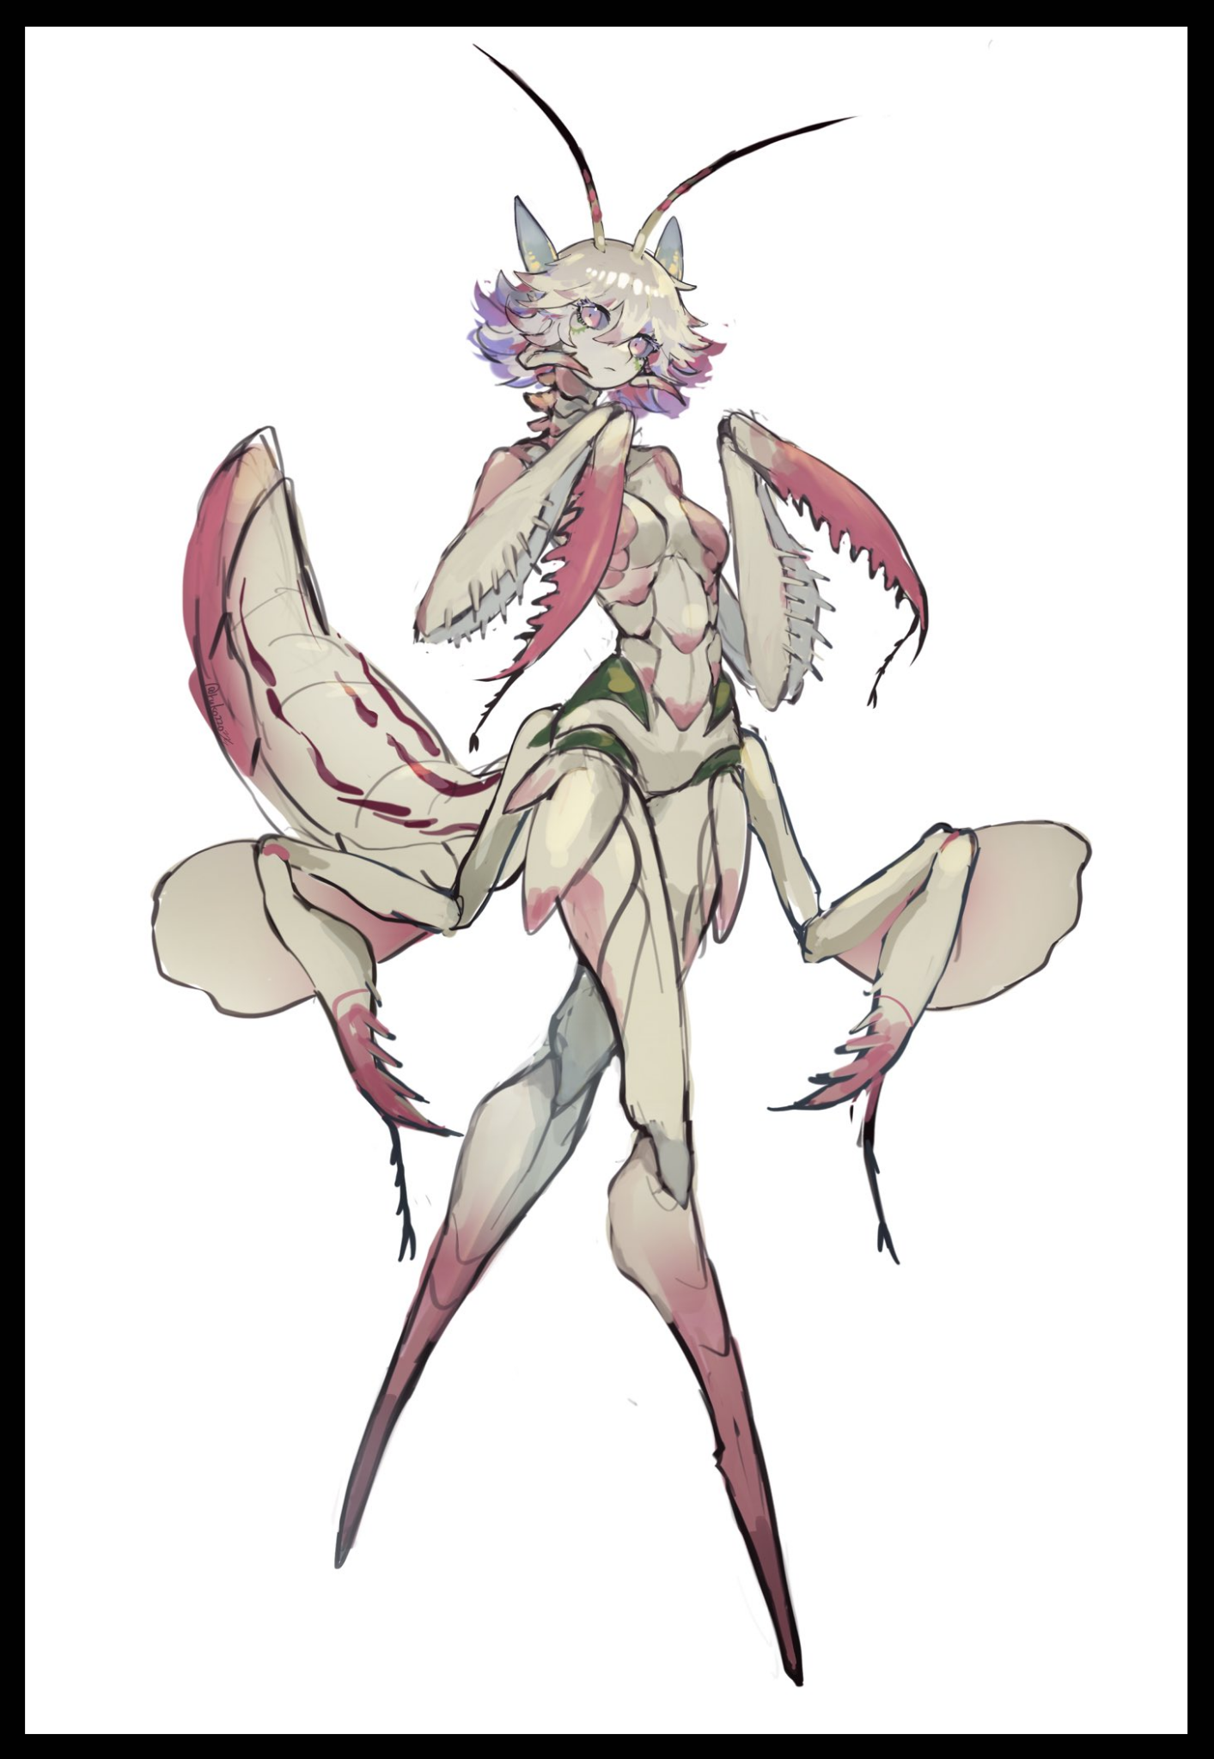

The moment the man’s body begins to bloat and come apart at the seams however, my brain was quick to connect the dots, something like a Jimmy Neutron moment where all my synapses just…explode. Linking the transformation I was viewing on the blurry monitor before my fixated eyes with the one that had afflicted Mirza minutes ago. Except this one was spontaneous, occurring all at once in a forceful 'pop' that rids the resulting creature of cloth and human flesh as it's lies curled inside it's pod; a naked, feminine silhouette struggling as two new limbs extend from behind perfectly sculpted hips while a beige colored carapace begins to emerge, swarming over its exposed dark innards in flowing waves of milky fluid before hardening, forming a gentle series of connected curves all across the inmates undeniably female body as it…she…whatever he had become, springs to life, banging against the tube face first to give the cameraman a good shot of her new visage framed by a short cut head of frilly platinum hair that tapers off into a mix of faint strawberry pink and mauve maroon. She was adorable; wide eyes taking in her surroundings with innate curiosity as feelers and sensory organs twitched behind her head, tapping softly at the glass with her brand new appendages, producing a thump every time she raps the dull end of her wicked sawtoothed limbs against the glass keeping her contained.

From her face, the camera pans downward, going over the entirety of her slim, curvaceous form clad in segmented insectoid shell. Where I once remembered the prisoner being quite a burly one, she instead sported a petite set of breasts that I admit, felt good to look at. I'm not sure if it was the color combination of her exoskeleton but it had my eyes instantly gravitating to her privates, taking in every detail from the dips of her collar bone to the pointed nubs faintly protruding through the tips of those angelic orbs.

And where there was supposed to be a dick, all that remained was a glistening labia hidden behind a strange natural flap of skin like material the insect woman sported around her tight hips and second pair of arms…they looked like the flaps a praying mantis would produce whenever they were interested in courting a mate or scaring off predators.

Just like it shocked the cameraman from the way the view suddenly jerks back up to stare the creature down face to face, I too jump a little as the recording reveals an eerie sight; the once innocent face now having split in half down below the nostrils like the mandible jaws of a Yautja hunter, revealing a simple hole connected to her digestive tract, flanked by a secondary set of jaws ending in wicked fangs spraying some sort of venom that bubbles in her gooey prison. Something told me the man was planning to test his luck by remaining still, but her neck beginning to extend to unnatural lengths alongside her abdomen vibrating like mad was more than enough of a signal for the guy to book it out of there, and he was right to do so. Because right as he pushes his through a sliding door leading out to yet another drab metal hallway, the distant sounds of an unfiltered alien's scream fills the speakers alongside a cacophony of shattered glass, spilled fluids and an ear piercing alarm.

And then the feed dies along with my desktop as it begins to slit sparks before the entire front casing blows off its hinges, leaving the ultimate fate of the man behind the camera largely unknown…except it didn’t, not when I already knew the rest of the story. The inmate being transformed into that mantis creature, the sight of her fangs and the injury in Mirza's legs. The man I assumed to be a streetside wastrel was in fact someone who had probably violated enough laws to intrude upon and extract vital footage that could seriously hamper the Sectoid's pristine image in the eyes of the public before making it out of there by the skin of his teeth, probably being harassed by Sectoid forces and that transformed inmate which would certainly explain the terrible condition of his clothes and the unique wound on his leg. If word got out that they were experimenting on inmates like this, there'd be backlash for sure.

But as I would soon find out in the coming weeks ahead, the public were more than happy to play along as long as it wasn't them on the receiving end of the Sectoid's unethical practices.

Paying my ruined workstation no mind since I had the funds and parts to repair it, I tried my attention then to more important matters, returning to Mirza's stash to see if there was anything else I'd missed…and indeed there was. A simple flip phone that I was initially surprised to see considering how rare the things were even before the Sectoid's arrival. Although it was a little worn out, I could turn the thing on, realizing there was only one purpose this thing served;

A distress pulser. Once activated, it would probably ping Mirza's current location and send it to his associates, only to be used as a last resort I guess, seeing as how he never used it when I found him out there on my front door, collapsed and barely breathing. He'd probably planned to trigger it if he was going to be captured by Sectoid forces. Makes me wonder just how powerful his friends are if they'd be willing to directly confront the aliens to save one of their own…would they consider me a threat if I pressed the button? Would these mythical saviors I never would've realized existed till now even arrive? What would I tell them about Mirza's current condition if they did? All these questions burn within my mind as I write this, staring down the pulser on my desk, contemplating on hitting the big red button on its center, tempering the urge to do so as it grows with every passing day since the incident occurre-*doc.d.k(\*?*

Sorry back there, minor disturbance by Mirza…seems like she would like me to go back a little in the story. Despite her inability to speak English anymore, she's been proving herself to be quite the precocious learner in the arts of cross species communication. Pleasant buzzing to signify satisfaction, a curious trilling song from her altered vocal chords she'd busy herself fine tuning whenever she was bored and something else altogether I'm still not sure about…don't blame me, I was never the sociable type so reading women is something that's beyond me…

After discovering the phone, I remembered then that I still had one major problem to deal with lurking somewhere in the living room. From the recordings, all I had to go on was that whatever Mirza had turned into could be highly aggressive if the mantis girl was anything to judge by. Already I'd nearly gotten my head lopped off from her wings emerging earlier, and yes, I said her…the resulting transformation had been a female Sectoid hybrid so who's to say Mirza ended up any different? And from the briefest glimpse of a pert bubble butt earlier, I was more than certain the former agent had lost everything, including the junk all men cherished greatly…plus I think I saw the thing falling off anyway…as I pushed aside the desk, I almost didn't want to look at the floor in case it was just lying there. Flaccid and dead!

With a slow twist of the lock and a push, the door swings open, and I feel my heart break. The place looked like a typhoon had come by and flipped everything upside down. Fixing all this was going to take a lot of time and effort…if I survived the cause of it all standing in the center of the room of course; Mirza herself, already aware of my presence as she maintained eye contact with me, staring into my soul with intense purple irises. And then she begins to approach me, stepping past the muck with clopping heels, chittering jaws and a creak from her sinewy joints.

Unlike the insect girl from the footage, the being Mirza had become bore a stronger resemblance to the Sectoids physical appearances taking heavily after extraterrestrial insect traits instead of those found on Earth. The closest comparison I could think of was a moth from the appearance of her spine like feelers, but that was it.

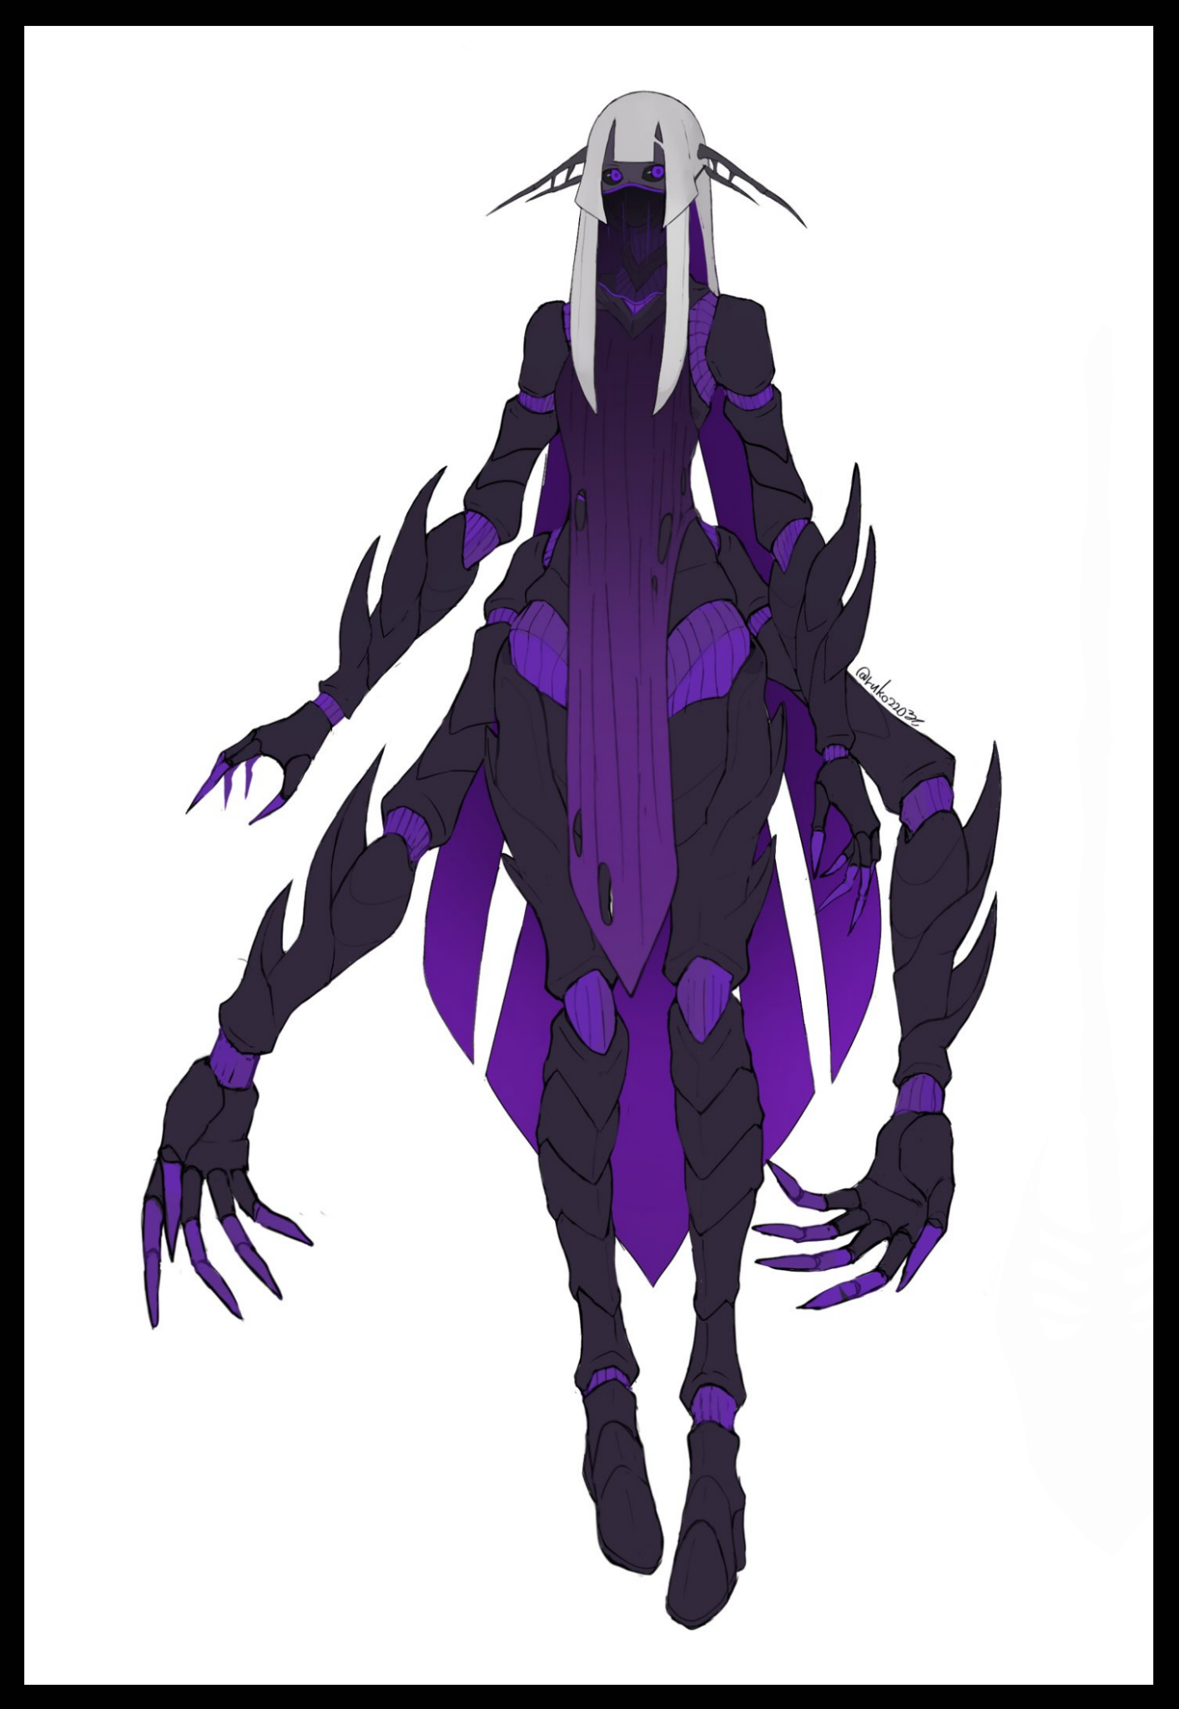

Within the brief time since i took shelter in the bedroom, Mirza had grown herself a new head of polished silver neatly trimmed at the fringe with sharp angular cuts to draw emphasis to her gorgeous face, realizing it wasn't wings she had grown earlier but the lengthy mane of her new hair, diverging near the bottom into 4 seperate extensions with two fusing together at the middle to form a toughened rearguard that remained malleable and tensile like ordinary hair, free to reshape however she pleased as she does so to block my escape, forcing me towards her as her hair stretches out behind me like the walls of a cage.

Before I know it, my feet leave the floor, hanging helplessly as Mirza picks me up with her spare hands, doing so gently with raking claws clasped lightly around my shoulders as she brings me up to face level. She’d gained a full head or two in height, and from the way her eyes were squinting until I was face to face with her, it was easy to tell she had terrible eyesight. But this reduction in distance allowed me to properly examine her face. Black sclera, a small, slant nose, spider like fangs jutting out from her canines and a semi transparent veil masking plump lips. An exotic piece far isolated from the bearded Caucasian it once was.

A small, guttural click from the throat, a curious cocking of the head and Mirza seemed satisfied with her inspection. Putting me down before retracting her hair and pushing past me into the bedroom I was just in, sniffing the nauseating scent of burnt electronics before sidling over to her bed and placing her bum on it, curling into a fetal position before the purple glow within her joints dim slightly, accompanied by an adorable cooing that sounded a bit like the snoring of a tuckered out human.

And down between her legs, shamelessly exposed beneath a self fashioned loincloth was a hairless vagina, dry and succulent with folds of pale purple beneath a swollen clitoris. Twitching every so often to the tune of her feelers flitting up and down like radar sensors…it was my first time seeing one so I did have abit of a hard time keeping her in my sights as I moved to secure the house, eventually cleaning up enough that I managed to right the sofa and lie down, feeling drained and exhausted once the adrenaline rush of it all fades away, it didn't take long for me to drift off to the sweet embrace of sleep alongside the bug girl I now shared a home with.

The next few weeks from then till now served as an excellent adjustment period for learning to deal with Mirza and her new habits. After that first day, I tried everything to try and get her to remember her old self, or try to say something even. But no matter what I said, a simple stare was all she gave back in response. Funnily enough, she never once expressed a desire to leave, spending most of her days wandering the living room, sampling the furniture or sleeping in that strange curled up position of hers when I left home to tend to the shop. But when the time came for dinner, I came to think of her as something like…a puppy?

I didn't even know she was standing behind me while I cooked myself a batch of fresh stew after the previous night's ruined dinner, looking for something heftier to fill my belly with. And when I did finally notice her, she was drooling way too hard overhead, getting my hair and shoulders wet with her saliva while damn near getting some into the sauce as well. Considering the sheer size and strength gap, there was no way I was able to get her to budge until I finished cooking,

By then my hair was drenched in sticky, aromatic goop and the stew was miraculously saved and prepared. Split evenly into two bowls, one before me and the other already halfway down Mirza's gullet in crushed chunks. She begged for seconds with wide puppy dog eyes and a cute wagging of her feelers, refusing to let me move an inch until I finally gave up my share, pushing the bowl to her before it instantly vanishes as she lunges forward, snapping up the entire thing in one bite before scurrying off to the room on all six limbs…chittering softly as she drifts off to sleep. Leaving me alone to cook up some porridge again lest I go to bed starving again…

The next few days would start to prove interesting when I next came home from work to find Mirza already waiting at the dinner table instead of sleeping. Starting a loop where I'd be able to test her for likes and dislikes, what was edible and what wasn't to her new biology. Most importantly however…training her to use utensils and eat slowly was something bordering on impossibility, with one dangerous encounter almost ending with my arms being diced in half when she became too excited, lunging for the noodles I was trying to get her to watch me eat from.

It was a hassle, a dangerous one, but with a girl like her, I just couldn't find it in me to get mad at her. Pushing hard till a measure of patience and good table manners were instilled within her. It was pretty impressive though, watching her use a spoon, fork, knives and chopsticks all at once thanks to those arms of hers. And despite the difficulty of getting her to sit still and upright, I managed to get that need through to her thick skull when she unsurprisingly got a stomach cramp from indigestion after bouncing around the house with a belly full of luncheon steaks and eggs. Who woulda thunk a hybrid human alien abomination could get tummy aches?

But that was exactly it. Here I was, playing with a human-turned-Sectoid hybrid like it was nothing, treating her more like a pet than the human she once was. It was so easy to forget that eventually, I just stopped caring about whatever ominous plans the Sectoids had planned for Earth and seeing if the secretive agent could be returned to her former self. It was just me and Mirza the big girl…did I mention I got her to respond to her name? It was pretty cute seeing her hover like a missile out of the room whenever I called for her when the time came to gather round the table.

Eventually though, the happy routine we made for ourselves couldn't last forever. Not when we were watching the TV one day when a news broadcast came on, announcing some sort of collaborative effort between local law enforcement and their Sectoid financiers, the same announcement that made me realize Mirza's sacrifice was all for nothing as I watched the snobby host proudly read off a script detailing a new way criminal offenders could 'contribute' to the public while a side scrolling line of text dismissed all the other unfortunate souls to have been used in experiments within Sectoid installations….experiments like the one that managed to transform a man into a harmless Sectoid hybrid…experiments that ultimately led to the array of emotionless hybrids currently on screen. Some looked like Mirza, but all of them lacked a soul. Their eyes were deadpan, staring a thousand yard stare even while the man on screen grabbed and squeezed inappropriately. Showing off their obedience to a world desensitized to control.

Needless to say, it's got me thinking about the distress pulser again with the thought of the Sectoid's sinister plans fresh in mind. I noticed Mirza looking distressed as she watched the broadcast with me. Even after I turned it off, she seemed deep in thought as we both ate dinner in silence…even now her playfulness seemed dulled, usually she'd be trying to get me to read her a book…but after checking on what I was writing, she's gone off to sleep again…I wonder if her friends know of her fate, accepting it as fact and moving on…or are they still hoping she lives on, struggling to get back to them…Whatever the case…I'll have to decide soon…before I do something I'll end up regretting.

*As good as Mirza's company was…sometimes I just wish I never helped that man…*

*To Be Continued…*