IDOL RESTART
MAY 2021 REQUEST STORY
BY CHALDEACHANGE
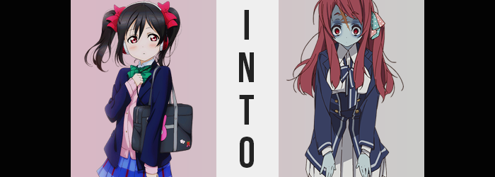

When it came to the future of the school idol group, μ's, all of the members were constantly thinking about how they could evolve as a unit. But none were as thoughtful about it all than Nico Yazawa, who despite her sometimes abrasive and grating personality was one of the most invested members. She always wanted the group to be the best that they could be, and while that was true of everyone, she was constantly searching for new methods of success.

Perhaps it was searching for new costume inspiration to share with Kotori, or perhaps it was checking what all of the latest music trends were in the depths of the internet – Nico would explore every avenue to find new ideas and bring them to the table.

Except getting rid of her ‘NICO NICO NII’! That was timeless!

“Hmm. ‘Type in your wish and it will be granted’?” In this case, she wasn’t doing anything quite as helpful as those other scenarios. It was just before midnight and she was furiously searching the internet on her laptop while dressed in pink, flannel pajamas. They had a big show coming up the next day, and she was looking for some good luck charms.

Did she believe in such things? It was hit or miss. Well, she didn’t really think websites like these did anything except make her feel a little better. Nico had been searching horoscope sites and the like as well, making sure the stars themselves aligned for the show. Then again, it might have been easier to ask Nozomi on that one.

It was just one of those sites where you submitted your wish, nothing more. Her data might be collected? But she supposed she could be vague. What mattered was the feeling behind your wish, right?

I WISH OUR GROUP COULD BE ETERNAL.

That seemed good enough! “Musicians are always saying they want to be remembered forever, so μ's should be the same!” She slammed the enter key without even giving it a second thought. The wish was innocent enough, of course, but…

THUMPTHUMPTHUMPTHUMPTHUMP

Suddenly, the world around Nico was completely different. She was still dressed in her pajamas, but she was sitting in an antique chair in what looked to be an equally antique living room. “…Huh?” Small hands rubbed at her big eyes as she attempted to process such a sudden change in setting. This was like the kind of thing that happened in movies and anime, right?

“I’m totally dreaming, huh?” As she looked around again, this utterly wrong assessment was what she’d settled on. But what she didn’t realize? She wasn’t alone. All of the members of μ's were in this building, but they’d all been tossed into different rooms. Each of them was strapped with the same confusion and were seeking a way out.

They wouldn’t find one.

So… Figuring out where she’d ended up should be her prerogative, right? Even though she was still under the impression that she was dreaming, Nico pushed her tiny frame off the chair and wandered over to a nearby bookshelf. Despite the Victorian-esque design of the furniture in the dimly lit room, all of the books were written in Japanese, so she was still in Japan? The girl had the thought of pulling a book down just to check though, but upon doing so? She paused.

Nico was shivering. Not just a little, but a lot. It had come on so very suddenly that it had struck her while reaching up at the bookshelf and was accompanied by a feeling of weakness that forced her to instead grab the shelf itself to hold her upright. “Wh-What’s happening to me!? Is this a nightmare instead!?” Still hung up on the belief that this was a dream, she was easy to dismiss this sudden illness as a part of it all.

THUMP THUMP THUMP THUMP THUMP

Even as she fell backwards, head smacking against the wooden floor. “Augh!?” It’d hurt! Wait… No it hadn’t? Well, this was a dream after all, so maybe it wasn’t all that odd? At least that was what she was thinking, but for some reason the arm she had used to grab the bookshelf was locked in an upwards position and she couldn’t drop it. Weird. Weirder still was something she hadn’t quite noticed yet.

The tips of her fingertips had turned blue.

Not simply her fingertips in actuality, but the fingers were her best bet at noticing considering she couldn’t seem to move her body as she was. The truth of it was that blue was decorating her skin all over, most noticeably in points where her blood flow was weakest in the beginning. If it had simply been a change in color then perhaps it wouldn’t have been all that alarming, but any flesh that was tainted with this color dried out, almost like the blood had been sucked free of her body’s container?

“Wh… at…?” Nico’s words came out as little more than a croak as she finally noticed it, a blue spreading down her hand and arm. Her vision was blurring as her breathing shallowed, so she couldn’t fully make it out, but along with the discoloration came the appearance of purple veins sticking out beneath, almost as if her body had experienced rigor mortis.

THUMP…….. THUMP…….

But her heart did not thump any longer, and Nico blacked out on the floor of the unfamiliar room, her body cold and shriveled up, wide eyes now stained a startling crimson. She only persisted in this lifeless, thoughtless state for a moment though – because she suddenly sprung up and back to life.

“AH!?” The girl gasped for breath, each inhale feeling extremely labored. She still felt cold and clammy, but she could move again! “This really is a strange… dream?” Sitting cross-legged on the floor, she’d glanced at her hands briefly after remembering what she’d seen, yet… “I-It’s so gross! What happened to my hands!?” They were a pale, greenish-blue and she could make out her veins! They looked all shriveled up, too!

Noting a mirror in the room’s corner, she scrambled to her feet and ran to look in it. But what she saw? “AAAAH!? A ZOMBIE!?” A ghastly creature was looking back at her. An undead girl with dry, blue skin and red eyes surrounded by ugly bags, who had short, black hair and was dressed in her pajamas!

Her… pajamas?

“AAAAAAH!? IS THAT ME!?” Blue hands slapped her face, and she could feel one of her eyeballs bulging – no, she could see it!? It was going to pop out! “AH!? What do I do!?” Almost instinctively she slammed her eye shut before the ball could pop out, and slapped it with one of her hands, knocking it back in. Crisis averted. “Huh? How did I know how to fix that?” It was almost like it had happened before…

Nico blinked again, fixated on the zombie in the mirror. “That’s really me? The cute Yazawa Nico, reduced to a zombie!? Oh! This must be like one of those dreams with a meaning, right? Like me being a zombie must mean I’m working too hard?” She’d read a book like that once!

“But why so much red? My eyes, and now my hair…” It was a keen observation. Her black hair had traces of red flowing into it, dyeing individual strands that in turn grew longer with time. Before long, the fire had spread throughout her entire mane, painting a lengthy crimson that was excessively frayed – which wasn’t all that surprising considering she was a ZOMBIE!

What the school idol was more oblivious to was what was happening to her face. Then again, shriveled up as it was? It was difficult to blame her. Even so, her forehead appeared to be broadening beneath messy bangs, and her cheeks looked a little fuller? At the very least her jawline had lengthened, removing the roundness of Nico’s childish visage. Paired with more pronounced lips, she looked significantly less like herself than she had moments before.

The longer this wore on though, the more uncertain Nico was that this was a dream. Not because she felt like the contrary had been proven to her, but because she just felt more comfortable? Like this was normal. Like she’d been like this for a while, even though it had just happened to her. “Am I forgetting something?”, she asked herself, and in a slightly deeper voice to boot.

Unbeknownst to her, she’d grown a little taller. It was too significant, hardly even an inch, but it was enough for the base of her tummy to be exposed since her pajamas had been a perfect fit upon her body prior to this entire debacle. Which, really, ended up being her undoing as some more dramatic altercations were made to her girlish figure.

A whole lot of BYOM, really.

“H-H-HUUUH!?” Comical overreactions on Nico’s part were leaning into the realm of excessive, her facial expression quite hilariously surprised as something at the base of her spine suddenly cracked, resulting in her hips jumping wider. The suddenness of their growth found the waistband of the pajama pants digging into her zombie skin, pants made even more uncomfortable by what was to come.

Tied in the front, that tie had no choice but to unravel as the girl’s thighs and butt suddenly bloated, fattier weight seeing her lackluster curvature arch into something quite impressive for a girl of her age. The growth forced the pants to slide a little down her upper thighs before getting caught, but it also revealed that her right thigh was wrapped in bandages for some reason – concealing a flesh wound beneath that couldn’t be patched up even as a zombie.

The nature of her pink, flannel top was that it was completely buttoned up down the center. This made things extremely interesting as a sudden explosion of weight suddenly erupted from within her bosom, forcing Nico forward to the point that her head would have cracked the mirror if not for her hands reacting in time to stop her. “Why am I flopping around everywhere? My body’s acting strange!?”

Huh? Hadn’t she just been surprised about how weird her body looked? Well, she was a zombie and all, but hadn’t she come to terms with it like a year ago?

The source of the weight – and her sudden imbalance – had clearly been the girl’s bosom. Perkiness hadn’t been lost even in depth, and her bosom had been implanted with significant, natural weight that rounded them out and increased their heft. Unfortunately, this blew out the top four buttons of her pajama top in the process, leaving ample blue cleavage on full display.

In the end, the girl pulled herself away from the mirror she’d almost smacked into, paying no mind to her wardrobe malfunction just yet. “Whoa!? Did I actually hit my head!? That scar…” A huge one had formed from the right side of her head down to just above the left side of her nose. It looked like it had come from a fatal wound, but when?

When? I got this when I died, remember? Hit by a truck? Geez, I’m having an off day!

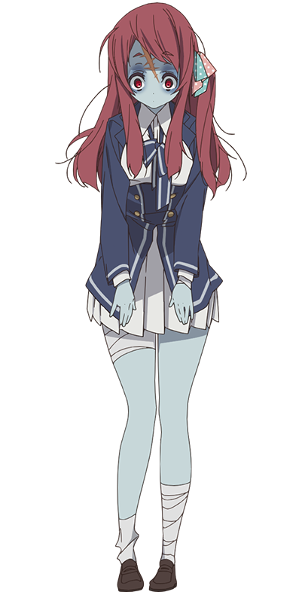
“Eh!? Why am I wearing these pajamas!?” Once the girl was fully aware of both herself and her surroundings once more, the first thing she took notice of was the fact that she was bursting out of her clothing. The buttons in the front had been blown out to expose her big but green-ish blue bosom, her tummy was fully exposed, the sleeves were pulled up to her elbows, and the pants were like extremely tight shorts.

Sakura Minamoto couldn’t fathom dressing herself like this. At least not unless she wanted to be teased by Saki. But… who was Saki? What were these names? Saki, Nozomi… No, wait! Who was that second one? The names of her fellow members of μ's were? …What was μ's? She was a proud member of Franchouchou, Zombie Number 1! “Maybe this whole being a zombie thing is finally getting to me… It isn’t like me to be so scatterbrained!”

Oh, no. It was absolutely like her. It just wasn’t like the girl that she used to be.

Standing upright, Sakura had completely forgotten about her clothes until she went to stretch. “Oh, right! I guess I should fetch my pajamas! I hope none of the other girls are in the dressing room though, they’ll totally laugh if they see me…”

But one of them most certainly was.

