**CHAPTER 2**

**COVERING HER SCENT**

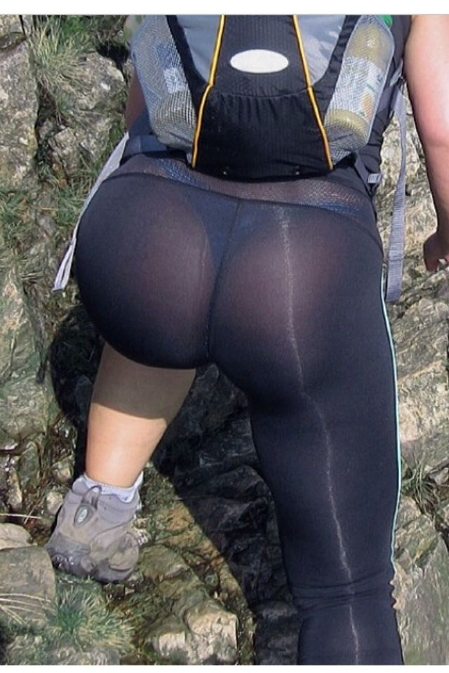

“Please! **NO! ANYTHING BUT THAT!**” Allison cried with her urine covered lips! The hot steamy piss was still dripping down the sides of her face as she stared up at Katniss’s jiggling cheeks just inches from her face!

**“SHH! QUIET!**” Katniss screamed at her before slamming down on the poor girl's face! Katniss could feel her screaming between her sweaty cheeks but it only came out as a muffled vibration!

“Are you trying to let the entire island know where we are!!!” Katniss said in a strict and dominant tone while wiggling her ass on the young woman’s face!

Allison was in hell! Drinking a strangers urine was bad enough, but this was another level of humiliation! Her nose was pressed right up against Katniss’ asshole! It was wet and sweaty, the surface was wet and oily! Even though Allison wasn’t breathing in, she could still smell the unbearably strong earth aroma of shit! The hole puckered on the tip of her nose as a long hissing stream of gas seeped out! It was so hot that Allison felt the methane burning her cheeks and skin! She began screaming but Katniss just sat harder!

Katniss slammed her ass down again, mashing her face deep as the gas stream flowed out softly! The tree branches below them shook from the weight as Katniss moaned loud, it felt so good to let it out, the heat was burning the rim of her anus and she was glad it was out of her colon! Her insides were practically trembling!

“Ugh, stop complaining! Remember who’s helping who here!’

Allison cried from the smell of burning eggs and spoiled cheese as Katniss slid down her face resting her entire weight on her mouth! With her leaning forward, the weight of her body forced Allison’s mouth open wide so wide that it felt about to rip off! She trembled, her entire body shaking as Katniss’ sticky anus puckered in her open mouth! She could feel the heat from her asshole on her tongue, she had never been so scared in her entire life!

**“Ughhh HNNNGGG,** ahh” Katniss pushed for a moment, her anus stretching wide inside Allison’s mouth before closing back up tight!

“You’re lucky i didn’t have any milk during breakfast, otherwise your face would have been a mess!” Katniss commented with a giggle as Allison whimpered and cried under her ass!

Allison closed her eyes, trying to pretend she was somewhere else entirely, somewhere where her mouth wasn’t being used as a toilet. She began to picture her soft warm bed at home, her head resting on the pillow, just as another hot rancid blast exploded out! Allison was ripped from her short fantasy as the cheesy egg fueled gas sprayed across her tongue! The smell was terrible, beyond horrible, but the taste was worse! It washed over her tongue like a wave of flavor, like an appetizer to her shit soon to come! Allison’s eyes went wide as she gasped, sucking the gas deep into her lungs before choking wildly! Her head bobbed up and down, smacking the tree branches under her as Katniss stayed on top, riding her like a horse! Leaves began raining down below them to the ground from the chaotic struggle.



Allison felt like her insides were rotting, like she had inhaled something truly toxic! Her eyes began to feel hot as she coughed over and over, blowing the air out her nose between Katniss’ sweaty cheeks! She reached up with one shaky hand, grabbing Katniss ass and trying to move her. Her hand was quickly smacked away.

“Shhh, be quiet” Katniss said while raising off her face to her knees! Her fat cheeks were hovering above Allison’s face now as she gasped for air.

Katniss looked into the distance, squinting for a second and focusing her sight. Suddenly she saw them, two male competitors heading directly towards the tree they were in! It didn’t look like they had noticed them which was good, but this was still a very dangerous moment! Allison let out a gasping choke from the hot gas still brewing in her lungs just before Katniss **SLAMMED DOWN.**

Allison let out a tiny muffled cry as the fat sweaty cheeks smothered her face! Each one slapped the side of her head, wrestling with her facial features as Katniss’s assole slowly found her nose! Allison felt her sit back hard, her anus **PUSHED HARD** against her nose with her wet pussy lips completely sealing her mouth! Her entire face was covered in wet smelly flesh and there was **NO AIR!** Llison began to struggle but Katniss grabbed her wrists holding her down tight.

“Shhhhhh, someone’s coming! Be quiet!” Katniss said in a whisper as she looked down at the two men approaching.

Allison’s heart was beating so fast that it was almost jumping out of her chest! She could hear the footsteps far below them on the ground coming closer and closer as her lungs ached for air! She could feel the burning in her chest as Katniss sat with her entire weight on her face! Her skull felt like it was going to explode! The footsteps got closer and closer as Katniss wiggled, driving her nose deeper into her asshole!

Allison felt a wet squish as the tip of her nose entered her anus sending a shiver down her spine that stretched through her entire body! She felt a bit of wet shit drip down to her upper lip before Katniss sat even more heavily, smearing her face into her ass fat.

The footsteps were right below them now, Allison was weeping, crying into Katniss’ ass cheeks. She could feel Katniss’ pulse beating through her ass cheeks as the sweaty shitty anus puckered and gripped her nose, pinching the tip tight!

“I swear i saw two women running up this way!” one of the guys said as he looked around in circles with one hand over his eyes.

“Yea, well, wherever they are, they're gone now” the other guy said while taking out a big machete and cleaning it off on his pants leg. Katniss watched and saw he was cleaning off fresh blood.

“So what now?”

The other guy took a look around, surveying the surroundings.

“Let’s hang out here for a bit, we can see the entire area below, it's a good vantage point, eventually, if we wait long enough, we’ll spot someone!” The guy said to his team mate. He stopped and swung his machete hard into the side of the tree getting it stuck deep before taking a seat and looking out at the hill below! His friend sat down under the tree doing the same but looking out the other direction! Both of them **RIGHT UNDERNEATH** Katniss and Allison!

“Shit!” Katniss said under her breath as Allison grabbed at her ass cheeks trying to lift her! Katniss looked back over her shoulder at the young woman, the top of her forehead was dark red! She lifted up just a tiny bit, letting Allison suck in hard through her nose before sitting back down hard and silencing her! She couldn’t lie, it felt a bit nice having cool air blown out and sucked in through her wet ass cheeks. She had a serious case of swamp ass from the heat in this tropical climate.

Allison felt like she was going to suffocate! Katniss anus was pressed right to her nose, sucking on it, pinching the tip. She could feel her vision fading, her body going numb, just seconds before Katniss lifted up. Allison breathed in right away, sucking in air between her ass cheeks, the odor was rotten, foul to the core! She could feel the sticky shit on the tip of her nose and was about to gag, but Katniss came down hard! Before Allison could make a peep,Katniss’ ass smothered her to silence!

Allison could just see over the mounds of Katniss’ ass cheeks as she looked back over her shoulder and down at her. Katniss put her finger to her lips and made a shhhhh motion before sitting back and covering her eyes! Allison let out a cry as her anus pushed deep down sucking in the tip of her nose.

Katniss, while sitting on top of Allison’s face, grabbed her bow and slowly took out an arrow! She tried to steady it while aiming downwards at the men but the angle was too steep! She couldn’t pull her arm back far enough to shoot straight down! There had to be some sort of way to ambush them, she thought to herself while slinging the bow back onto her back silently. Allison began clamoring at her fat ass cheeks once again, clearly needing oxygen! Katniss let out a light groan, This girl was becoming more trouble than she was worth. It was just at that moment when Katniss’ stomach made a terrifying wet rumble! Her eyes went wide as she remembered why she was sitting on her face to begin with.

“Did you hear that?” one of the guys asked while looking around…

“Hear what?” the other guy asked as Katniss cupped her hand over her mouth! Her stomach was gurgling.

“I don’t know, it sounded like an animal!” the guy said while looking back and forth…

“Probably your imagination, stay on alert!” the guy said while continuing to survey the land below them.

Allison felt like lungs were about to explode! She was grabbing at Katniss’ asscheeks, praying she would lift up! Her anus was squeezing the tip of her nose and dripping bits of wet shit every few seconds! It began leaking down the sides of her cheeks before being smeared by the cheeks smothering her! Suddenly Katniss began to slide forward! Allison’s nose popped out from her ass cheeks as fresh air flooded over the top half of her face!

Allison’s nose was coated in shit so the smell was completely tainted, but she was so thankful for air! Katniss adjusted above her, spreading her ass cheeks wide giving Allison a short glimpse of her very dirty pink puckered asshole! Her eyes watered as she took in the odor, gasping and filling her lungs with the smell of fresh shit!

Katniss came down hard, her asshole covering Allison’s mouth as her ass cheeks slid over her nose! Allison was once again without air as she let out a muffled cry into Katniss’ anus! She responded right away by blowing back at her with a rancid curdling fart!

**SBBBbbsfppprrt apppspprppttttvvbrbtttpp pspprttttttt**

The fart bubbled and sprayed inside of Allison’s mouth like a hot mist covering every inch of her cheeks with wet feces! She felt it coat her tongue, slowly running down to the back of her throat as the gas forced its way down into her lungs! She cried salty tears while choking but her voice was muffled to almost a silence!

The taste of hot burnt cheese and spoiled eggs was getting worse! It was like she could taste the swiss cheese inside of her mouth! It had such an earthy salty flavor! She began gagging and Katniss grabbed her head, intertwining her fingers in her hair and **FORCING** her head even deeper between her ass cheeks! Allison let out a muffled cry as she choked on the gas.



Katniss began to push! She could feel Allison quivering under her but she couldn’t have cared less, those two guys had only delayed the inevitable. She was going to use this girl's mouth, over and over, until she forgot what food actually tasted like. She would sacrifice her at the end if need be, and if not, she could make a good toilet back at home too. Katniss pushed as another hot fart squeezed out of her asshole! She could feel a large hard turd pushing at her anus, blocking her up! The gas was squeezing around the monster shit all morning giving it a terribly foul smell. Her gas was always bad but today was a true exception!

**BBBBBbbbfrrvvttttsppprtttbb spppfrtttttttttttttttttttt sprtttttt**

A very wet fart leaked out into Allison’s mouth and Katniss actually felt bad for a split second. It was so hot, practically burning her asshole! The gas was accompanied by a spray of wet shit that leaked around the hard turd that was clogging her up. Suddenly the odor hit Katniss’ nose and she herself nearly gagged! That never happened from her own gas! Her stomach let out a sickening gurgle as she covered her nose and grunted hard.

“Oh god, do you smell that?” one of the guys asked as Katniss blushed a deep red!

“Smell what?” the other guy asked…

**“UGH**, oh god! It smells, like, **UGH FUCKING SHIT!”**

There was a slight pause before the other guy began reacting too…

“Ugh, what the hell is that?” he asked while covering his nose!

“It must be a wild animal, I've never smelled anything so bad!”

“Asshole” Katniss mumbled to herself above them as she plugged her nose and pushed! Her other hand was wrapped around Allison’s hair keeping her face firmly lodged inside of her ass cheeks! She could feel her mouth shaking, her tongue was trembling.

Allison froze her struggling as Katniss began to push! She felt her anus expand within her mouth, spreading wide and pressing to her lips, almost stretching them outwards from the pressure! Katniss was bearing down, grunting hard, using all her strength. Allison’s eyes watered as bits of wet shit dripped to the back of her throat coating her tonsil in sticky feces!

The massive turd began to emerge, suddenly pushing through the barrier or Katniss’ anus and entering Allison’s mouth. She was completely frozen with fear as the monster crawled across her tongue! There was a wet crackling sound coming from inside of her lips as Katniss grunted and pushed, the long chunky log began slithering out fast! The tip of the massive shit hit the back of Allison’s throat, immediately getting stuck as the body and tail filled her mouth, pushing her cheeks outwards! The head of the turd was rock hard, like a chunky boulder, butthe body and tail end were soft, steaming, almost mushy! It immediately broke apart filling Allison’s mouth!

The flavor was truly from hell! Allison could taste the burning methane and fumes from the eggs! There was a deep sour taste from the cheese that flared up inside her mouth getting stronger the longer she sucked on it. Both of those were mixed with a deep earthy bitter shit that reminded Allsion of cow manure!

There was no way she could eat this, no possible way she could get it down her throat! She was quivering with the hot mess sitting in her mouth, dripping from the corners of her mouth! The shit was so warm it felt like it was baking her tongue! She moved her tongue through the mess and let out a gag, inhaling the shit while choking! The thick head got caught in her throat as she tried to sit up, bouncing Katniss on her face!



Katniss squeezed her fingers into her hair tight and sat back on her lips! Her arms and legs were flailing, smacking the tree branches and causing leaves to fall! Her heart was racing, there was no time to think about that though, there was more shit coming!

Allison pushed hard on Katniss’ cheek, trying to lift her from her face! She felt her ass cheeks clench for a moment as she sat back hard, pushing her anus to her shit filled mouth! Allison could feel her anus quivering, puckering and pulling in and out over her lips.

**Sppppprbbr sllrppfprt srppptptptppp rbrtpttttt spprpprfrtt bbfrrttpspprttt spprtttt**

**Sppprttt rpptttttttt spprtbbbfrrrt sppfrtttt fprptttttppfrt spprttfrrt s frrtttttttttttttttttt**

“Oh fuck!” Katniss said out loud while holding her stomach and feeling the wet shit run down her ass cheeks!

Allison had no time to react as the waterfall of diarrhea dropped down over her lips! There was almost no room available inside of her mouth but the diarrhea quickly filled it. She felt the hot liquid blow her cheeks out before overflowing and running down the sides of her face! It felt like gallons! Katniss lifted up a bit, her anus pointed right at Allison’s poor nose before letting loose!

Allison gasped as the hot lava like shit exploded at the base of her nose, injecting itself inside of her and spraying into her nasal passages! There was so much that it completely covered her face and began running down the sides of her head! Katniss couldn’t help but let out a deep throated gag!

Hot shit began dripping down like a waterfall, splattering onto the guys sitting below! A large clump followed by a stream of light brown and yellow dripped down one of the guys backs! He jumped up in disgust just as more landed right onto his friends head, dripping down his face!

**“WHAT THE FUCKING SHIT!”** he screamed while tearing off his t-shirt and falling over onto the ground!

**“AH GROSS!”** The other guy yelled as he bent over and began scraping shit off the top of his head and hair! His fingers were coated in feces and he began violently vomiting!

Katniss pushed hard, letting another blast of liquid shit loose and onto Allison’s face behind her! She felt a bit of splash back on her ass cheeks and grimace in disgust! The shit smelled so foul that she felt on the verge of passing out, that was rare, usually she wasn’t bothered by her own scent!

Katniss, with her pants down and her ass covered in shit, Jumped from from the tree while gripping the trunk. She slid down in a few seconds landing right behind the two men! They were still busy cleaning the shit off their heads as they screamed in disgust! She turned around and grabbed the machete stuck in the tree, pulling it out with all of her strength. The first guy had turned around just as she swung at him. The blade came into contact with his head chopping it clean off! The other guy watched in shock as his friend's head rolled by him. He turned around to catch a glimpse of Katniss before she sent him to the same grim fate! His body fell lifelessly as she stood there, gasping for air, her heart was racing. The forest was silent except for the sounds of Allison gasping from up above.

Allison turned her head sideways as liquid feces poured from her mouth! It was followed by a thick chunky log! She could hear it plopping to the soft ground at the base of the tree as she began gasping! Her mouth was entirely coated with shit, not a single inch remained untouched! She could feel the sticky slimy substance leaking down her throat, staining her insides! Entering her stomach! She rolled onto her stomach while up in the tree and began gasping. She tried to breath but instantly began vomiting. How could Katniss do this to her, to anyone? How could she treat someone so low! She began weeping and crying, her entire face was smothered with shit! She tried using her hands to clean it but just smeared it around more!

**“HEY, GET DOWN HERE!”** Katniss yelled from down below as Alison cried harder! She never wanted to leave this tree! She would stay up here forever if it meant being away from Katniss’ ass.

**“IM WARNING YOU”** Katniss yelled…

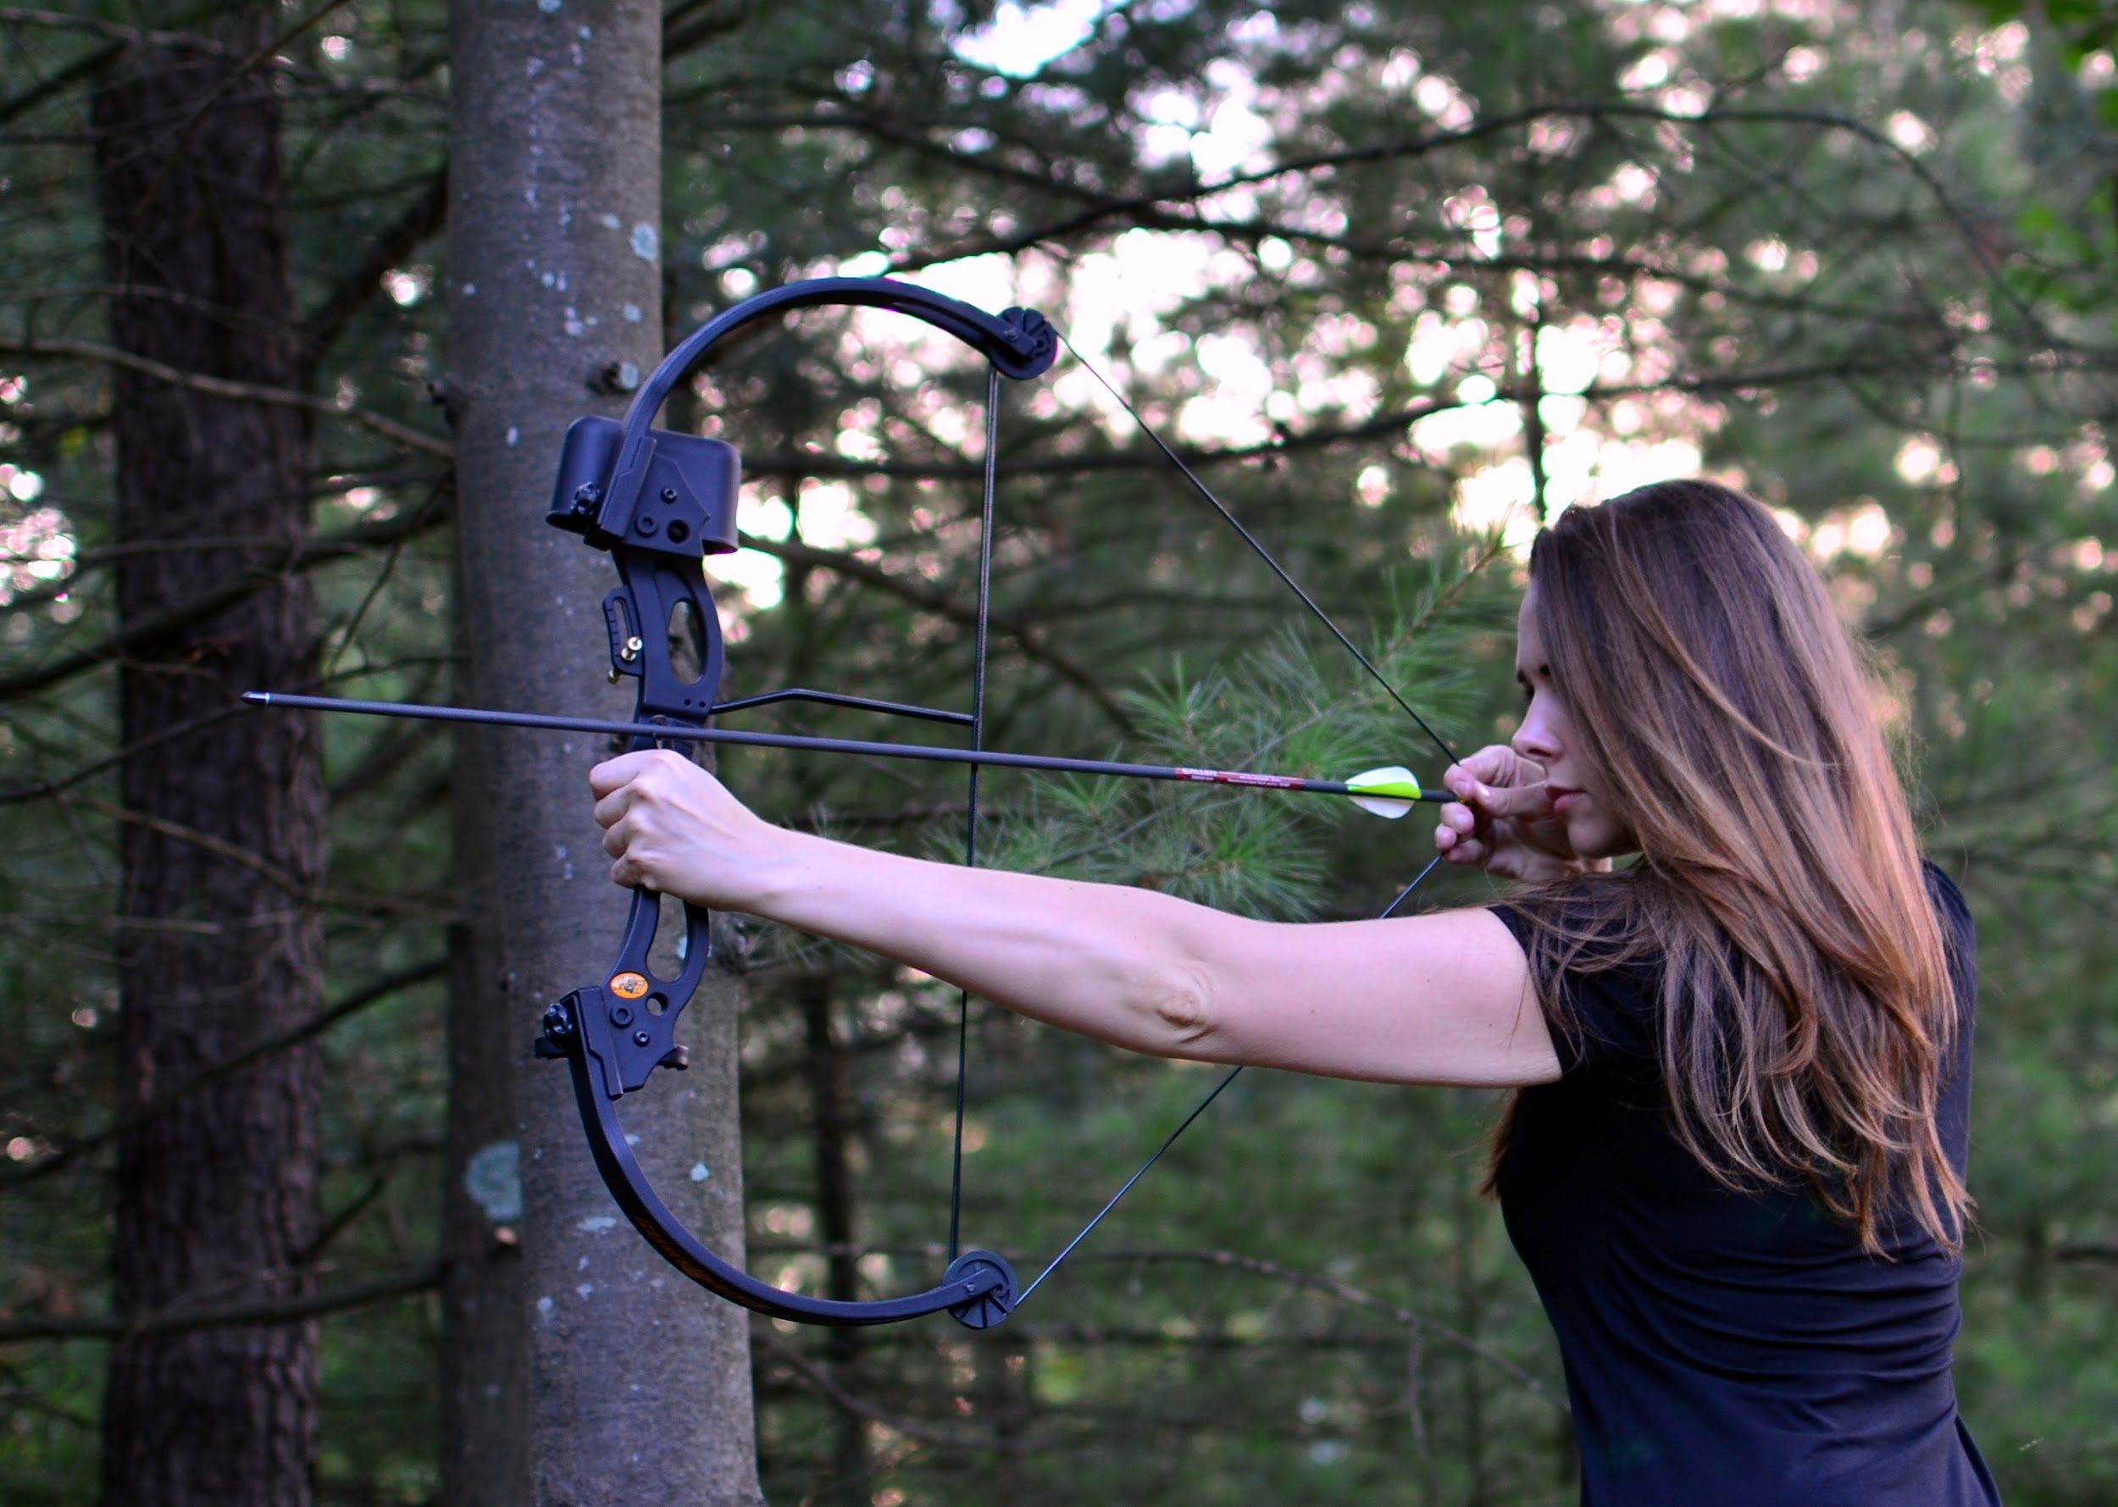

Allison laid there on the branches high up, knowing Katniss couldn’t reach her without a boost from below. She was safe here. She continued to gag and choke, trying to rid her throat of the sticky hot shit as a whizzing whipping sound flew by her face. Allison opened her eyes a bit through the shit and squinted. She could see an arrow stuck in the tree trunk next to her. She quickly looked down to see Katniss, Aiming a second arrow right at her!

**“LAST WARNING**” Katniss said while pulling back the drawstring and steadying the bow!

**“PLEASE! DON’T!”** Allison cried while choking, her face still smothered in feces!

“3...2…” Katniss counted down as Allison whimpered.. Slowly she crawled over the branches and looked down, it was so high up. She almost slipped with her hands covered in shit but managed to grab the tree trunk to slide down, like Katniss had done but much less gracefully!

Allison landed at the base of the tree on her butt as she let out a whimper and cried! She barely had time to open her eyes before Katniss grabbed the back of her shirt and began dragging her across the tree covered hillside!

**“LET ME GO!”** Allison screamed…

“I still have to finish using the toilet!” Katniss growled!

**“JUST! JUST! USE THE GROUND! WE’RE ALREADY OUT OF THE TREE!**” Allison screamed while choking on the shit staining her mouth!

“And what, leave a **BIG STEAMING PILE OF EVIDENCE BEHIND?** That’s real smart! Then no one will find us!” Katniss said sarcastically as she forced Allison onto her back in the leaves and grass! She gasped as her back hit the ground and Katniss gagged!

“Ugh, your breath smells like shit!” She laughed as she turned, presenting her big fat shit covered ass cheeks to Allison!

Allison lay there, frozen with fear, she knew there was no way she could over power Katniss, there was also no way she could out run her, or get away without being shot in the back of the head! She was trapped, a prisoner in the middle of nowhere! Katniss looked back and grabbed her ass cheeks to spread them before immediately letting go and grimacing, her fingers were covered in shit now! She bent down and began wiping them on the grass while muttering to herself.

***“Ugh, gross, fucking disgusting, oh god, it smells”*** Katniss mumbled as she cleaned her hands!

Allison whimpered, she could feel the layers of shit on her cheeks beginning to harden as she ran her tongue over it. The taste was horrendous! She began gagging from deep in her throat as Katniss looked back at her..

**“SPREAD MY ASS CHEEKS WITH YOUR HANDS!”** she barked…

**“NOW YOU WORM!”** Katniss continued, seemingly very impatient.

Allison’s hands were shaking as she reached up and grabbed the fat cheeks! Each one was covered in a layer of fresh shit making them wet and slippery! She gripped her fingers into the fat trying to spread them wide as Katniss looked back and squatted a bit further!

“HURRY!” she demanded!

Allison tried to spread the ass cheeks but her palms slipped letting the fat globes crash together sending a wave of jiggles down the surface of each one. She could hear Katniss groan in frustration as she quickly reached up and began spreading them again. As soon as the cheeks were spread and Katniss’ asshole was visible, it puckered and pushed outwards letting a vile wet fart loose! It was short and splattered shooting a small jetstream of light brown shit combined with ass juice right into Allison’s waiting face! It splattered into her features as Katniss sat hard and heavy, her anus crashing into her lips!

Allison cried out as Katniss’ asshole met her lips, blasting out a hot load of liquid shit the moment she had settled down! The hot feces filled her mouth as Katniss wiggled back and forth a bit.

“This is much more comfortable! Don’t you think so… gosh, i can’t remember your name, was it Ally, hmmmm.. Or Ariel?” Katniss asked while grunting and letting another hot load of shit loose! It coiled out of her asshole before blasting out pure liquid again! Katniss moaned loudly.

Allison cried under her fat ass! Her mouth filled to the brim with bubbling diarrhea as more began pushing in! Katniss was sitting so much more heavily then she was up in the tree! Now the feces were being forced right down her throat! Allison squirmed and writhed under her, trying to get free, but Katniss was so much more powerful. Her throat filled with hot shit as she gasped, sucking it into her lungs before feeling it fill her stomach! She had no time to even think about what she was ingesting! More filled her mouth, it was even hotter and more liquid consistent! Almost like bile! Katniss moaned as her anus bubbled and blew out a fart into Allison’s shit filled mouth.

**SBBFPPRBTPPFPPPPRPPTBBBSPPPRPPRFRVVRVTTTTTRRTT**

It was over twenty minutes before Katniss could finally stand without shitting herself! Her legs were shaky from how long she was squatting and her asshole was burning sore! She waddled around for a few steps groaning in pain before grabbing a bunch of leaves to clean her ass! It was so sore to the touch, she could barely even rub it. That’s when she remembered, she had a tongue she could use! Katniss spun around, about to speak, but suddenly froze. She burst into laughter upon seeing Allison.

She was laying on her back, her arms and legs splayed out like a star. Her face and hair were completely covered in shit, her mouth literally dripping as she choked and gasped! She was a sorry sight that’s for sure! Katniss laughed a bit as she looked down on her.

“God, you’re disgusting! Didn’t your parents ever teach you not to play with your food?” Katniss laughed.

Allison lay there, gasping, whimpering, she couldn’t even speak.

“Ugh, get up! We need to move, find a new hiding place. This one is actually sorta shit!” Katniss laughed!

“Well, it smells like it at least” she corrected herself, Allison was still laying on the ground…

**“COME ON, LET’S GO!”** Katniss yelled again as Allison scampered to her feet with her head bent low!

“Lazy piece of shit!” Katniss mumbled as she led the way deeper into the forest!

**STAY TUNED FOR PART 3**

