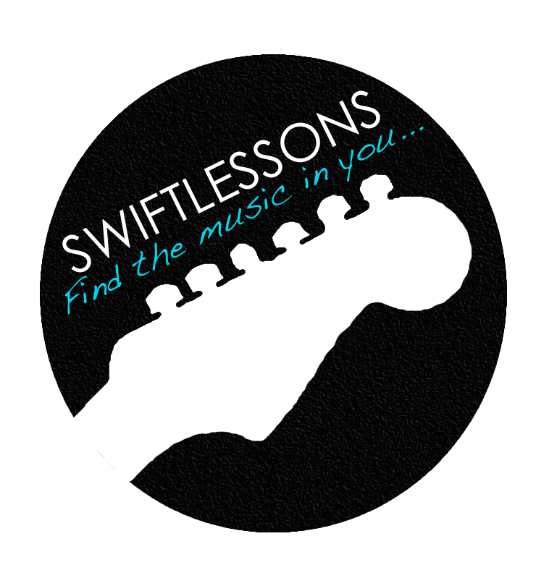**Swift Guitar Lessons**

***GoGo Style Rock Lick - Patreon Lick of the Week for 4/4/16***

In today's lick of the week, I'll demonstrate how to use the Em Pentatonic scale to jam over a "gogo style" blues progression. This lick will encompass double stops, string bends and a whole lot of syncopation. Don't forget to jam with the backing track at the end of this video. Let's get started!

**Source Scales:**

**E Minor Pentatonic (A position):**

E|------------------------7-10-|

B|-------------------8-10------|

G|---------------7-9-----------|

D|-----------7-9---------------|

A|------7-10-------------------|

E|-7-10------------------------|

**(Learn about how the CAGED system can allow you to play scales in five different positions)** [**CLICK HERE**](https://www.youtube.com/watch?v=0borvf30Smk)

**With your source scales practiced and memorized, let’s tackle your lick of the week!**

**Version #1 Version #2**

E|-/10-10-10-9--7--------------||-/10-10-10-9--7---------7----|

B|-/12-12-12-10-8--------8b----||-/12-12-12-10-8----------8b--|

G|----------------9--7-9----9v-||-----------------9--7-9----9-|

D|-----------------9-----------||------------------9----------|

A|-----------------------------||-----------------------------|

E|-----------------------------||-----------------------------|

Check back every Monday for another Patreon Lick of the Week.

Thanks so much for your support!

Be well and enjoy your progress. -Rob