GYARU OF HER PEERS
COMMISSION STORY
BY CHALDEACHANGE
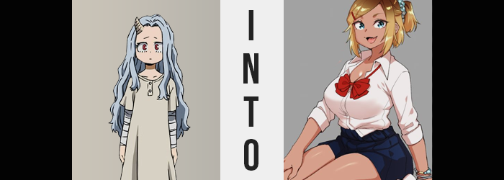

It was hard for the young Eri.

After being saved from Chisaki, she had been brought to U.A. High School to help her start her life anew. No longer did she have to suffer simply because she existed, simply because there were those that wished to use her time manipulating Quirk for evil. No longer did she need to be cut nor jabbed, and for once in her life she finally had things she could look forward to and smile about.

In the beginning, the most difficult part had been learning how to smile again in the first place. Did she deserve to be happy? Was she allowed? Young as the child was, she naturally did not know what to do with these thoughts considering she’d hardly had an opportunity to feel happiness in the past.

Deku, Mirio, Aizawa, and everyone else around her at the school had helped her so, so much though. Through their actions she had come to smile again, and for the first time in her life she felt like she’d been gifted a place that she could call him.

But that was what was hard about it.

For everything they had done and continued to do for her, she didn’t feel like she was in a position to do anything for them in return. That was the problem with being a young child. She had so many dreams that she couldn’t realize, and her fondest ones at that moment involved giving back to the people that had already given her so much.

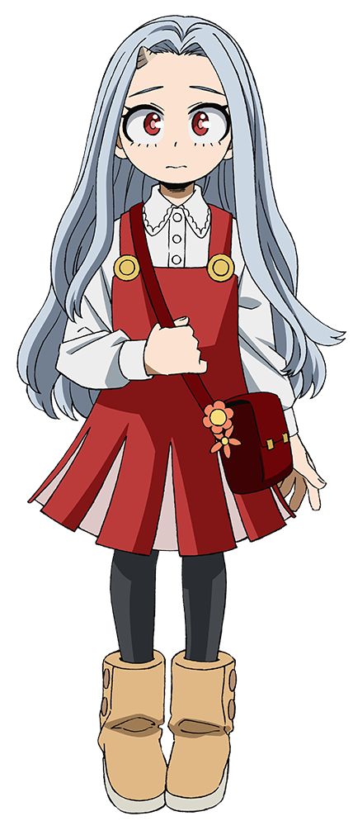
It was so late at night that day, and thoughts like these were much alive in her head. Aizawa had helped her change into her bright pink kitty nightgown some hours ago, but Eri hadn’t been able to sleep at all. Of course, the fact that her horn had grown so much over the past few weeks didn’t really help her at all either. No one could ascertain the reason behind this, but at the very least the girl wasn’t having episodes of her Quirk activating without intent like had been the case when she’d been with Chisaki.

On the other hand though, she couldn’t seem to activate it willingly either. Which was a shame, because if she could learn how to control it then she could help Mirio recover. Something else that she would readily do if she was capable of doing so.

“I just want to help everyone who’s helping me, but at my age…” Her comforter pulled up and over her mouth, Eri mumbled this to herself while laying awake. She couldn’t have possibly fathomed that doing so would provoke her horn to suddenly turn alight. “Ah!?” Her sheets cast off, she threw tiny feet over the side of the bed. Aizawa had told her that if anything was to happen with her horn and Quirk that she immediately go and get him, but this didn’t really feel like it had back when she was Overhaul’s ‘daughter’.

In fact, it felt kind of nice?

“Umm…?” Was this dangerous? Should she tell Aizawa? The girl went back and forth a little bit on what the correct option should have been. Aizawa had told her if anything happened to get him as quickly as possible, but on the other hand this was her Quirk, and she could tell that no harm was really meant to her. In fact, was it actually trying to help her?

It was lucky for Eri that she was still standing beside her bed, because she almost fell over suddenly, and that bed had been the perfect thing to use to help balance her so that said fall didn’t happen. “Ah!?” ‘What had knocked her off balance?’ was the question for her to ask, for she hadn’t moved a muscle, and there hadn’t been a wave of dizziness to accompany her. Well, to begin with Eri was only a kid. More advanced, critical thinking wasn’t really her forte to begin with.

Her fingers almost slid off the bed though, and that gave her initial clue. At her height, at her age, she was hardly taller than the bed she slept upon. That meant that her arm should have been raised to reach the top of the bed to keep herself steady. Yet while this was certainly should have been the case, her hand was now reaching down to hold herself up. Just slightly at first, but once it registered as ‘wrong’ with her, red eyes went wide at the realization that she was having to reach down farther and farther to keep her fingers on the bed.

“Uh… Um… Umm…?” Well, that explained why her nightgown was beginning to feel strange at the same time. She was growing taller, and at a pace that was pretty quick. “Am I growing up?” There was some surprise in her voice of course, but there was also a tinge of excitement. After all, Eri had just wished that she could become older. So her Quirk was granting that wish for her?

Only 3’7” when her growth had become, she’d already surpassed four feet in height at this point in time and was well on her way in approaching the five-foot mark. She wasn’t simply growing vertically, however, because this would leave her body shape looking extremely bizarre. She was also filling out as well to keep things consistent, which meant broadening shoulders, widening hips, and a broadening of everything in between to avoid her visage become too lanky.

This brought about problems for her night ensemble though. Eri was only dressed in her gaudy, pink kitty nightgown and the undergarments beneath. As her body filled out, the panties could do little but tighten around her crotch and butt, and before long the nightgown was little more than a tightly fitted half-top that’s sleeves had been blown out by her broader shoulder gait. “Nn…”

Her head was still spinning a little, and it felt a little heavy. Certainly this was in part because her head had physically enlarged some, but in a way it felt like a haze had been listed from her mind as well. Like there was some clarity and understanding that she didn’t possess before.

She eventually surpassed five feet, and had to wander over to a nearby desk to make sure she didn’t fall since her hands no longer reached the bed without bending over. Just as her limbs had lengthened, so too had her fingers grown long – and the very same was true about her feet, of course. The girl was fortunate that she had not worn socks to bed that night, honestly, else she might have slipped.

“No way! Did I really get older? I must be like… eighteen! Uh… Huh? Wait, I can remember going to high school? I remember living out my teens?” That didn’t make any sense, did it? It did in a way, but she hadn’t actually lived that time. Even so, the intellect she now housed matched up with the way she was now speaking. There was definitely more life experience behind both her phrasing and choice of words.

Suddenly remembering the cause of her growth, a hand reached up to feel for the horn that was on the right side of her forehead. It was still there and glowing, but its size had diminished a lot. Little did Eri know that by the time she reached this age that her Quirk would evolve though. It would evolve in a way that capitalized on Eri’s desires – which wouldn’t typically be an issue, but she had just had twelve years of new memories dumped into her head.

And according to those memories, as of late she’d taken a huge interest in reading magazines featuring gyaru stylings.

“Wha-!? OMG!?” A rather strange outburst escaped the girl’s lips, for the fabric of the nightgown that bound her chest suddenly erupted in a loud tearing noise. It wasn’t a noise without cause of course, but the cause in question was certainly a doozy. Considering she was eighteen now, it went without saying that her chest had developed originally. But it had only grown the bare minimum, giving her a set 0f B-cups.

On the other hand, in this situation her chest had suddenly surged forth with a great deal of bounty in mind, far surpassing the initial schematic intended for Eri as a young woman. Her nipples dug into the hot pink fabric while the jiggle weight of her bosom was largely repressed by the remnants of the nightgown. It all looked like it would explode at any moment, and the force of it all caused no shortage of discomfort for the girl. With tits peaking at E-cups, the gown had been presented with little choice other than to rip and tear at various junctions, allowing some of the soft flesh to emerge from within.

Hands thrown out to the sides in surprise, the nails that decorated them had lengthened dramatically and were now decorated with a shiny, pink polish. “Is this, like, really happening to me!? Why!? My tits are all huge!” It wasn’t simply her breasts that she had to be concerned about either. Hips had been forced wider than her shoulders for one very simple reason: the fact that her lower half was filling out with the same vigor as her upper one.

It was honestly a miracle that her panties did not snap at the waistband, and in this case it was more or less a testament to the make of the undergarments in the first place (luckily, Aizawa had sprung for the most expensive brand since he didn’t really understand girls’ underwear after all). They did, however, find themselves wedged deep in between the cheeks of an ass that flourished like the ripest of peached. Each cheek rivaled a breast in size, jiggling freely as she shuffled uncomfortably in place thanks to the wardrobe malfunction.

Thighs had grown in kind as well, and where a gap had initially been left between her thighs with the widened hips, not only was that gap rapidly filled in, but those thighs had little option other than to rub together as the teen moved about. “I’m totally getting all thicc! Aren’t I talking all weird too? But it doesn’t really feel bad!” Her voice was airier, and she really was trying to withhold a moan of sorts since her panties were cameltoeing the hell out of her groin.

While not quite sensual, a fullness did come to plague her face as well. It made it all appear rounder with wider, brighter eyes, and lips that were a fair degree thicker. Once complimented by bushier eyebrows, any chance of recognizing the teen as Eri had essentially been softened away. Not that anyone would believe this well-endowed beauty had been that little girl in the first place!

The horn atop her head almost faded entirely now, but before it disappeared into obscurity it released one final burst of energy while the light dwindled. This provoked the color of the girl’s hair to change, at first darkening to a much more normal black before blonde dye settled in more predominantly near the tips, while fading out closer to her roots. On the other hand, her eyes swirled with something far more definitive – for their distinctive reds gave way for much more normal blues.

Not quite done with this shift in coloration though, Eri’s extremely pale skin tone was quickly assaulted. Fading in gradually and evenly, there was an undeniable tan that took form, giving her a more exotic look when paired with her blonde hair. But that was wholly intentional because it matched a very specific type of style. Even the skin beneath her clothes was tanned, but the tan was about as fake as the blonde in her hair. It was a tan earned through oils and booths, not naturally, and certainly not from spending time at the beach.

“OMG! Did that really happen!?” Clad only in the scrapped remains of a torn-up nightgown and a pair of children’s panties that were clenched around her groin, the teenaged girl was in absolute awe of herself. Excited, she couldn’t help but lift her tanned tits and let them drop, their weight bouncing about just as excitably as she felt.

For whatever reason, her Quirk had pushed itself into overdrive while feeding on Eri’s desires, and the end result? She had become a young woman at an equivalent age to a third year in Japanese high school. Were that not enough, it was clear based on her dyed hair and artificially tanned skin that she had also become a gyaru. This wasn’t how Eri would have naturally looked at this age however, and it had wholly been affected in the worst possible way by an evolved Quirk that she had not grasped until it was already too late.

Either way, it had influenced her mind just as much as it had her body. “Wow, I’m tots all cute and definitely hot!” From the way she was talking to the more refined yet flippant motions of her body, it was evident that she certainly conducted herself like a high school girl of her age. “But, like, my horn did this, right? It’s gone, though…?”

Manicured fingers had rubbed the spot beneath her hairline where that horn had once been, and there wasn’t even the slightest bump. Would it grow back again, or was it gone for good? She didn’t really have an answer for that, but something of great importance suddenly occurred to her. “Wait… I’m older than Deku and them, huh? Does that mean I can…?”

One week passed after that night, and there had been no shortage of chaos over that period. For a well-endowed gyaru to introduce herself as the little girl that everyone was familiar had certainly inspired a great deal of initial disbelief and even rejection. Aizawa had almost had a heart attack, in truth. But experts had ultimately gotten involved to confirm that, at least genetically, she still was Eri at heart.

“Dekucchi, you’re my kouhai now so you need to listen to your big sis! You too, Uraracchi!” Eri could be found in the cafeteria in the wake of it all, dressed in a uniform with open cleavage and exposed thighs – against Aizawa’s orders. Her tastes had taken on this more risqué appeal with her age jump, but fortunately her personality wasn’t exactly lewd. She’d become something of an innocent gyaru that just knew how to capitalize on her charms.

She was wiping at Deku’s face at that moment while Uraraka sat beside them in awe. Calling Eri ‘senpai’ was certainly strange, but every time she was called ‘Eri-chan’ she insisted upon it. “E-Eri-senpai? I think you’re hurting Deku! Can’t you do it a little more gently?”

“LOL! He’s fine, look! Dekucchi is way tougher than this!”

Actually, he was on the verge of passing out thanks to her big breasts rubbing up against his arm.

