SHIP BEACH
BIWEEKLY STORY #68
BY CHALDEACHANGE
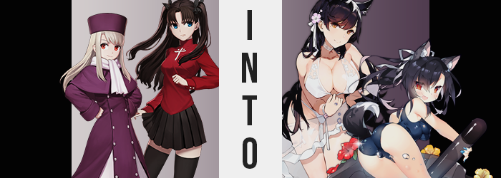

“Wow! Is this really what the beach is like!? I’ve never been before!” Dancing atop the sand in sandals, a white one-piece swimsuit the only thing covering her body, Illyasviel’s red eyes were wide as she watched the water crashing against the shore. With the Fifth Holy Grail War behind them and summer now upon them, Rin Tohsaka had thought it might be a nice change of pace for her albino friend to visit the beach for the first time.

As she’d already said, Illya had never been to a beach before. It made sense seeing as she’d been withheld from the world outside of the Einzbern manor for so long. As her time living in Fuyuki after the war had exposed, there were plenty of experiences the girl had never had the privilege of experiencing before. It was tragic, really.

“Illya! Don’t run too far ahead! We need to set up where we’re going to sit for the day!” It was a public beach, but the two of them had come so early in the morning that no one else was there yet. Rin had planned this; else it would have been hell trying to find a spot later in the day. But in all of her enthusiasm, Illya had sped down the beach ahead of her friend. “And that request fell on deaf ears, it seems.” This left the Tohsaka to shake her head from side to side as she put their bags down. Maybe it was for the best? Unlike Illya, she still had to get changed. She was hopeful the girl wouldn’t run too far.

And she hadn’t! Though Illyasviel did disappear from the public eye. There was a small alcove carved out of the beach where water from the nearby filtration station filtered through a caged tunnel. Children often played in this alcove, since the water was only ankle deep and entirely clean. But Illya hadn’t wandered in there to play. Something had caught her eye.
“Hue? What’s this?” Sitting in the stream of clear water was a device of some kind. It almost looked like an antennae? Like the kind you might find on a vehicle. The child-bodied eighteen year old didn’t even realize that it was broadcasting a signal, one that her mind had picked up and had drawn her closer to it. “Oh, this is the kind of antennae you’d find on a ship, right?”

It took the half-blooded homunculus a moment. “Why… do I know that?” Although it eventually did occur to her. She knew nothing about boats and ships, and she certainly shouldn’t have possessed enough awareness of the subject to identify the antennae as belonging to a seabound vehicle. “Um… I feel a little strange.” Like her head was buzzing.

Feet done up in sandals, Illya stumbled back slightly in the ankle high water and shook her head from side to side, trying to kick whatever dizzy spell had suddenly struck her. Though, on the other hand? It wasn’t simply dizziness. Her entire body either ached or was plagued by some kind of numbness, forcing her movements to be erratic enough that the girl decided remaining perfectly still was her only means of avoiding falling over.

“Whoa! I… I… Hehehe! WHA-!?” Without any intention on her part, a giggle erupted from her lips that sounded very out of character for her. Typically her giggles were much more childish in melody, but this one almost sounded deliberate in sounding and had been adorned with a deeper pitch than Illyasviel would typically pepper her laughter with. “My, am I being affected by some sort of magecraft!?” Out of all the possibilities, this seemed the most likely. Her symptoms could have been explained by illness for a time, but the way her manner of speech seemed to be conforming to something dissuaded sickness as an option entirely.

And the girl had come to this conclusion without yet even realizing what was happening to her body. From the neck up showed the most prominent of the encroaching issues in the very beginning, almost like it was setting up for the rest of the debacle. The girl’s long, white hair – an attribute of her background as the daughter of an Einzbern homunculus – was the first casualty of what was to come.

Streaks of pitch black swept through this white, intent on removing the cotton coloring entirely as it seeped through more and more of her fluffy mane. One strand became two, which became four, which became eight, and sixteen, thirty-two; until her entire head of hair was raven black. Not only that, but it cascaded farther down her back than ever before, dancing past her hips and all of the way down to ankles. This might have appeared almost comically long at the time, but it would inevitably even out once she grew taller later.

Otherwise, the girl’s face gradually began to look strange. More like it belonged to a woman and not the girl she physically was. At first, it was merely the surfacing of a beauty mark beneath her right eye – despite the fact that Illya didn’t have any such markings on her face or body before. Then it was her eyes themselves. Their abnormal reds took on a glossy shiny, glittering gold instead before long. Her lashes fluttered longer, and the eyes themselves both narrowed in shape and widened in expression simultaneously. With her hair and eyes, she now looked more like a pure-blooded Japanese girl than the half-blooded one she was.

But her facial situation promptly escalated. Her eyes and mole already created the impression that she was a more mature-looking individual, but these were only two pieces of the puzzle. “Thith mustht be thome kind of… Ah!? My wips!?” Try as she might to express her concerns, the girl was plagued by her lips fumbling against each other almost like they were numb. They weren’t, but they were swelling bigger as the seconds wore on. At first, they were more akin to a child’s flatter pair, but before they were both rather pronounced and resting beneath a lengthened nose. In fact, her maw was much narrower, giving her a longer face – and somehow even her complexion itself appeared to be better aged.

Illya herself was distracted, tracing her lips with a finger for a moment. “I have the lips of a big sister, so what’s the problem? No! Wait, that’s a big problem! And what’s going on with my voice now!?” She had managed to overcome her swollen lip syndrome, but now her voice was deeper and sweeter, almost like it carried honey through its tone.

“It isn’t like I have the body of a big sister.” Why was she so fixated on an elder sibling status all of a sudden, anyways? Sure, she had always wished she had the body to be the big sister to Shirou that she was meant to be, but she’d never cared this much before. Although no sooner than she’d made this comment did the jarring feelings affecting her body worsened. “Why do I feel so bloated?” A little like she was going to explode, really, and not just from her tummy.

And in the end? She really did explode. Up, out, you name it. But hey, at least her hair would only reach her hips when all was said and done? “H-Hey? What’s going on here? Why is—?"

RIIIIIIIIIIIIIP

Illya’s one-piece swimsuit tore right at the belly as a direct result of a sudden, sharp jump in height. She’d only been around the height of 4’4”, as her half-homunculus lifespan limited her growth before puberty even started. But in a matter of seconds she sprang up to 5’5” like a weed. “Ahhh!? Ahh… I’m so tall!?” Not only that, but her frame had stretched horizontal to maintain some semblance of consistency. Her shoulders and torso had broadened, and her hips had swung so wide that the lower portion of her one piece was dangling on by a single thread on either side.

Though, those strings were tested even further. Her legs, much longer now, had begun to swell so that they were much shapelier – beginning with thighs that that filled the gap between her widened hips with much more prominence in their ample fleshiness. Pink skin was stretched tightly around these thighs, their depths so great that pressing against them would allow white marks to linger for a moment before fully reshaping. They were wholly sensual in their curvature and arched ever so gingerly around to her rear.

A rear that was, fittingly, growing with just as much abundance as her thighs had. Cheeks jiggled in tandem with one another as surging fat fed them in bursts, buns rippling each time until the arch from her back to her buttocks almost seemed sudden with how ample the rear was. Of course, her poor swimsuit ended up wedged between those buns considering it had been fashioned for a child.

Not that the swimsuit that clung to her torso faired any better. Her body now better mirrored the adult woman her previous facial transformation had suggested, which meant that there was only one place of interest remaining to make this a reality. Illya had never properly grown breasts because her growth stopped before any secondary sexual features might bloom, and, well? As if to say, ‘fuck that’, they now bloomed excessively.

“Ahn!? Oh my, this feels so good!” A sexy moan sprung from sensual lips, that she in turn licked from the stimulation, as the one-piece top tore once more, this time down the center. There could only be one cause: breasts, sudden and gratuitous, had burst forth from her once completely flat bosom. The exuded such force in their growth that the swimsuit had stood no chance, not as E-cup breasts gloriously surged out and bounced up and down midst the tatters. Illya herself was so enamored by them that she pinched her elbows to her torso with her fists balled up in the air, all so she could efficiently giggle her torso so that they might jiggle freely.

At least until the realization struck her that she was in a public space. “Oh my! A proper big sister wouldn’t do this here!” She looked away from her chest for just a moment, and during the time she had? All of the cloth from her one-piece had re-shapen and was now clinging to her flesh as an elegant, white with floral, lace straps. “But what am I doing here again? In fact, who am I?” The question was certainly strange, but she really wasn’t sure. Eventually she remembered, but the name that came to mind wasn’t Illyasviel von Einzbern.

In fact, the moment she realized? A pair of dog-like, black ears sprung up from atop her head.

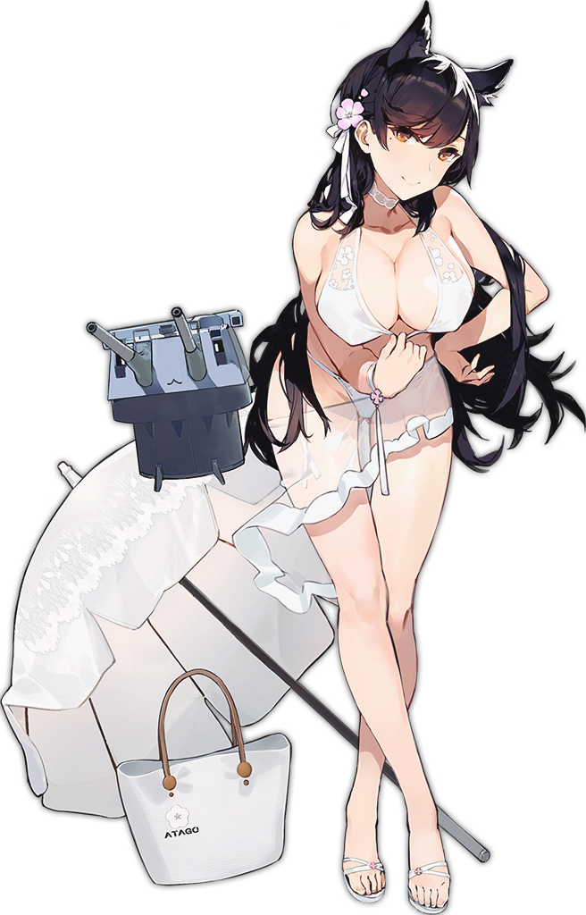
The woman couldn’t help but giggle cheerfully after realizing the antennae was still there. She plucked the antennae from the water, horizontal mount, and all. “What a silly thing to find alongside the beach! I wonder if one of the other girls misplaced it? As their big sister, it falls on my shoulders to return it to them it seems!” Atago had no issue identifying the antennae as a piece of equipment one of her fellow ship girls. After all, she had a few in her collection herself!

“But hmm~! I have to get back to her, don’t I? I don’t want her to get into any trouble. As her big sister, of course!” This elder sister wannabe had no recollection of the fact that she had once been the one being babied like a child. How could she, though? Her body was so sexy and voluptuous, there was no way she could see herself as anything but a young adult.

Without clarifying who this girl she was referring to was, she adjusted her white bikini from wedging her cheeks with her free hand before skipping back to the main beachside area, antennae still underneath her other arm.

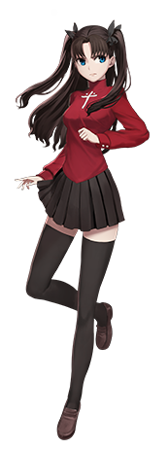
While Illyasviel had been off exploring, Rin had found her way into one of the beachside changing rooms and had managed to change into the crimson bikini she had brought with her. It was a little showy, but that was intentional. Shirou and Sakura were going to be joining the two of them later in the day after his part time job was finished, and she was planning on earning his attention through her looks alone.

“And looks good!” She posed before the full body mirror in the changing room one last time, admiring the curves of her butt and the shapes of her thighs. Rin was never heavy set in the breast area, but she more than made up for it down below. A girl had to work with the gifts that she was given, right? “I hope I’m not getting sick though. Where did this dizziness come from?”

It had come on suddenly, almost like the air itself was abuzz. Thinking it might have been the heat felt from holing herself up in the hut, she locked the cubby she’d chosen for her normal clothes and opened the door…

Only to find a Japanese beauty with what looked like animal ears atop her head, clad in a white bikini and holding what looked like an antennae. Before she could apologize for taking so long (because she assumed the woman needed to use the room), she was suddenly crushed in the woman’s embrace – by the arm not holding an antennae. “U-Um!? Can I help you!?”

Rin wasn’t exactly used to unfamiliar women suddenly embracing her in public. In fact, she wasn’t used to intimate interactions in any capacity. “Why are you squirming? Let big sister hug you to her heart’s content!” The stranger breathed this into the Tohsaka’s ear with enthusiasm, and on impulse Rin managed to squirm free and push her away. Not seeing any other options, she closed and locked the hut door again, keeping the two of them separated. “Shigure-chan!? What’s wrong!?”

Shigure? Who was that supposed to be? “I think you have the wrong person!” Rin replied while backing into the changing hut further. But she was already under the influence of the antennae that had created Atago, and the name ‘Shigure’ would soon become extremely familiar to her.

Seemingly out of nowhere, Rin suddenly tripped. “Woah!?” Or, at least, she thought she had, but she didn’t stumble or anything. She’d assumed solely on the fact that it felt like she was falling, and once the realization that she wasn’t falling forward set in she was left to re-evaluate just why her point of view might be dropping as it was. The strange feeling was worsening as well, and the best she could describe it as a feeling of not feeling comfortable in her own skin.

“Wait, were the cubbies always that high up? I could have sworn I put my things in one that was eye level with me…” But now? The very same cubby appeared to be at a height that she’d need to stand on her very tippy toes to reach. And why did her bikini feel… so… loose…? “AH!? I’M TINY!?”

It had taken the teen a moment to finally realize but looking down at her body she realized that not only was she smaller – but her body was shrinking still. The straps of her bikini were sliding down, forcing Rin to hold them up, while the lower straps barely held on by the mercy of her hips. But if she was shrinking, why weren’t her hips or shoulders pinching inward?

Rin had mischaracterized just what was happening internally, thinking at first that she was shrinking with some consistency, like she was just going to end up a tinier person. But her arms, legs, and torso? These were all the areas that were actually regressing, limbs becoming shorter and everything instead looking a little chubbier by contrast – just because all of her body’s natural weight now had less space to occupy.

Some of that weight was taken away, but not all of it. That meant that, despite her height bottoming out at 4’8”, her arms and legs were fairly squishy. Her hips had shrunk in such a minor way that it was hardly noticeable, while her thighs remained plenty thick if only because that lingering fat still needed a place to settle. But plump thighs, and a plump rear, did not seem particularly sexual on this new frame.

“Wait, am I a kid!?” The squeak of her voice more or less helped prove what she was already assuming, and a single glance spared at her face would promote a similar sentiment. Baby fat had all but returned to her features, leaving cheeks plump and eyes incredibly wide – albeit shining with a red that was closer to Illya’s natural color than Rin’s own blue. “Is that why I feel so… so… What word am I thinking of? A big word…?” Energetic. The word she was looking for was ‘energetic’. Yet her mind, now as youthful as her body, was struggling to grapple with more complicated verbiage. And she was finding that she couldn’t sit still at all.

She rocked back and forth on the balls of her heels, growing more and more confused about where she was and why. Was I playing? No! I’m not a kid, why would I be playing!? Rin’s inner voices really didn’t help things. Bouncing as she was, her bikini inevitably should have fallen from her body with how compressed her childish figure was – short of her breasts, which hadn’t shrunk but ended up looking bigger on this new body thanks to how short she was – but beyond her notice the fibers of it had begun to creep and crawl.

Crimson crawled across her body, its color darkening to dark blue as it coated her breasts, butt, and crotch. Her belly was consumed entirely, ultimately leaving her torso entirely clad in a blue, one-piece swimsuit reminiscent of a traditional, Japanese school swimsuit. It was much more befitting of a girl of her (new) age, and even the black ribbons in her hair had turned white, while still keeping hair bound into two, short twin tails even if the hair’s color remained the same.

“Nununu… I was doing something im…por…tant? Wasn’t I?” Her bare feet practically danced in place now, chubby ankles jiggling with ever step against the floor. Rin was further wracked with confusion as a momentary deafness claimed her, but moments later her sense of hearing returned with the vengeance – alongside a pair of black animal ears atop her head that replaced her animal pair. They were pointed, with white tufts of fur inside of them. Their colors matching…

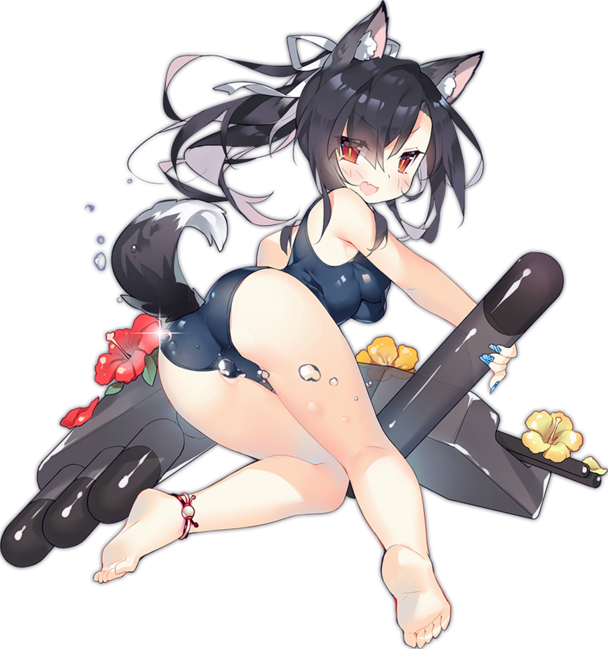
Her tail. Even though the swimsuit covered most of her torso, there had been a single spot left bare, a small circle just above her butt crack. Through this her tailbone lengthened, black fur sprouting from its skin as it extended a handful of inches and flicked upwards. White then grew from its tip, and said tail soon began to wag back and forth with the same boundless energy that the rest of her body was experiencing. Unfortunately, this tail meant it was Game Over for the remnants of Rin’s ego.

“Heheh! This is the best hiding spot! Atago-nee-san will never find me in here!” All of the child’s confusion was promptly swept away by her new, carefree attitude. Not only did she sound like a girl around the age of twelve or thirteen, but she both looked like and was acting like one. The once mature and composed Rin Tohsaka had been transformed into this furry gremlin, and she could hardly remember what she’d had for breakfast – much less the fact she had once been a girl in her late teens.

From what she could recall, her favorite big sister had challenged her to a game of hide and go seek! A game Shigure identified as a master of. Considering she was so small; she could often fit into places most of the other girls couldn’t. Her plumper than normal behind sometimes made narrower spaces a little more difficult though – wearing this one piece swimsuit helped though. But that was why the changing hut was perfect! Atago would never check in here! She’d just assume someone was getting changed! “Shigure-chan! Stop hiding in the changing room! You win! Don’t you want to go for a swim with your big sister?”

“Geh!?” She’d been found out? So easily!? Her perfect plan had been foiled! “Stupid onee-san! I’m not in here!”, she barked instinctively, even though it completely gave her away. “I-I mean! Of course I won! Now my prize will be a dip in the ocean!” A recovery befitting of an idiot, to be certain. If Rin had still held any awareness, she likely would have been distraught by the fact that her keen intellect and her mature appeal alike had been stripped away. On the other hand, Illya might have reveled in her sexy, adult body.

But neither Illya nor Rin were there anymore. It was just Atago and Shigure, two ship girls. And there numbers would increase and increase so long as Atago carried that special antennae around.

Shirou and Sakura would be among them.

