AMERICAN ULTIMATE
COMMISSION STORY
BY CHALDEACHANGE
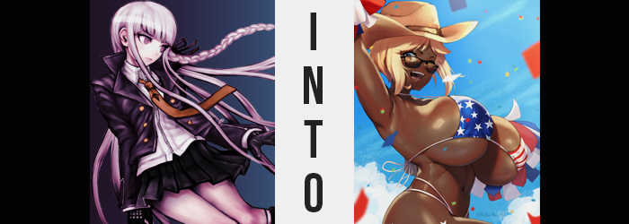

Something strange had happened at Hope’s Peak Academy recently.

Incidentally, there was nothing particularly odd about that statement being taken at face value when it came to Hope’s Peak. It was an exceptional place where exceptional incidents took place regularly. It was the perfect den of mystery for a girl with the title of Ultimate Detective to flex her knowhow. Much to the dismay of some of the school’s faculty, of course. A lot of them didn’t like Kyoko Kirigiri digging around in their business, and there was often a lot of dirty business taking place. You just had to keep an ear to the ground.

But this incident was exceptionally odd even by Hope’s Peak standards. Once of Kyoko’s classmates had mysteriously gone missing the week before. Makoto Naegi. That in itself was strange, but things got stranger still. They’d received a transfer student right after. An American woman who was definitely too old to be their classmate. She had to be a young adult, at least. She also had a very strange Ultimate title.

Ultimate Rich Bimbo? Just what kind of title was that? It certainly matched her personality and skimpy manner of dress, but everyone else was treating her like she had always belonged. That didn’t make a lick of sense. Seeing as she had been friends with Naegi too, Kirigiri ultimately took it upon herself to begin investigating. But it seemed like the teachers were covering for this… bimbo. And so, it was an investigation she had needed to conduct at night.

As such, it was now well after 10pm and Kyoko Kirigiri had been carefully navigating the halls of Hope’s Peak Academy. Students weren’t permitted in the school building after 8pm without special permission, and she knew well enough that the teachers wouldn’t give her that permission on their own considering her recent track record with them. It had more or less become necessary for her to sneak around the campus, dodging security guards and camera alike. All in pursuit of a lead.

The place where Makoto Naegi had last been sighted before his disappearance. The information had just kind of landed on her lap randomly – she had overheard some students in her class talking about it, in fact. That Naegi had mentioned getting an invitation to one of the clubrooms on the night of his disappearance. The ‘Vacation Club’, it seemed? It was on the top floor of the building.

Which meant it had been a real pain in the ass to get there without being seen. “Phew…” Nonetheless, Kirigiri breathed a sigh of relief once she finally managed to open that door and slide inside. There were no cameras in the clubrooms, which was likely why no one seemed to know where Naegi had gone. The teen was quick to get to work, turning on the lights and examining the nearby desks. The room had the ocean painted on one wall and the beach painted on the opposing one. “Fitting for the Vacation Club, I guess.”

Before the detective could make much progress on her investigation, however…

CLICK
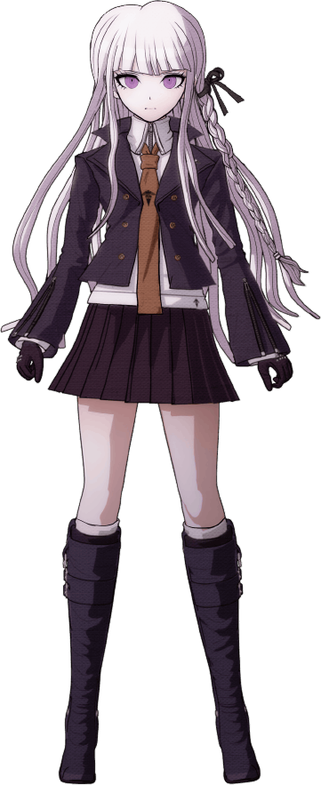
The sound of what could only be the door locking caused Kirigiri to turn to the door in question. On the other side? There was a girl. Kirigiri recognized her from class. “Enoshima!?” She ran to the door and tried to open it. All to absolutely no avail. It wouldn’t budge, and the buxom gyaru on the other side simply smiled and waved without uttering a word. She eventually skipped off on her own. Was she the reason Naegi had disappeared? No. Was she the reason that Kirigiri herself would disappear?

“Shoot!” Because the detective couldn’t not notice it. A hissing sound cried out from the many vents in the room. Gas. If she looked closely, she could see it. It was translucent like a mist. She covered her mouth, but it didn’t really matter. Her skin would absorb it if she didn’t inhale it, and the results would all be the same in the end. It was just that these effects would actually be different from what the girl was expecting. She thought it would knock her out. That wasn’t its purpose.

Kirigiri struggled with the door in an attempt to get it open. It didn’t work, which was agitating. She was so close to an answer. She knew that Enoshima was related to Naegi’s disappearance now. But if the gas knocked her out? She would likely never get the answers she needed and would instead just become another victim of whatever Junko was doing. Was it related to the other rumors she’d been hearing about that girl lately? It was getting harder and harder to think. Because she was losing consciousness? No…

Critical thinking was just harder somehow.

“I must have inhaled some… I feel so darn…” Darn? It wasn’t like she had said a Japanese equivalent of the English word. She’d outright said the word in English. Kyoko vaguely understood its meaning. It was something that Southern Americans seemed to say, at least according to what very well may have been some stereotypes in old westerns. The origin of the word wasn’t realistically that important in the moment, nor why she had said it (despite it being concerning). She had absorbed the gas, so it was inevitable that she was going to black out!

At least that had been her assumption, but this fate never came. The gas even began to thin in the air, the hissing sound dissipating. For a brief moment, Kirigiri wondered if the worst had come to pass. Had Enoshima’s little plan somehow failed? The detective considered the possibility and reached out for the door again, now uncovering her mouth and nose. But she was almost immediately forced to reconsider her analysis of the situation. No, it had been careless for her to come to those conclusions in the first place. A rookie mistake. Like she wasn’t thinking like herself.

“That ain’t right…” Another slip of English. This time consuming her entire sentence. It would become more and more common as the state of her mind continued to alter under the effects of the gas. Her analytical abilities were duller, but that wasn’t the issue here specifically. Her Japanese was actually worsening. Her thoughts were gradually being communicated to her in English instead of her native tongue.

What had caused the girl to re-evaluate things in the first place wasn’t even a mental difference she had noticed. She hadn’t really noticed anything that had transpired in her mind. But she had been taken aback by the sight of a hand that looked much, much darker in color than it should have. Her complexion was usually so pale, but there was a chocolatey brown demonstrated in fingers that likewise seemed to be a little longer. Not to mention bonier. “My skin ain’t supposed to, like…”

Wait. Why was her skin showing in the first place? Where had her gloves gone!? Both of her gloves were gone and the scarring was gone from her hands. No, her jacket and top had disappeared too? This allowed her to watch the darker skin color travel up her arms. Only her underwear seemed to remain on her body, and because of this it was easy enough to see that it wasn’t merely her arms succumbing to this extremely unusual phenomenon.

It had begun in her feet, too. Feet that swelled a little larger. This darker skin tone traveled up her legs just as it did her arms, but all of her limbs appeared to succumb to the same snag around the same time. The coloring seemed to linger for a moment without any signs of movement. “Eh!?” And it only took the teen a moment to figure out why that was. Looking at a nearby desk, she could tell it was farther away from her point of view than it had been before.

“I’m totally getting’ taller ‘n’ stuff!” There was a lot to unpack in just her words alone. Kirigiri was speaking in fluent English entirely. A Southern accent was strong in her speech now, but she also sounded vapid somehow. Like some sort of bimbo. Realistically this aligned with what could best be described as a ‘dumbing down’ of her thought processes. How could she be a detective when she hadn’t the foggiest idea what could even be used as evidence in a case anymore? But she’d forgotten things that were even more fundamental than that.

In the first place? She wasn’t even wrong about what was happening to her body. Her limbs and torso had all stretched longer, supplying a rather gratuitous enhancement to her overall build. She’d originally been 5’6” but must have been much closer to the six foot mark by the time the vertical growth came to cease, and her body was almost entirely darkened to this new shade, nipples and all. “Or have I totes always been this dang height?” She somehow didn’t sound sure of it.

What was for certain was that Kirigiri’s changed skin tone was actually part of a greater racial change – one that was made obvious once the chocolate coloring finally crept up her neck and into her face. Her facial features rapidly matured, granting her a pair of lips that were far plumper than should have been possible for a teenager, but the reshaping of her eyes, jawline, and cheekbones all suggested that she was no teenager. She had to have been a woman in her early twenties. And she was, likewise, black. An African American.

The coloring of the woman’s hair darkened first to black, but quickly lightened again. Not towards her original violet color, but towards a sandy blonde that could only really have been the product of an excess of hair dye while, at the same time, the long length retreated into a short bob. You could tell by how the color had faded in her roots, making it seem like she had dyed it a long time ago. “Actually… I gotta be due for a recolor, right? It’s sure been one hell of a while since the last time! LMFAO!” From the way she talked, was she a redneck or a bimbo?

Realistically? It seemed like she was both.

For a country bimbo, though? While she was extremely tall, it felt like she was missing a little something. Or a lot of something, really. She still had the lacking figure of a teenaged girl, darkened skin or not, and her unchanged undergarments still fit her properly. But naturally, this was but a fleeting ‘issue’ (if it could even be referred to as one). Eyes went wide as she felt another change growing in, and this made it easy to see how her irises had shifted to a yellowish brown.

“Oh!? My ass!?” The sudden sensation of her booty growing heavy almost sent the woman stumbling backwards. She managed to catch herself and arch her back simultaneously, catching sight of her dark skinned rump expanding excessively out behind her. Burgeoning cheeks were amply padded, which in turn pushed out her hips until they were practically Hartmann shaped. Undergarments struggled more and more to contain this full butt, but their fit eventually loosened as the cloth appeared to change. The sides thinned into straps while the front? Cloth hardened into latex, and white cotton darkened to blue with white stars on it. Like the bottom of a swimsuit.

By the time her ass extended nearly six inches out behind her from the back, her thighs had thickened in a similar manner so that they were plump and plush. But Kirigiri’s figure wasn’t only being enhanced down south, and the cups of her bra could be seen suffering a change similar to what had befallen her panties as the once small mounds beneath them showed signs of growing, and growing…

And growing. “Wowzers!?” Or so she cried out vapidly as hands slid underneath what was soon becoming a star spangled swimsuit top. The cups could barely cover tits that were growing so heavy that her posture passively leaned forward, and the impressions of nipples that rivaled her eyes in size were visible well before the growth of her tits themselves reached their conclusion. The woman couldn’t stop herself from fondling her heft and twerking her nipples. Before long? Not only did they rival her head in size, but each breast surpassed it. Even the slightest breath saw to it that a visible ripple jiggled through them while she heaved. But from her perspective? Her tits were supposed to be that big. It was expected.

Several accessories ended up appearing out of nowhere. A cowboy hat for one, and a pair of sunglasses being the other. She looked dressed for the beach, but there wasn’t really a beach to be seen. That didn’t tame her enthusiasm at all, though!

“Yeehaw! I’m so darn excited to hit the beach!” Kasey Kobalt couldn’t contain her excitement any longer as thoughts of the beach overwhelmed the mental faculties that just barely remained after her extremely dramatic IQ loss. She was now every bit the American bimbo that the boy she had originally been searching for had been. But she couldn’t even remember that. She was the Ultimate Rich Bimbo as an old friend. As one of her own! Kasey herself was the Ultimate Beach Bimbo, after all! A beach obsessed babe from rural America.

Once her tanned tits finally stilled after that big bounce of hers, the bimbo looked around with confusion. “Uh… It’s, like, pretty late y’all, ain’t it?” Who was she talking to? Herself, mostly. But she had finally noticed that she was not at the club during its usual hours. It was clearly nighttime through the windows, and she was the only one present. There also weren’t any signs of the gas that had transformed her. Not that she would have been smart enough to put two and two together in the first place.

“Late… I suppose I can totally make this work ‘n’ stuff, though. Wonder how many of the boys are still up?” Bimbos would be bimbo-ing. Kasey was just as accepted by the student body as the Ultimate Rich Bimbo had been. She was allowed to walk around all day in only a skimpy American bikini, glasses, and a cowboy hat. She was allowed to attend classes despite being in her early twenties. She was allowed to participate even though her Japanese language knowledge was practically nonexistent.

And what was just as accepted by her peers? Her horny nature. It was embraced, in fact. She had a habit of fucking other students and the teachers, and the beach bimbo took no issues with being a human fleshlight for any man so long as she was in the mood. And Kasey was often in the mood. So, with her tits bouncing wildly about? She let out one more “YEEHAW!” of dumb excitement before storming out the door.

She was on the hunt for some dick!

“Upupupu! And that’s another thorn out of my side!” Junko Enoshima laughed her stupid laugh to herself as she watched the tanned American woman bounce out of the Vacation Club’s clubroom. She was naturally responsible for Naegi’s ‘disappearance’ just as she would be for what was now Kirigi’s sudden ‘disappearance’. It had all gone so swimmingly! “Who knew the best way to get rid of people that might be problems would just be to… make them women who would never be a problem?”

Because what were some stupid, horny bimbos going to do about her plan? Absolutely nothing! Those two were stuck craving dick and nothing else now, they would never catch on to what she was planning. There was just one very big problem with this plan of hers. Someone else had planted a trap with the very same gas. And that trap was aimed at Junko and her sister, Mukuro.

It was just a matter of them stepping into it, now.

