COLOR THEORY
COMMISSION STORY
BY CHALDEACHANGE
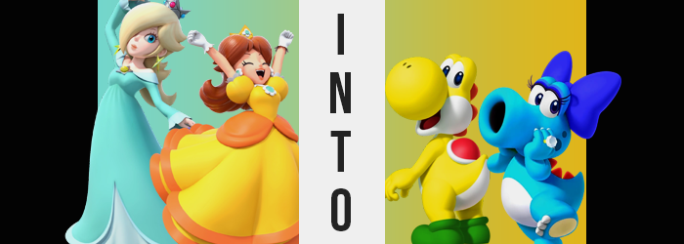

The Mushroom Kingdom certainly was no stranger to sporting events.

In fact you could possibly argue the opposite, that too many of them were held throughout the year. It was something of an obsession on the part of the kingdom’s princess, Princess Peach, and ultimately? It was a harmless trend that was born from good will instead of tyranny. In the eyes of Peach her kingdom, and the kingdoms that shared her world, were full of so many diverse and interesting peoples.

Under the banner of an event like a sporting outing you could gather everyone willing to participate and have them compete in a friendly manner, which in turn improved the relationships between everyone. Even King Bowser of the Koopas had been attending for a while now! …Why he was allowed considering he continued to attempt to kidnap the princess was anyone’s guess though.

The leaves of autumn had begun to fall which signaled the arrival of that season’s first sporting event. Every September the tennis tournament was held because the weather was cooler but still warm enough to move about outside still. Typically people could sign up in teams of two, but this year? Peach had added a stipulation that the teams would be randomly drawn from those that wished to participate.

Another step to ‘further the bonds between kingdoms’.

“Ha… Ha… This just isn’t working! Why do you keep flying into me Ro-sa-li-naaaa!?” For most of the drawn pairs this was fine, but for others? Like was the case with Princess Daisy and Princess Rosalina? It appeared that it was spurring forth more difficulties than there were benefits. Only a few hours of their first day of practicing as a team had passed by and it became clear that they were severely lacking in the synergy area.

Even playing with a ball launcher on the other side of the net the two women were practically tripping all over each other. Maybe it was because Rosalina was floating and didn’t leave any footstep noises but Daisy just couldn’t manage to figure out where she was moving unless she was looking right at her! “But if I run I’m more likely to fall over. Hm…” Rosalina could recognize the problem, but a solution…

She had one, didn’t she?

The space princess held out her palm and blue energy began to form upon it. Moments later? A pair of rings had taken shape. One that had a small diamond that glimmered the same yellow as Daisy’s dress, while the other glimmered a blue not unlike Rosalina’s. “These are communication rings from a distant planet. Supposedly wearing one with the favorite color of another person is enough to increase your bond and level of coordination.”

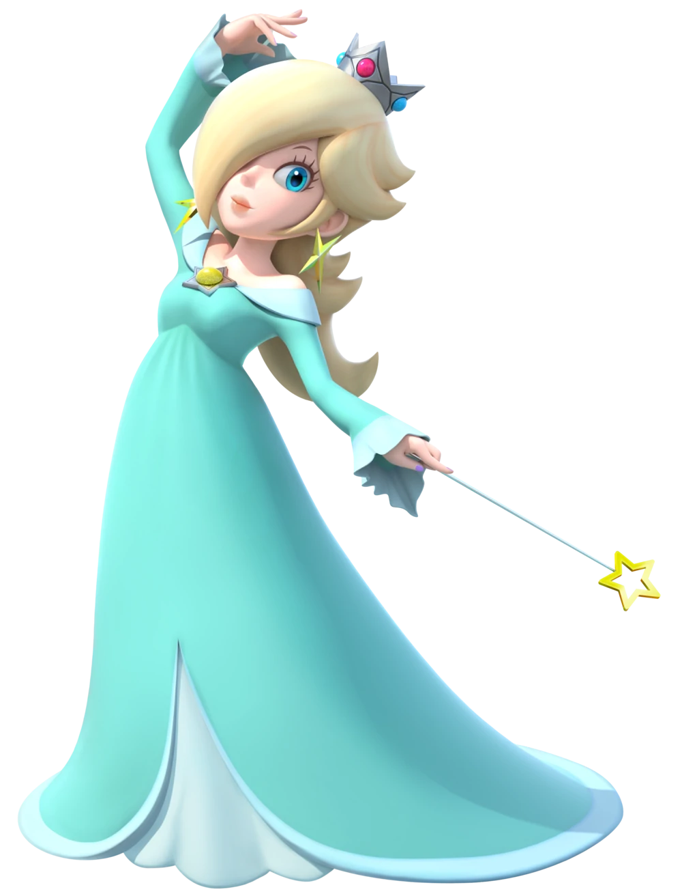
“That sounds a little too good to be true, don’t you think!?” Daisy was a doubter even though she lived in a world where powerups existed. Nonetheless, she snatched the blue ring and slid it on her ring finger over her glove. “I don’t feel any different…” Rosalina put on the other ring in the meantime, intent on explaining further once she had. The princess of Sarasaland didn’t give her a chance before running off the court. “One sec! I wanna grab some water!” And she disappeared behind the door.

Rosalina was left blinking her eyes for a moment. That woman had so much energy that she couldn’t really keep up with her. Maybe that was part of their problem? The thought brought her attention back down to the ring upon her finger. The yellow diamond had begun to glow? She supposed that was supposed to happen.

Or at least she did right up until the moment when she realized the ring felt uncomfortably tight. “Erm…?” Looking down at the ring and the hand it was connected to, she could only ask herself internally if something was wrong with her skin. Not only did the skin of her fingers appear a tinge yellow, but each digit seemed a little swollen too. That was why the ring felt so tight! Was she allergic to the metal the band was made of? That certainly would have been a sensical assumption…

If not for the fact that it seemed to be spreading into her palm. And if the very same effects weren’t being replicated on Rosalina’s other hand, which wasn’t even wearing a ring. “Oh dear!?” Spreading out both hands in front of her, the sight of them continuing to swell became more and more alarming. Already each hand was twice its original size with each digit the thickness of a sausage. Fingernails were shed as the skin brightened to an almost banana yellow, but that skin was also unnaturally shiny?

Rosalina brought one closer to her face and squinted. “S-Scales!?” That’s what they looked to be. Her skin had very tiny grooves in between these spots so that they appeared scaled; but only if you looked closely enough at them. Pinkie fingers merged into the fingers beside them too, leaving the woman with only four fat, scaly, yellow fingers upon hands that could likewise be described that way. They certainly didn’t look human.

That said, neither did what was happening beneath her skirt. The fancy heels that the princess wore had long since been forced off of her tootsies and for good reason at that. The toes and soles within had undergone a phenomenon similar to what had been transpiring with her hands at the same time. Bloating, growing, and merging alike as a bright yellow washed over them. Rather than form four sausage-shaped toes however, they instead took on a trio of rounded bulbs that had excellent grip.

CRACK!

“Oh no-shi!” Rosalina hadn’t quite grasped what was happening but she had easily understood that it was the ring’s doing. If she could remove it then she might have been able to stop and undo what had been done! But her finger had grown much too big for the ring’s band and ultimately? The ring and the gem upon it exploded into tiny pieces in a process that seemed unnatural. And while for a brief moment she had believed this might have brought the process to a halt? It most certainly did not do that.

The opposite happened and the process seemed to speed up. Before long the woman found her posture leaning forward, yellow scales continuing to spread across her body even where she couldn’t see them. The traveled up her arms, and as they did so? Inches were shaved off those arms so that the sleeves of her dressed bunched up but also tightened, for they were afforded no other choice by the fact that the arms were thicker.

Meanwhile her eye level was pulled closer to the ground – once thought a side effect of her posture hunching forward, but promptly recognized as a change beset upon her by her legs becoming shorter. You could easily see this by how her skirt was dragging against the ground now. Not only were those legs about half the length that they had been before, but on top of that the length that remained had swelled to a rather girthy thickness. Any femininity to her gait was erased as a side effect of this.

The woman attempted to move, but with limbs at new lengths and her posture more bizarre she found it difficult to do so. Each movement felt heavy and clumsy. “What is happening to YOSHI!?” Rosalina had wished to cover her mouth so badly after blurting that out. The sound of a creature that she was wholly aware of. One that had scales, and came in many different colors… “Is Yoshi becoming a Yoshi!?” It had happened again!

“Urp!?” Whether because of gas or something else entirely, her mouth opened to burp all of a sudden. She felt bloated, and upon examining the front of her gown it was an easy task to understand why that was. Her once trim waistline was pushing forward, a verifiably round bump pushing out where her stomach should have been beneath a chest that was now strangely void of any nipples or breasts whatsoever. To be fair it was still her stomach, yet it was one now covered with white scales that also reached up the front of her neck and now wrapped around the lower half of her face.

It was becoming difficult for her to stand up straight now that her body shape was thicker, shorter, and rounder. Of course the emergence of a tail where her ass had once sported two cheeks didn’t exactly help with how it lifted up the back of her skirt. Internally? She became able to produce eggs, even encasing anything she ingested through her mouth in one before shooting it out of her rear end. You know, typical Yoshi stuff with non-horrific implications. You could also make out the shape of a saddle-like shell upon her back through the stretching, blue fabric. This shell was red in color with a white outline.

Hair fell from the woman’s head despite desperate attempts to try and catch it with her grubby, golden digits. Her bald head was just as yellow as the rest of her body’s sides and back, and those yellow scales wrapped around her eyes while red spines went down the back of her neck. “No, I— MMM! – I don’t YOSHI!” Speaking, at least in a human tongue, had become more and more difficult for Rosalina.

She coughed, cheeks puffing out not from a buildup of air but because something physical had filled her mouth without warning. “BADUM!?” Guided more by instinct than anything she shot the source out of her mouth, soon tasting the nearby tennis court floor. Because her tongue, now long and ropey, had shot out about ten feet before landing limply on the ground. The woman realized she knew how to bring it back into her mouth and when she finally managed? It fit snugly. “Yoshi!?”

Eyes and nose alike began to bulge next, signaling the near end of Rosalina’s suffering. Her nose lost all of its definition and became a yellow ball with nostril near its top, growing practically to the size of a second head atop her face before it settled into place. She could smell much better, but she didn’t want to consider the pros in the moment. As for her eyes? They bulged and rose, taking up almost all of the upper part of her head. There was no forehead and she was lacking ears.

In a blink her dress was stripped from her and the only thing she was left wearing was a pair of big, green shoes.

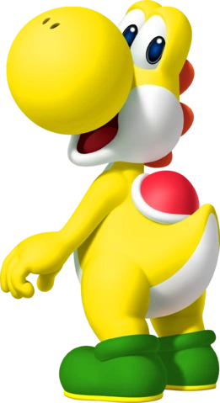
“Yoshi!?” That wasn’t an attempt on Rosalina’s part to express her surprise at the fact that she had, in fact, become a Yellow Yoshi. Instead it was the only word she could seemingly articulate as knowledge of the human language had been sapped from her understanding. Her body remained hunched over and she was still struggling to keep that massive tongue of her inside of her reptilian mouth. Each step felt clumsy with her new, round build.

And she couldn’t stop thinking about how hungry she was. Not for just anything. For fruit. The more colorful the fruit was the better! As hard as she tried to keep her head straight that desire just simply continued to resurface. “Nnn… NNN!?” But she couldn’t think of where any fruit might be found on the tennis court! That was an important distinction too. While Rosalina was acting like a Yoshi, Yoshis weren’t inherently stupid.

She could still think critically and remember who she was, but she had to deal with her new Yoshi instincts. Which were, at times, extremely overpowering. Was this all because of the ring that now laid broken on the floor. But wait…? “YOSHI!?”

What had happened to Daisy then!?

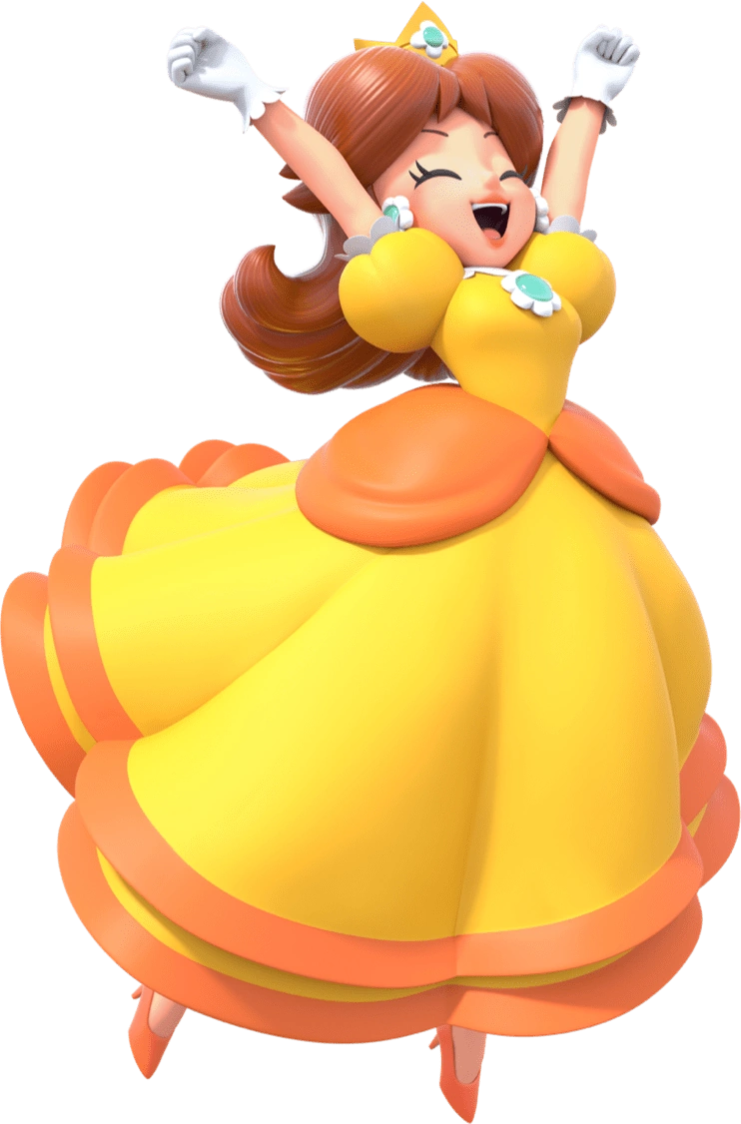
“A ring, huh? No idea how that’s gonna improve our coordination, but I guess it wouldn’t hurt to try.” Princess Daisy certainly had her doubts about the ring plan that Rosalina had proposed before she’d slid out into the hallway to grab a drink of water from the fountain. She was quick to perform that task, not noticing that the blue diamond had begun to glow in the meantime. Daisy must have been a lot thirstier than she had thought because she couldn’t help herself from continuing to slurp, and slurp, and slurp…

Eventually she pulled herself away though. “Much better! Maybe all we needed was a break? I’m probably blaming Rosalina for too much. It’s on me to help coordinate too…” She had a penchant for letting her emotions get the better of her at times only to recognize her folly later on. When she had resolved to go back and apologize was when she finally noticed. “Huh. Is the diamond glowing? Does that mean it’s working?”

Technically yes?

“OOOOOO! Whath!? WHATH WRONG WIFF MY FATH!?” Having intended on following up with her question, Daisy had promptly found herself both making an O-sound through lips that she couldn’t force out of an O-shape. It was as if her lips had been permanently puckered into a circle and try as she might? She couldn’t seem to force their shapes back to normal. No, it was worse than that. She could feel her lips being pulled farther and farther away from her mouth… and those lips were growing thicker.

A bead of drool dripped from the circular hole with both of her hands now raised to try and feel it out. She could see those lips pulling forward and not only were they farther away and thicker, but they had turned a bright, sky blue. “MMF!? MMF— HONK!?” Unable to form words any longer, not helped by her nose merging into this larger orifice, Daisy’s bluing cheeks turned purple with blush when she finally honked instead.

Her O-shaped mouth widened, stretching until it was just as wide as the rest of her face. She was having problems feeling inside of it with her tongue, and in fact was her tongue numb? The thought had crossed Daisy’s mind, but she couldn’t ascertain the truth. That her tongue was gone, as were her teeth. The inside of this strange, protruding mouth of blue was pitch black – useful only for sucking things up… or shooting them out.

Daisy was battered by a number of realizations back to back that weren’t exclusively reserved for her new mouth. That hands that had been exploring its sides and gap? She could see the same sky blue coating fingers that were thickening and merging, ultimately leaving her with three fingers on each hand that were decorated by white claws. Yet the ring she was wearing had not exploded like Rosalina’s. It had adjusted to fit her middle finger and the diamond had grown. The same transformation that afflicted her hands had plagued her feet in the end too, for they exploded from her heels with matching claws, their soles flat and padded.

“BWOW!? BROWR!? BWOB!” She wanted to cry out so badly but found herself incapable of making these strange, honk-like noises. The princess had heard them before but she didn’t want to admit the source because that would be tantamount to accepting that she was becoming one of them. “HONK!?” Another honk was sounded, this time because her body had dipped in height thanks to her arms and legs becoming shorter, stumpier, and thicker.

Finally finding the necessary sense to examine one of her clawed hands, she noted through eyes that felt increasingly swollen that her bluer body was covered with scales. The only place where this color wasn’t present was across her white-scaled belly beneath a blue bosom that was… decreasingly like the chest of a mammal. Her breasts flattened into a torso that was rounding and bulging in a different way, tears sounding thanks to her shorter body expanding into a bulbous shape not terribly different from a Yoshi’s.

She even sprouted a similar tail, though red spines ran all of the way from it to the back of her neck. Daisy’s back didn’t have the same hump shape even despite being just as reptilian as a Yoshi. Then again, Yoshis didn’t have mouths like hers in the first place. “Bwow…” A burst of depressed-sounding air was exhaled through her toothless, horn-like maw.

Her beautiful brown hair fell from her shoulders to reveal a bald, blue head that was shape more like her eyes. This was unsurprising as they’d been growing larger over her transformation’s course, taking up almost the entirety of the top half of her head much like Yoshi Rosalina’s had. But she retained her eyelashes in a big way, with them growing longer and thicker upon eyelids that were noted with dark mascara. Otherwise? The bottom half of her head was rounder on the sides before bleeding into this new mouth of hers.

And then she was naked. Naked aside from her ring and a big, blue bow on the top of her head.

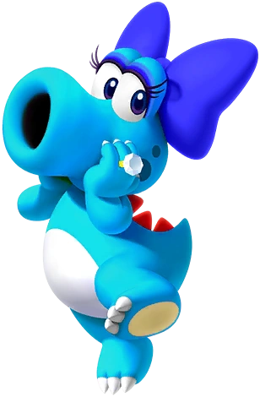
“Bwow!?” Try as she might to do otherwise, the only sounds that Daisy could make with her thick, O-shaped mouth were unusual honks and squeals that only made sense coming from a… Well, she had already figured out what had happened to her. She’d become a Blue Birdo. One wearing a big, regular diamond ring on the finger where the special ring Rosalina had given her had been. “Bwow worw!?”

While still bipedal, this new body of hers was difficult to move in. Her weight was distributed differently – her tummy bulged out and both arms and legs were shorter and chubbier. Not to mention the weight of her big head! It felt bizarre to have a toothless, tongueless mouth too. One she couldn’t close. But she had the strangest urge to shoot something from it. An egg? “BWOR!”

She promptly pushed her new Birdo instincts aside. Why had this happened to her!? How was this supposed to help Rosalina and herself perform better on the court? A few wobbly steps were taken towards the door with her scaly feet before she eventually found her stride. Little by little it was getting a little more comfortable to move about, and wasn’t she pretty cute like this?

Birdo could be pretty vain creatures, and that vanity had clearly been passed on to the newest, bluest member of their people. She eventually strut confidently back onto the tennis court only to find… A female, yellow Yoshi? Wait… “Bwow?” Could that have been Rosalina? Considering she had worn the blue ring and had become a blue Birdo, then…

“Yoshi!?”

The two, after getting used to their new bodies, would miraculously go on to win the entire tournament! Whether or not they could ever go back to the people they had been before, though…

That was something that Peach would come to study.

