**Organic Chemistry 1 Final Exam**

**Worksheet**

Organic Chemistry Tutor

1. Which of the following functional groups is not found in the molecule shown below?

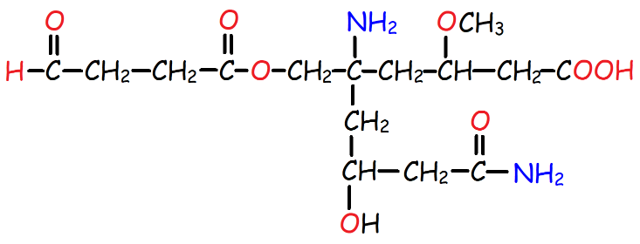

A. Ether

B. Ketone

C. Alcohol

D. Amine

E. Aldehyde

2. What is the IUPAC name for this compound?

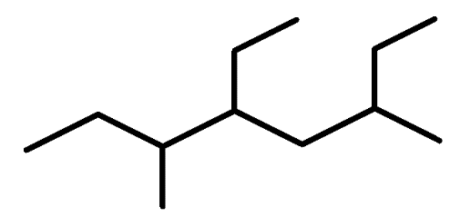

A. 5-ethyl-3,6-dimethyloctane

B. 4-ethyl-3,6-dimethyloctane

C. 2,4-diethyl-5-methylheptane

D. 4,6-diethyl-3-methylheptane

3. Which of the following carbocations shown below is most stable?

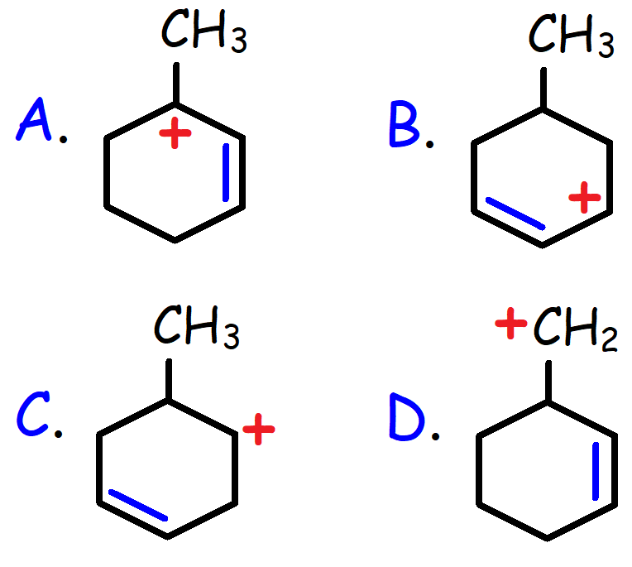

4. Identify the hybridization of the indicated atoms shown below from left to right.

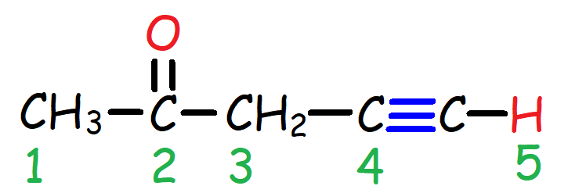

A. sp2, sp3, sp2, sp, sp3

B. sp3, sp2, sp2, sp, sp

C. sp3, sp2, sp3, sp, s

D. sp3, sp2, sp3, sp, sp

5. Which of the following Lewis structures contain a Sulfur atom with a formal charge of +1?

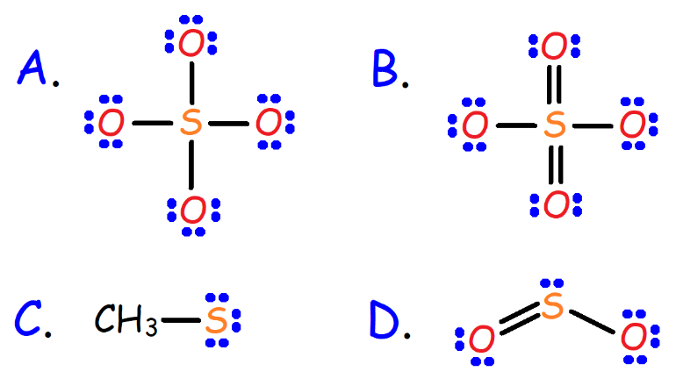

6. Which of the following represents the best Lewis structure for the Cyanide ion (-CN)?

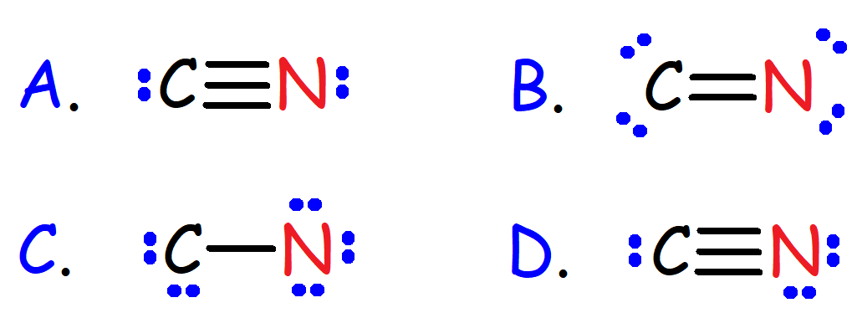

7. Which of the following represents a pair of resonance structures?

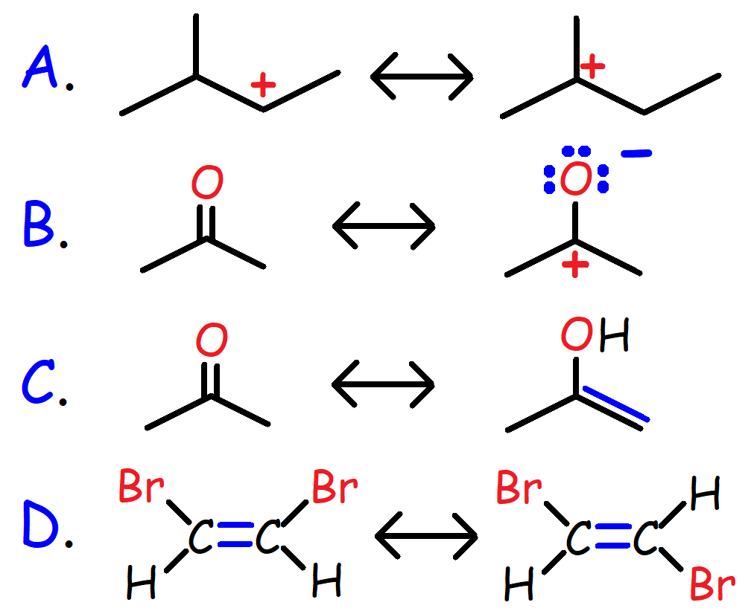

8. Which of the following would best act as a Lewis base?

A. CH3COCH3 B. CH3 Radical

C. BH3 D. H2O

9. Which compound is the strongest acid?

A. CH3COOH

B. CH3CH2OH

C. C6H5OH

D. CH3NH2

E. CH3SO3H

10. What is the IUPAC name for the compound shown below?

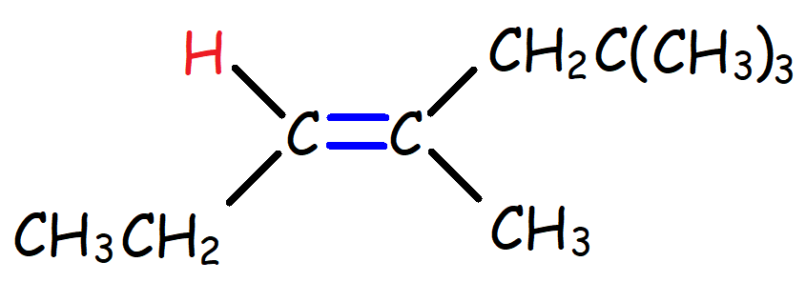

A. (E)-4,6,6–trimethyl-3-heptene

B. (Z)-4,6,6-trimethyl-3-heptene

C. (E)-2,2,4-trimethyl-3-heptene

D. (Z)-2,2,4-trimethyl-3-hexene

11. Which of the following molecules has the S configuration?

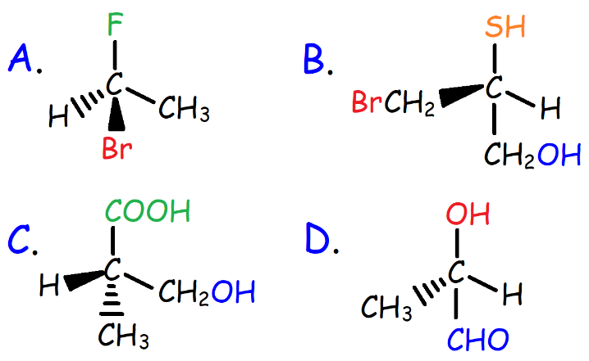

12. Which reaction will generate a pair of enantiomers?

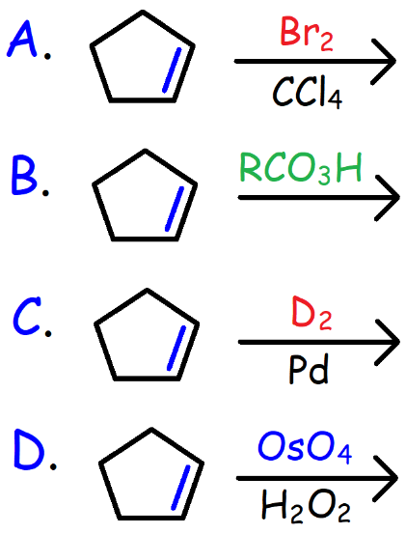

13. Which of the following Newman projections represent the most stable conformation of (CH3)2CHCH(CH3)CH2CH3?

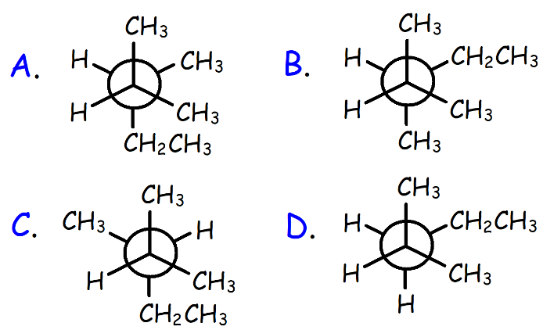

14. Which is the most stable conformation of trans-1-fluoro-4-methylcyclohexane?

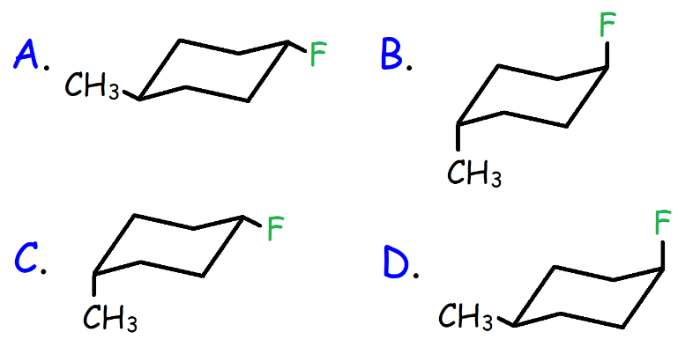

15. Which reaction will produce a racemic mixture of chiral products?

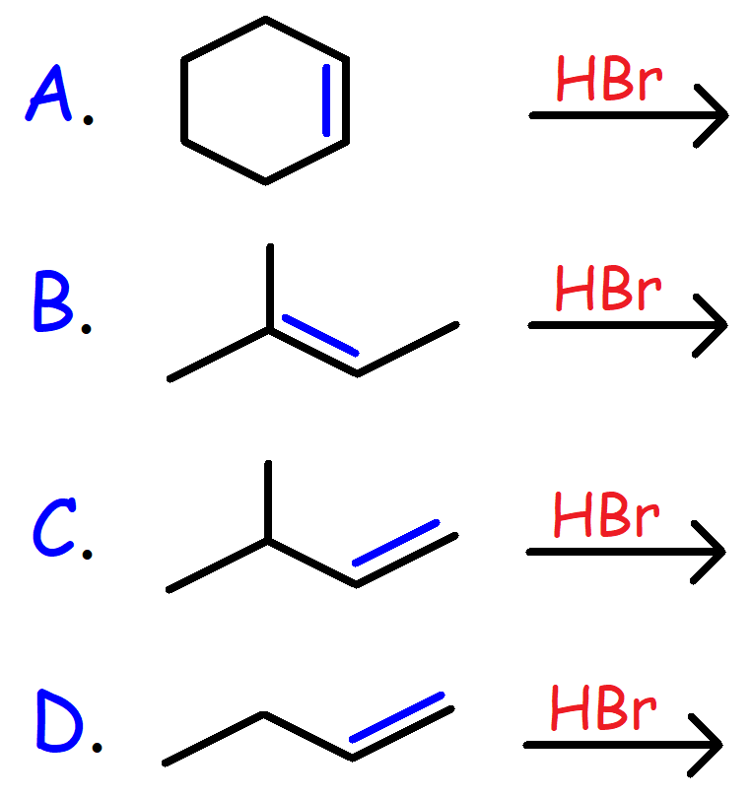

16. Which radical is most stable?

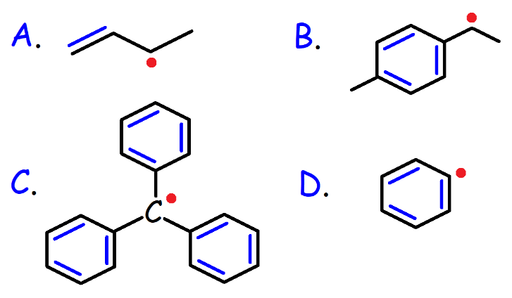

17. Which proton is most acidic?

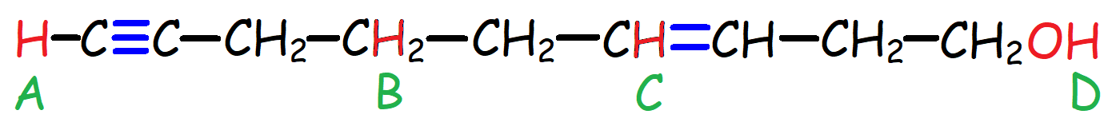

A. Proton A B. Proton B

C. Proton C D. Proton D

18. Which halide will react most rapidly with a hydroxide ion in a SN2 reaction?

A. (CH3)3C-Br

B. CH3CH2CH2CH2-Br

C. CH2=CHCH2-Br

D. CH3CH=CH-Br

19. What is the major product that results when (R)-2-Bromobutane reacts with NaI in Acetone?

A. (R)-2-Iodobutane

B. (S)-2-Iodobutane

C. 1-Iodobutane

D. Racemic Mixture of A and B

20. Which reagent will produce the product shown below?

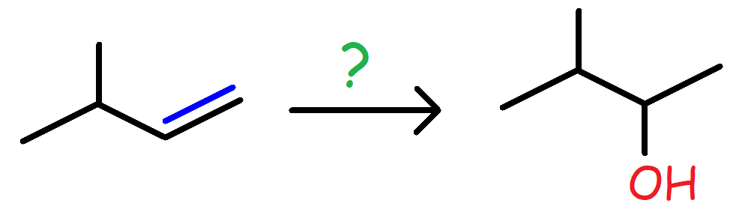

A. H2O, H+

B. BH3/THF followed by NaOH, H2O2

C. MCPBA followed by H3O+

D. Hg(OAc)2, H2O followed by NaBH4

21. What is the major product of the reaction shown below?

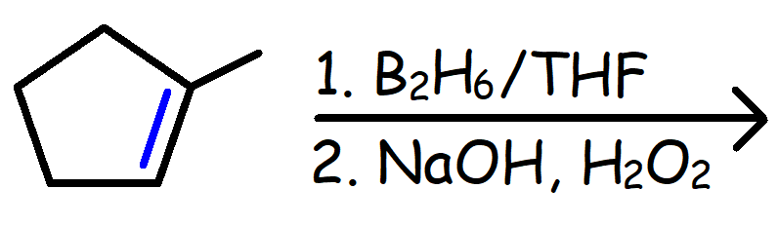

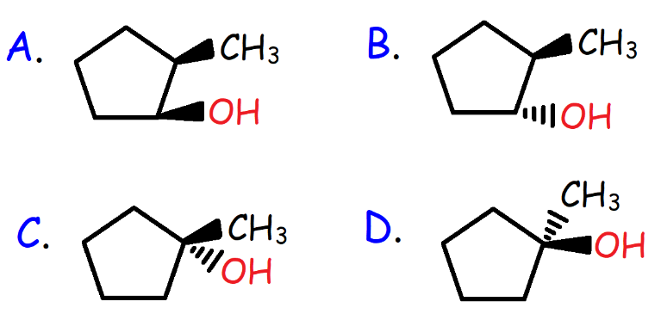

22. What is the major product from the reaction of Propene with Bromine in Water?

A. CH3CH(Br)CH2OH

B. CH3CH(Br)CH2Br

C. CH3CH(OH)CH2Br

D. CH3CH(OH)CH2OH

23. Which of the following represents a free radical termination step?

A. CH4 + Br* --------> *CH3 + HBr

B. Br* + *CH3 --------> CH3Br

C. Br2 + *CH3  --------> CH3Br + Br*

D. Br2 --------> 2Br*

24. What is the major product of the reaction shown below?

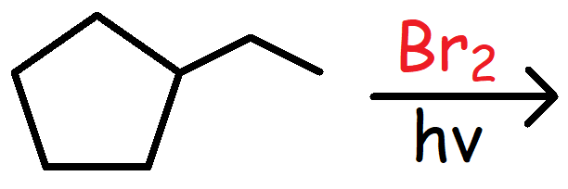

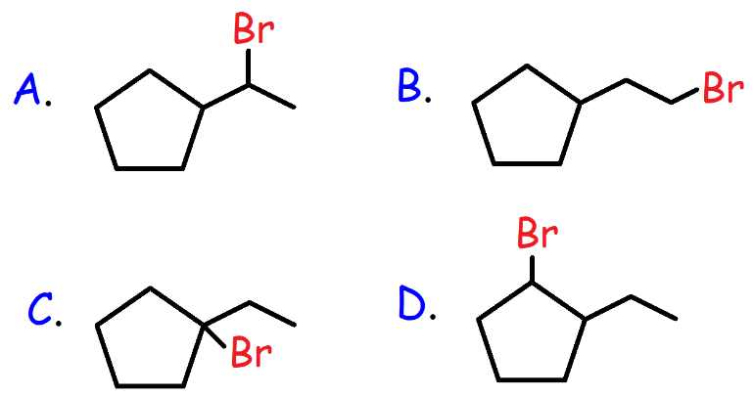

25. What is the major product of the reaction shown below?

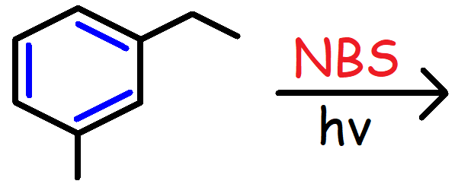

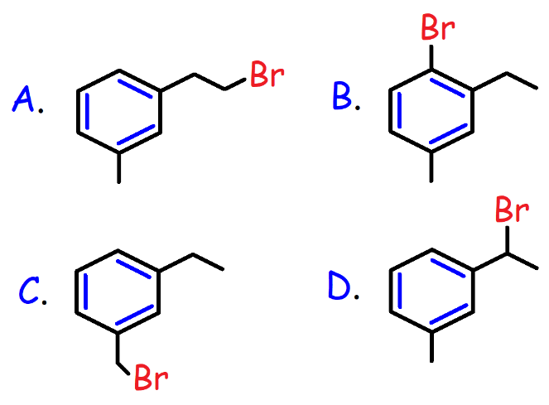

26. Which acid has the lowest pKa?

A. CH3CH(OH)CH3

B. CH3CH(NH2)CH3

C. CH3CH(OH2+)CH3

D. CH3CH(NH3+)CH3

27. What is the IUPAC name of the molecule shown below?

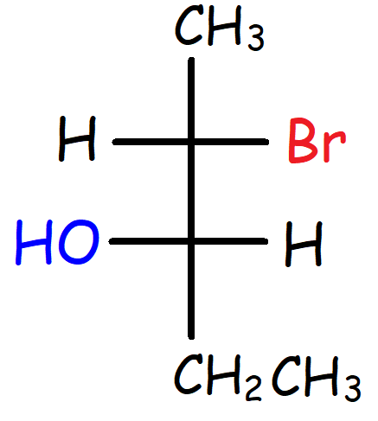

A. (2S, 3S)-2-bromo-3-pentanol

B. (2S, 3R)-2-bromo-3-pentanol

C. (2R, 3R)-2-bromo-3-pentanol

D. (2R, 3R)-2-bromo-3-hexanol

28. Which reaction will produce a meso product?

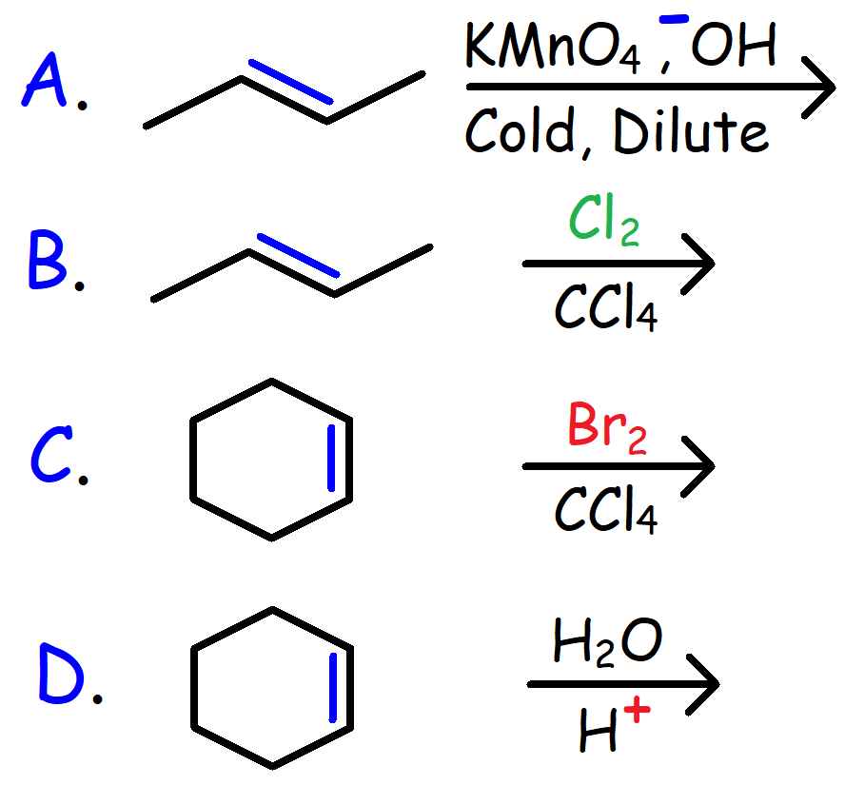

29. Predict the major product of the reaction shown below.

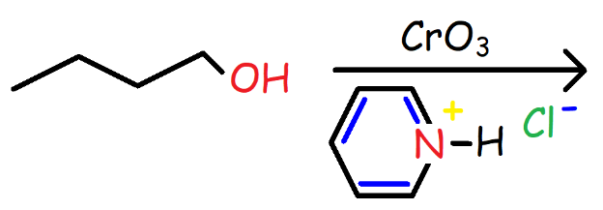

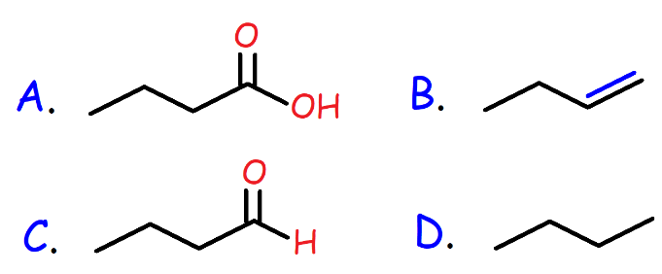

30. Which reagent will convert 2-Pentyne into Trans-2-Pentene?

A. H2, Pt

B. D2, Pd

C. H2, Pd/CaCO3

D. Na, NH3

31. Which of the following reagents can produce the product shown below?

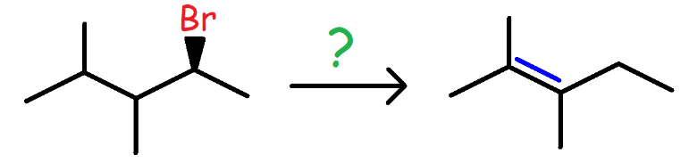

A. NaOCH3/CH3OH

B. NaSCH3/DMF

C. CH3OH, Heat

D. (CH3)3COK, (CH3)3COH

32. Which reactant will not produce the product shown below?

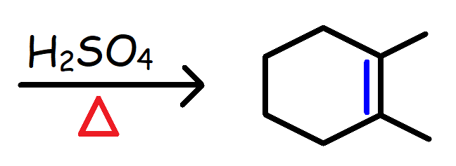

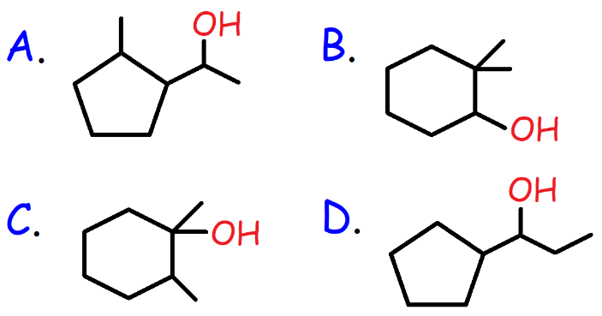

33. Which molecule will undergo solvolysis by a SN1 reaction mechanism the fastest?

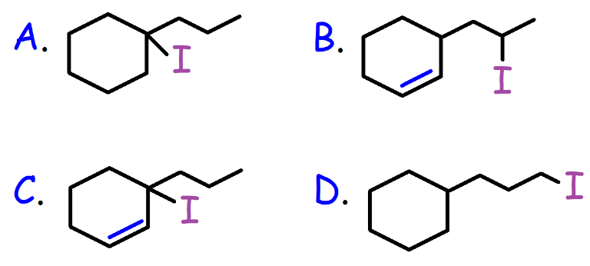

34. Which reagent will produce the product shown below?

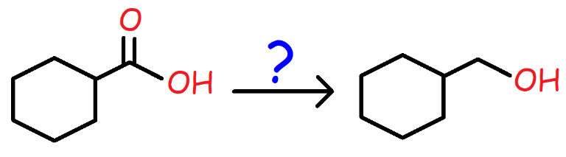

A. NaBH4

B. DIBAL

C. LiAlH4

D. CH3MgBr

35. Identify all possible products of the reaction shown below.

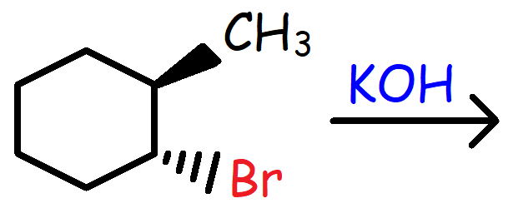

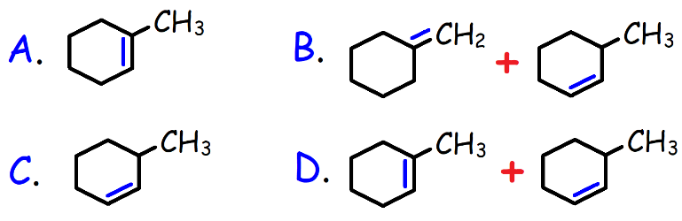

36. Identify all possible products that can be formed in the reaction shown below.

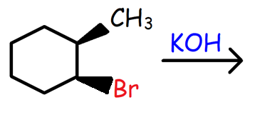



37. What is the effect on the rate of the reaction shown below if the volume of the solution is tripled?

I- + CH3CH2-Br -----> CH3CH2-I + Br-

A. The rate will increase by a factor of 3.

B. The rate will increase by a factor of 9.

C. The rate will decrease by a factor of 3.

D. The rate will decrease by a factor of 9.

38. What is the product of the following reaction?

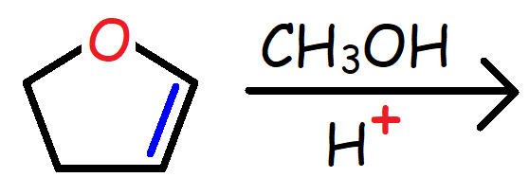

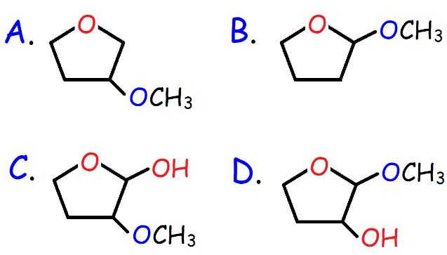

39. What is the product of the reaction shown below?

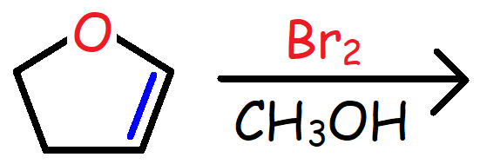

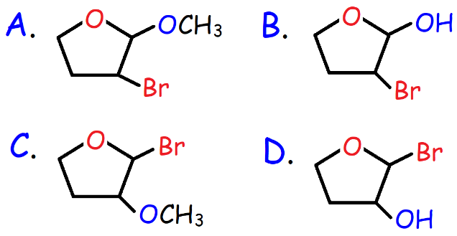

40. Which of the following reagents will produce the product shown below?

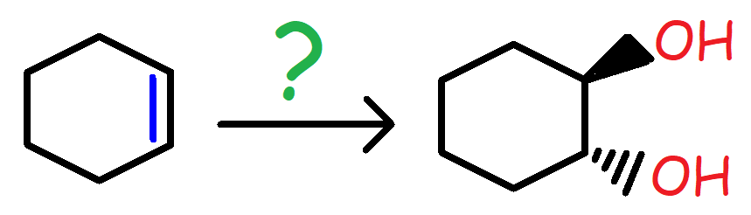

A. OsO4 followed by NaHSO3

B. KMnO4, OH-, Cold, Dilute

C. Zn(Cu), CH2I2

D. MCPBA followed by H3O+

41. Which of the following reagents will convert 1-Butene into 1-Bromobutane?

A. Br2 / CCl4

B. NBS

C. HBr / Peroxides

D. HBr

42. What is the product formed in the reaction of Propyne with HgSO4, H2SO4, and H2O?

A. CH3CH(OH)CH3 B. CH3CH2CH2OH

C. CH3COCH3 D. CH3CH2CHO

43. Which alcohol will undergo dehydration most rapidly with H2SO4?

A. CH3CH2OH B. CH3OH

C. CH3CH(OH)CH3 D. (CH3)3COH

44. Which is the strongest nucleophile in the presence of a solvent such as H2O?

A. C6H5-S- B. CH3CH2-O-

C. F- D. CH3CH2-S-

45. Which is the strongest nucleophile in the presence of a solvent such as Acetonitrile?

A. F- B. Cl-

C. Br- D. I-

46. Which of the following reagents is needed to convert Propyne into 2-Hexyne?

A. NaNH2, CH3CH2CH2-Br

B. NaNH2, CH3CH2-Br

C. NaNH2, CH3CH(Br)CH3

D. NaNH2, CH3CH2CH2CH2-Br

47. Which carbocation will be least likely to undergo a rearrangement reaction?

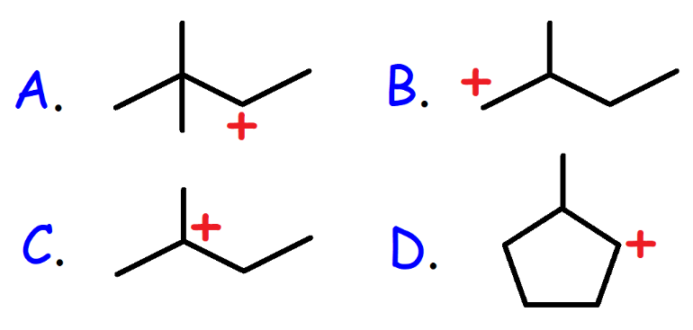

48. What is the major product of the reaction shown below?

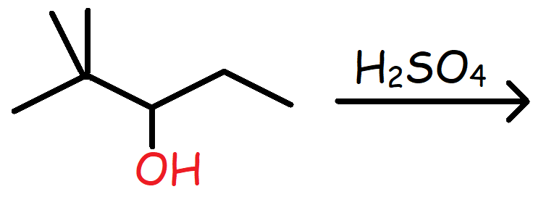

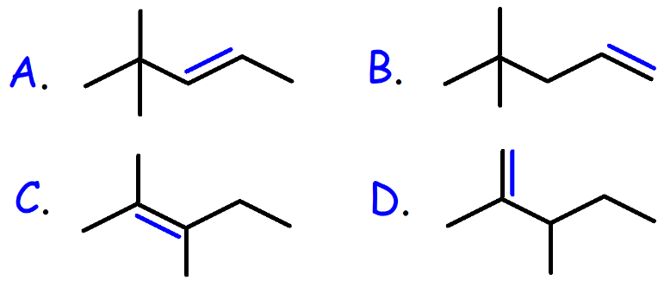

49. Which solvent is best suited for an SN1 reaction?

A. DMSO B. 12-Crown-4 Ether

C. Ethanol D. Acetone

50. Which alkyl halide will react most rapidly with NaOCH3 in CH3OH?

A. CH3CH2-Cl B. CH3CH2-F

C. CH3CH2-Br D. CH3CH2-I

51. What is the product of the reaction shown below?

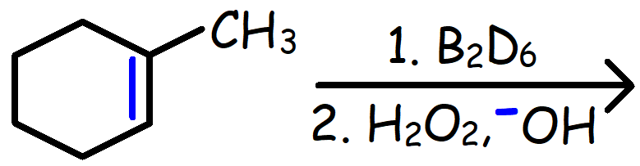

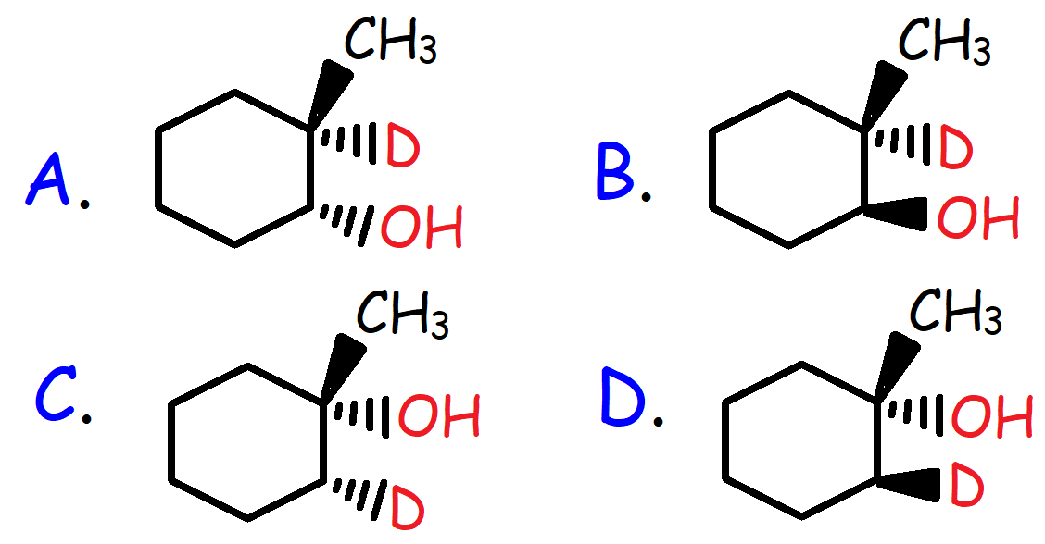

52. What is the IUPAC name for the compound shown below?

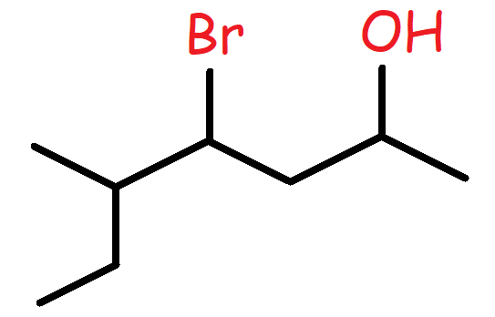

A. 4-Bromo-5-methyl-2-heptanol

B. 4-Bromo-3-methyl-6-heptanol

C. 4-Bromo-5-methyl-2-hexanol

D. 5-Methyl-4-bromo-2-heptanol

53. Which of the following is the major resonance contributor?

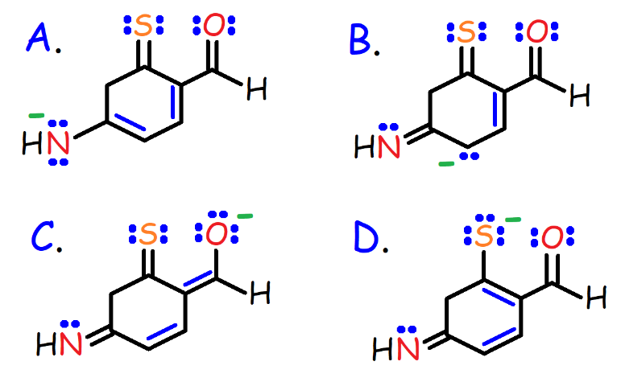

54. Which molecule is not capable of cis-trans isomerism?

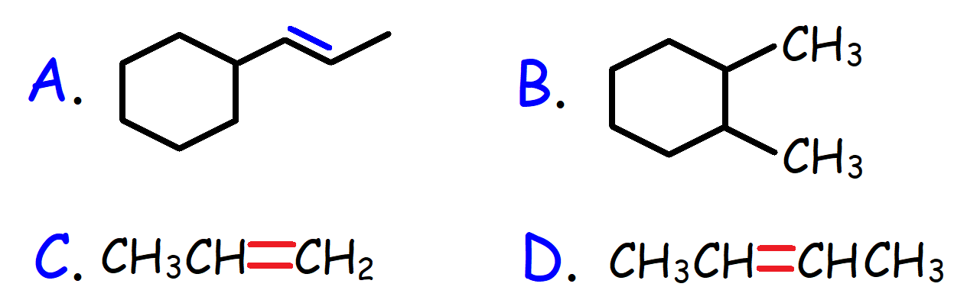

55. Which of the following statements is false?

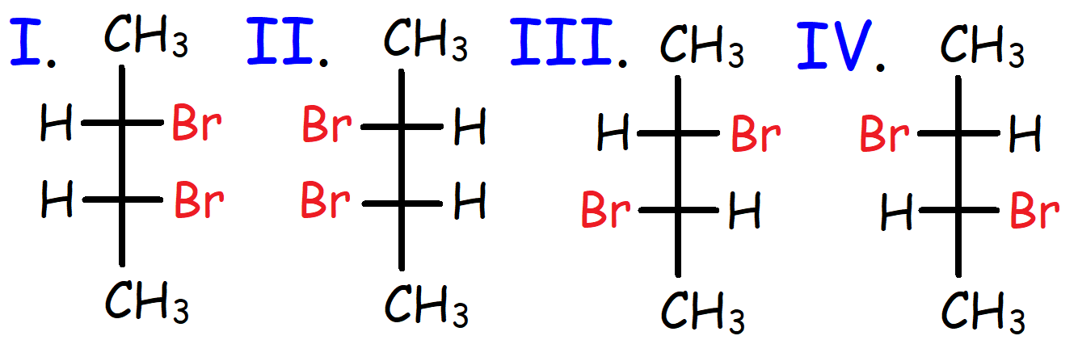

A. I and II are meso compounds.

B. I and III are diastereomers.

C. III and IV are enantiomers.

D. II and III are constitutional isomers.

56. What is the major product of the reaction shown below?

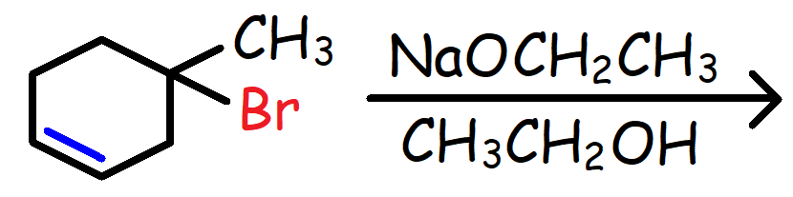

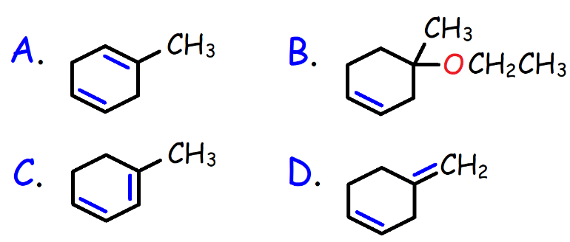

57. Which reagents represent the best option to complete the reaction shown below?

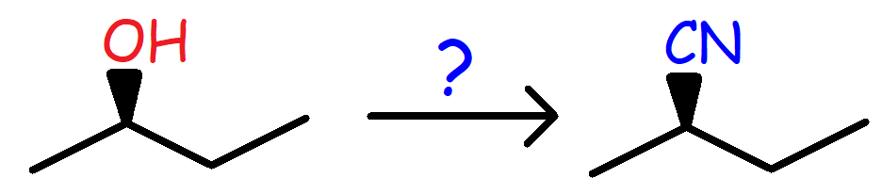

A) 1. HBr 2. NaCN, DMSO

B) 1. PBr3 2. NaCN / Acetone

C) HCN, Heat

D) 1. Tscl 2. NaCN/DMF

58. Which carbocation is most stable?

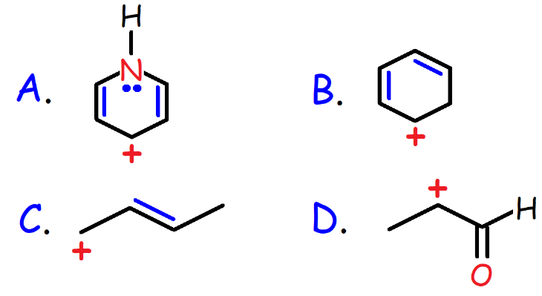

59. Which carbanion is most stable?

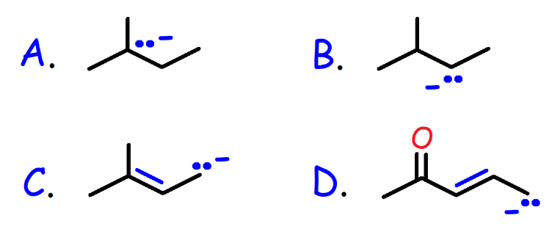

60. Which reagent can convert Cyclohexanol into Chlorocyclohexane?

I. SOCl2 II. HCl, ZnCl2 III. PCl3 IV. PCl5

A. I and II

B. III and IV

C. II, III, and IV

D. I, II, III, and IV

61. Which reagent will convert Propyne into

1-Propanol?

A) 1. R2BH 2. H2O2, NaOH

B) H2O, H2SO4, and HgSO4

C) 1. H2, Pd/BaSO4 2. Hg(OAc)2, H2O 3. NaBH4

D) 1. Li, NH3 2. BH3/THF 3. H2O2, NaOH

62. What is the product of the reaction shown below?

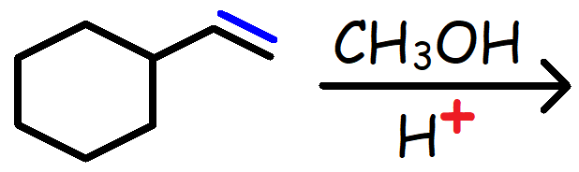

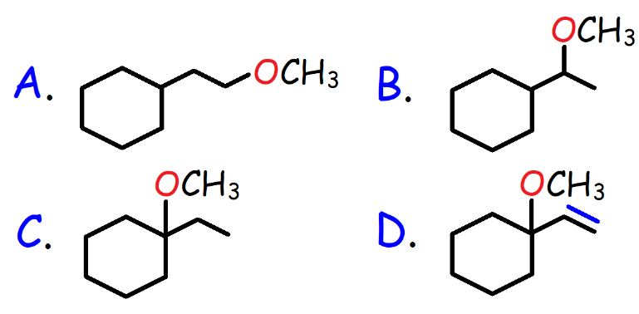

63. Identify the product of the reaction.

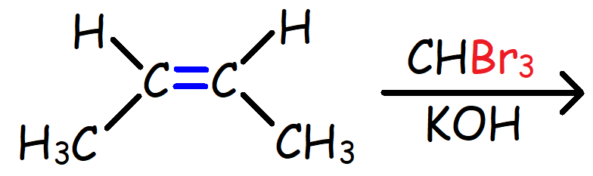

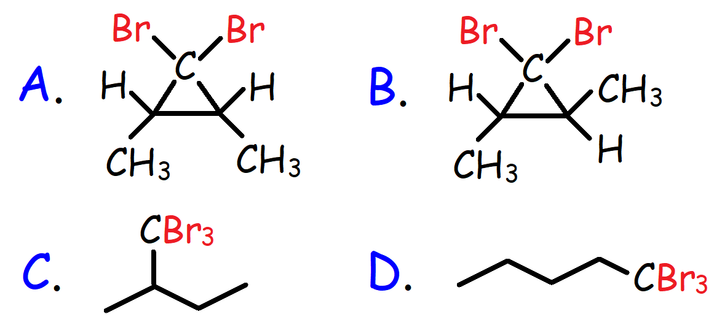

64. What is the product of the reaction shown below?

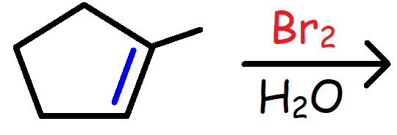

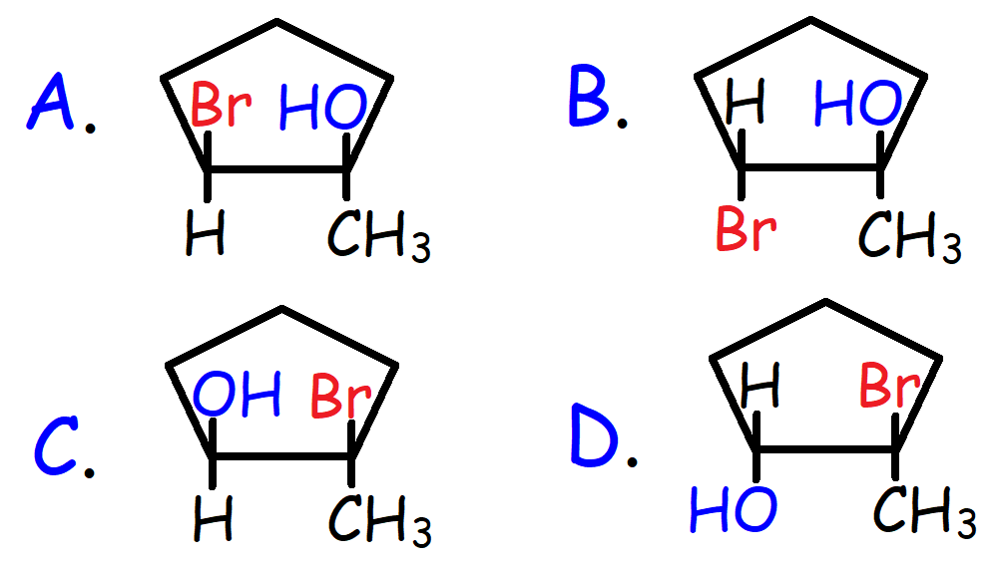

65. What is the relationship between the two molecules shown below?

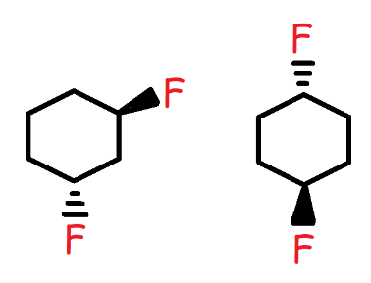

A. Enantiomers

B. Diastereomers

C. Constitutional Isomers

D. Identical Molecules

66. How many stereoisomers exist for the compound shown below?

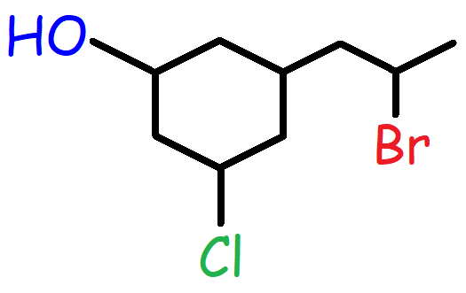

A. 4 B. 8

C. 16 D. 32

67. How many stereoisomers are possible for the molecule shown below?

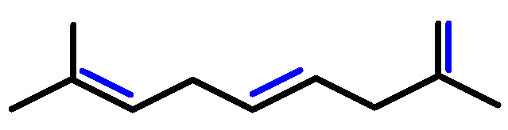

A. 2 B. 4

C. 8 D. 16

68. What is the major product of the reaction shown below?

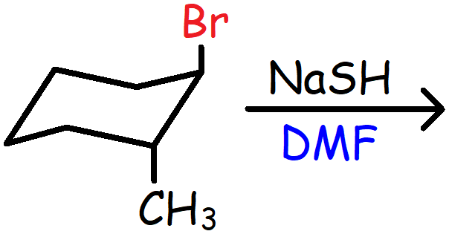

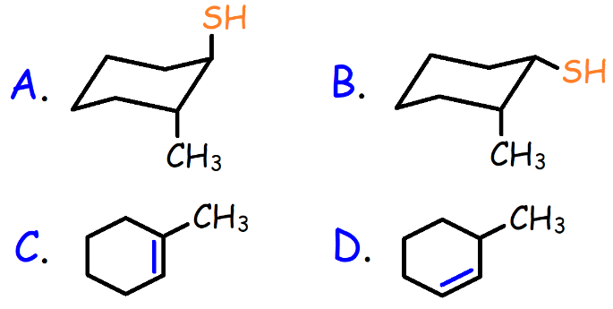

69. How many different monochlorinated products including stereoisomers can be formed from the reaction of 2-Methylbutane with Chlorine in the presence of UV light?

A. 3 B. 4

C. 5 D. 6

70. Which diol can be cleaved by HIO4?

A. Cis-1,2-cyclohexanediol

B. Trans-1,2-cyclohexanediol

C. Cis-1,3-cyclohexanediol

D. Trans-1,3-cyclohexanediol

71. What are the products of this reaction?

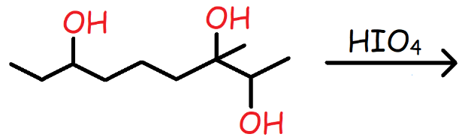

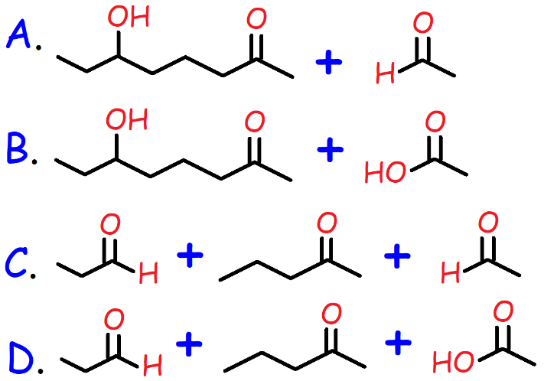

72. What are the products of this reaction?

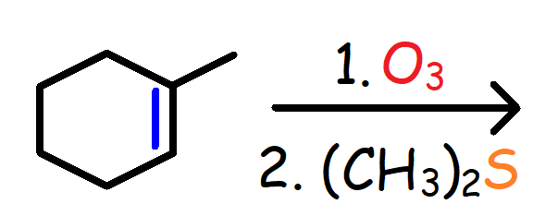

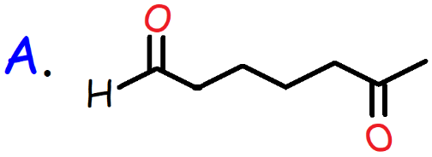

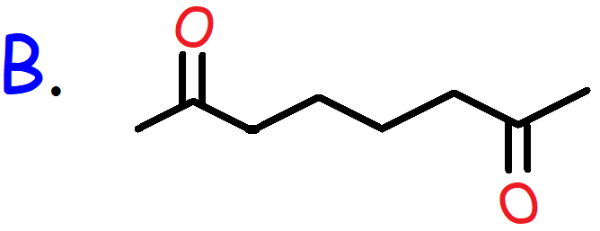

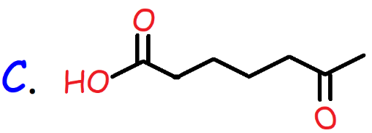

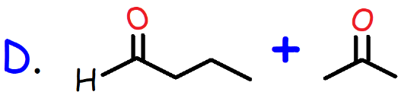

73. What are the products of this reaction?

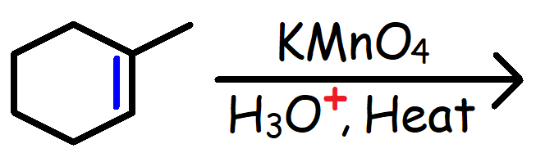

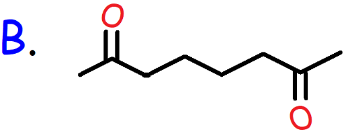

74. What are the products of this reaction?

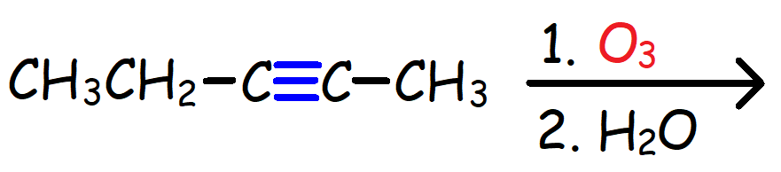

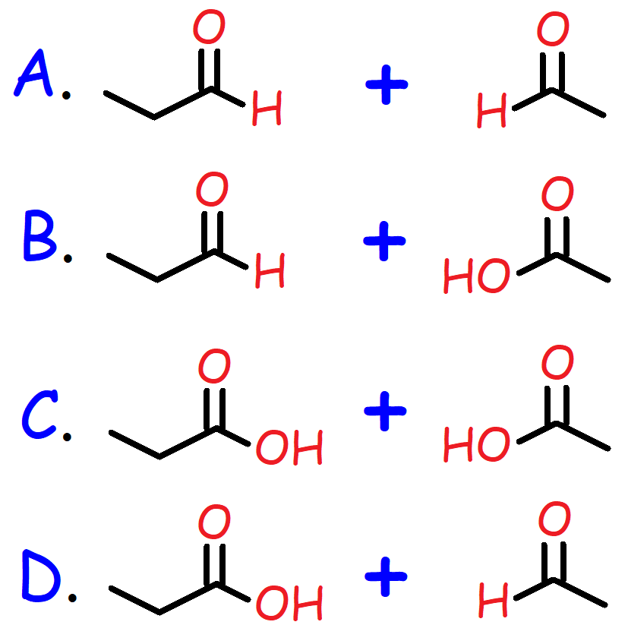

75. Which molecule will produce the products shown below during Ozonolysis?

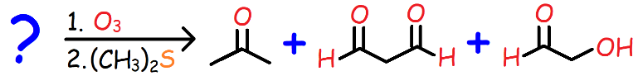

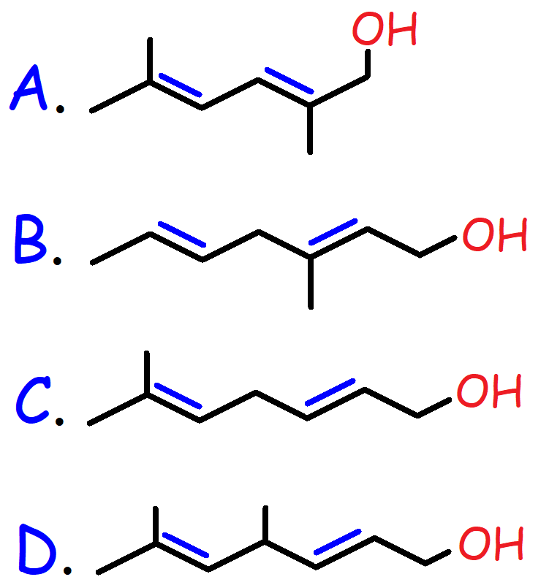

76. Which of the following reactions will not work?

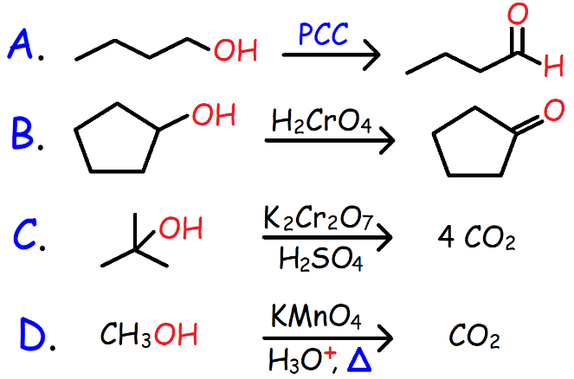

77. What is the major product of the reaction shown below?

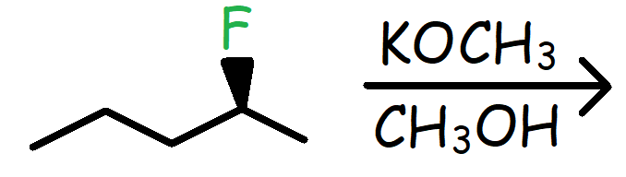

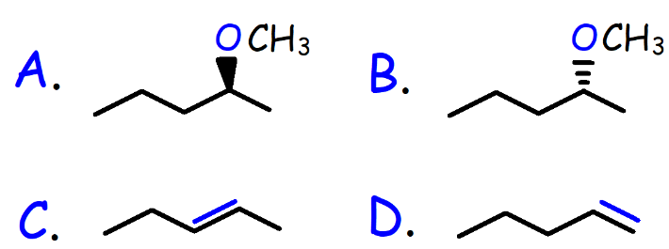

78. What is the IUPAC name of the bicyclic compound shown below?

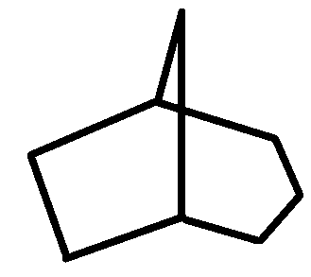

A. Bicyclo [3.2.1] octane

B. Bicyclo [4.3.1] octane

C. Bicyclo [2.2.2] heptane

D. Bicyclo [1.2.3] hexane

79. Which of the following conformations of Cyclohexane is least stable?

A. Chair B. Half Chair

C. Boat D. Twist Boat

80. Which of the following reactions will not work?

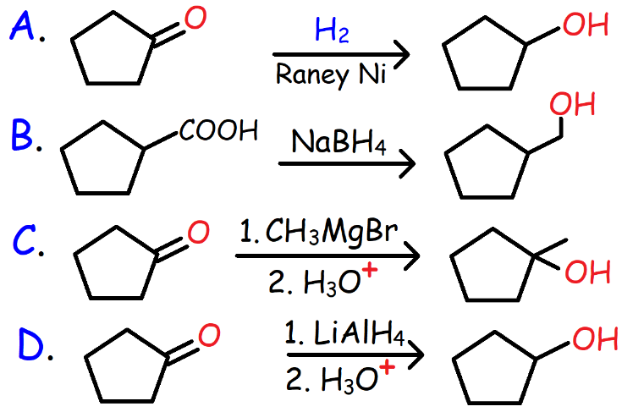

81. Which reagents will convert Propyne into a primary alcohol?

A) 1. NaNH2 2. CH3COCH3 3. H3O+

B) 1. NaNH2 2. CH3CHO 3. H3O+

C) 1. NaNH2 2. CO2 3. H3O+

D) 1. NaNH2 2. CH2OCH2 3. H3O+

82. Which of the following reactions will produce an epoxide?

A. Ethanol with H2SO4 and heat.

B. 5-Bromo-1-pentanol with NaH.

C. Phenol with NaOH followed by CH3CH2-Br.

D. Cyclohexene with Br2 and H2O followed by NaOH.

83. What is the major substitution product of the reaction shown below?

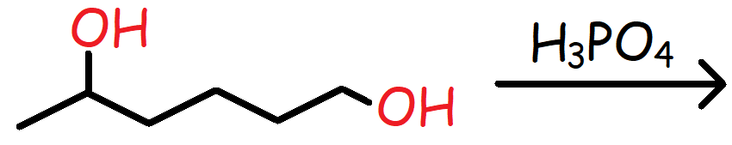

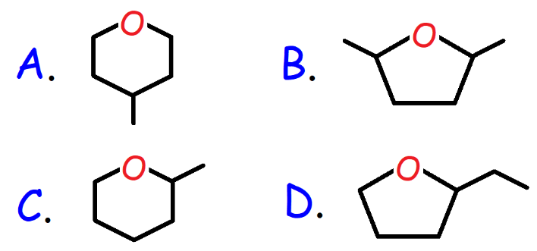

84. What is the major product of the reaction shown below?

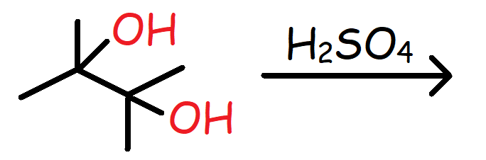

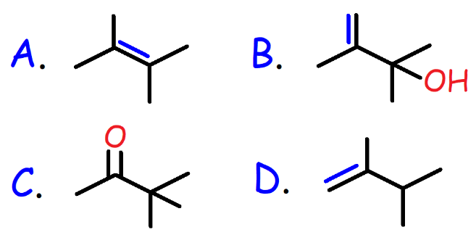

85. Which of the following statements is false?

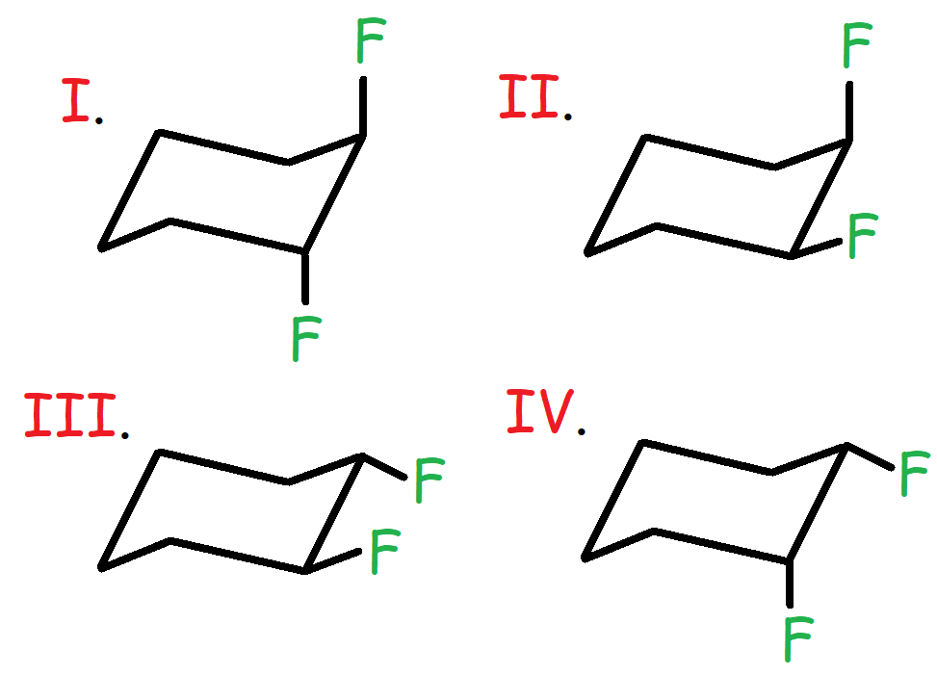

A. I and II are diastereomers.

B. II and IV are meso compounds.

C. I and III are enantiomers.

D. III and IV are identical molecules.

86. What is the IUPAC nomenclature of the molecule shown below?

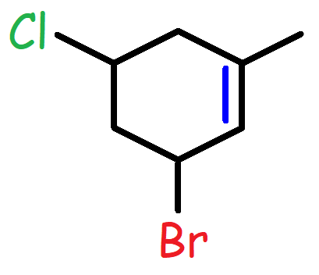

A. 3-Bromo-5-chloro-1-methylcyclohexene

B. 5-Bromo-3-chloro-1-methylcyclohexene

C. 6-Bromo-4-chloro-2-methylcyclohexene

D. 5-Chloro-3-bromo-1-methylcyclohexene

87. Which molecule is equivalent to the Fischer projection shown below?

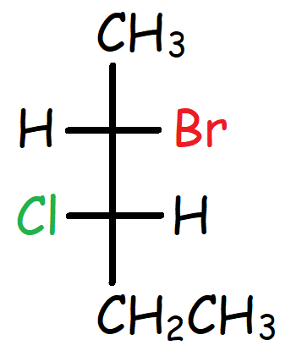

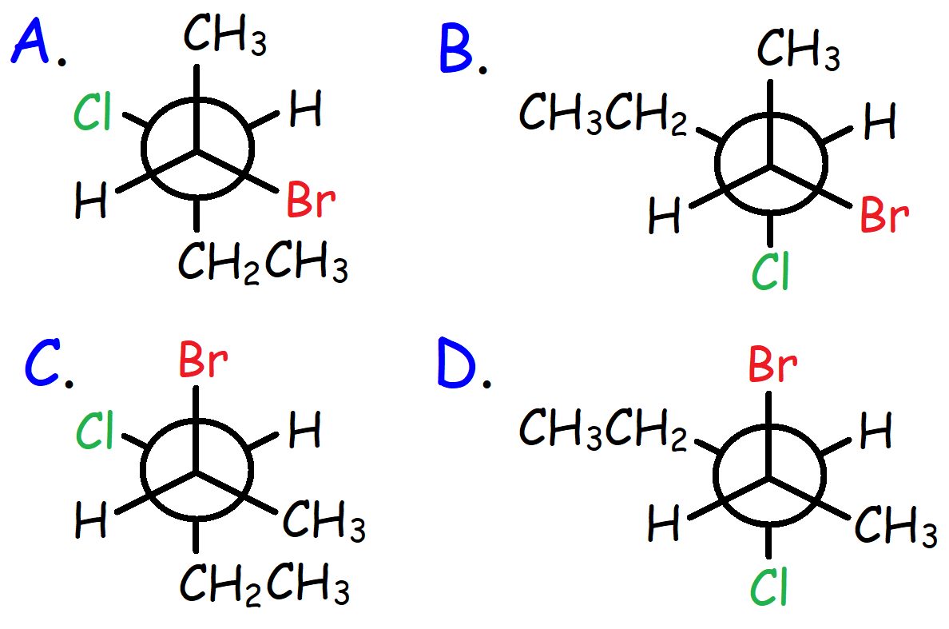

88. Which molecule has the highest boiling point?

A. 2-Butanol B. Pentane

C. Neopentane D. 1-Octanol

89. Which solvent works best for the reaction shown below?

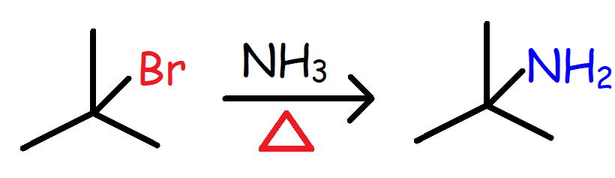

A. 80% H2O / 20% CH3CH2OH

B. 60% H2O / 40% CH3CH2OH

C. 80% H2O / 20% CH3OH

D. 50% H2O / 50% CH3OH

90. What is the major product of the reaction shown below?

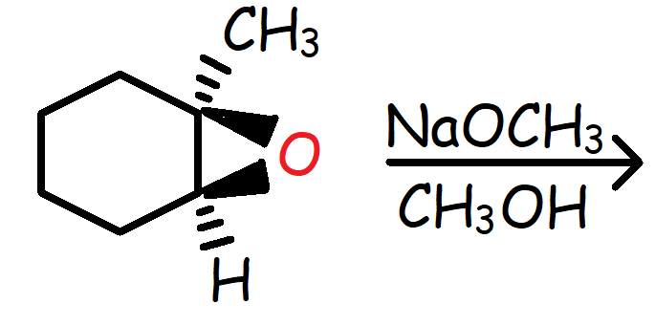

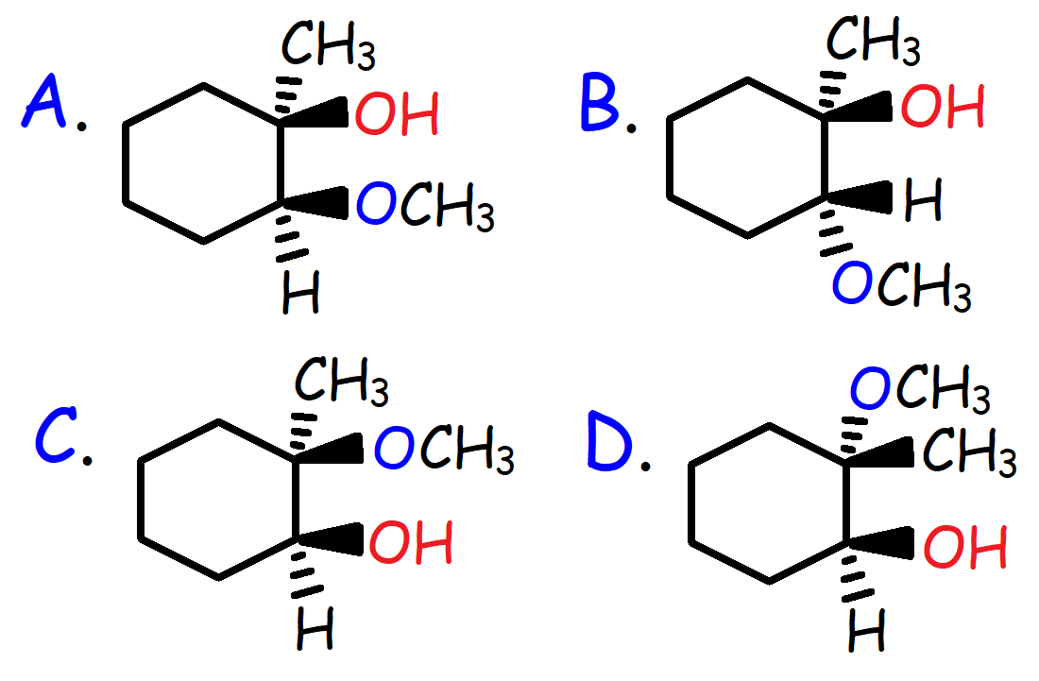

91. What is the major product of the reaction shown below?

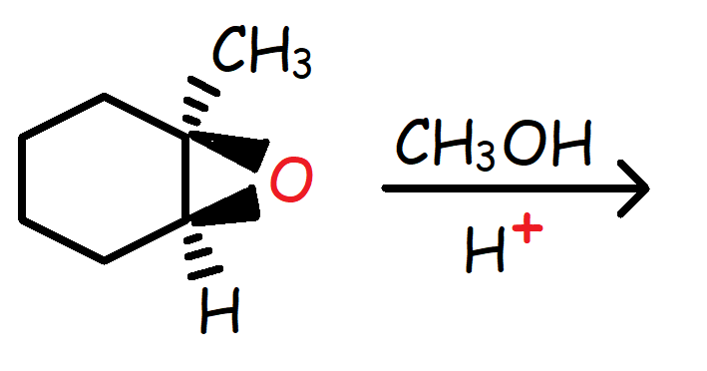



92. Which of the following reactions will not work?

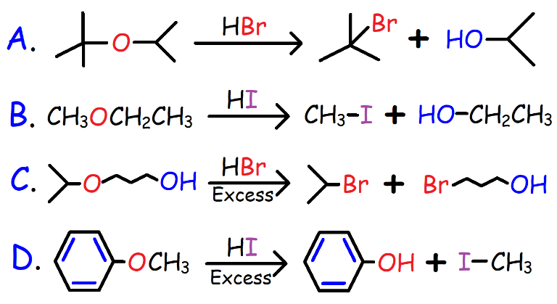

93. What is the product of the reaction shown below?

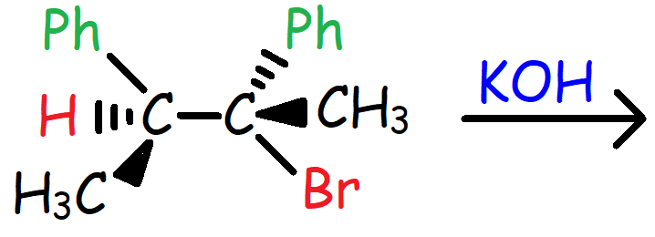

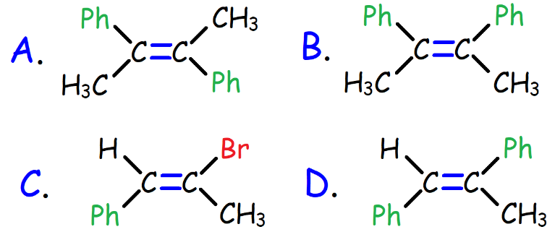

94. What is the major product of the reaction shown below?

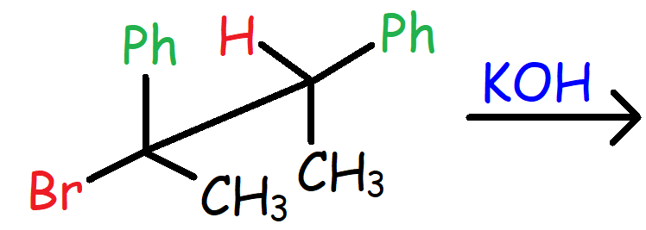

95. What is the major product of the reaction shown below?

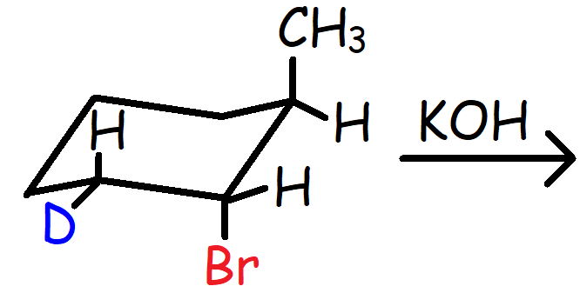

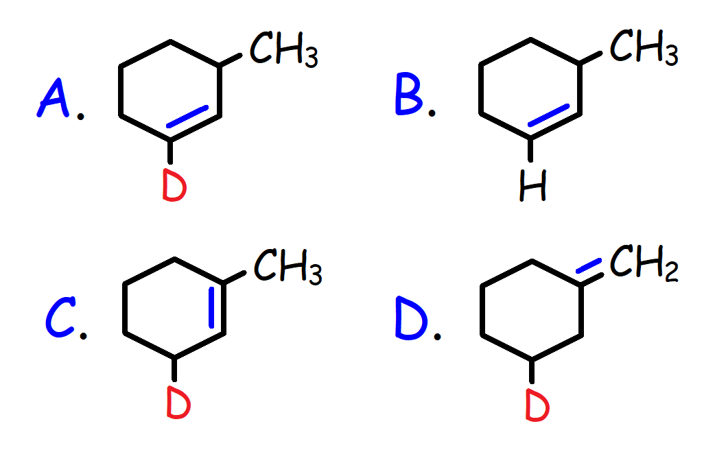

96. Which of the following molecules has the highest dipole moment?

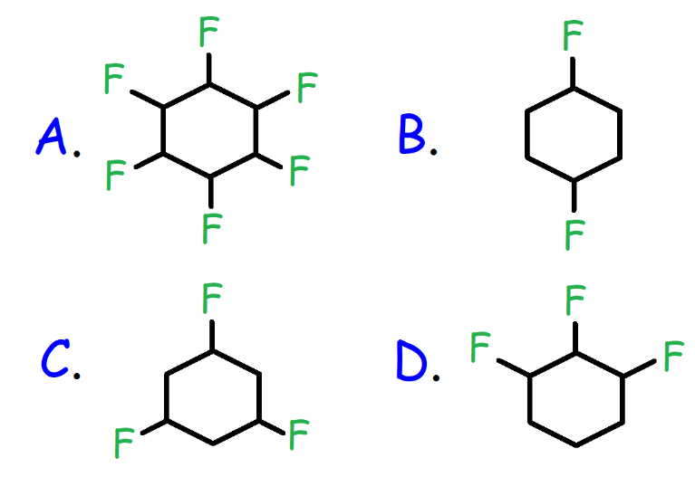

97. At high temperatures, a large alkane molecule can decompose into a smaller alkane and alkene by a homolytic bond cleavage of its carbon-carbon bonds. Which molecules are most likely to form from the free radical disproportionation reaction shown below?

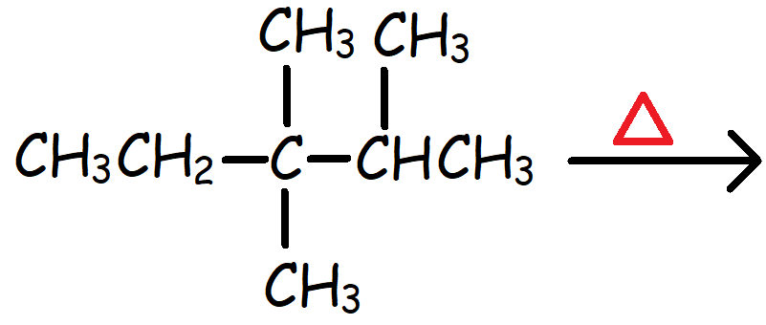

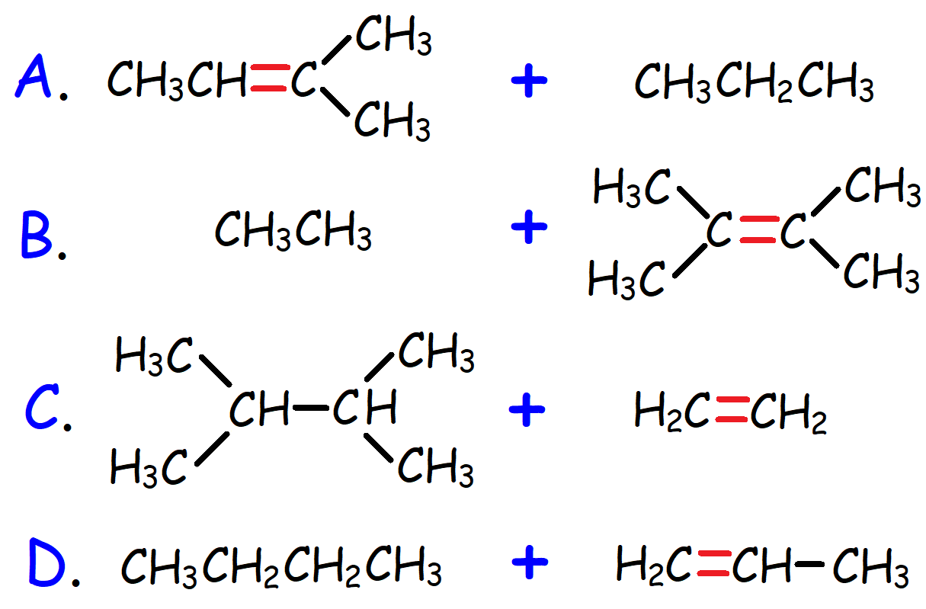

98. Which reagent is needed to complete the reaction shown below?

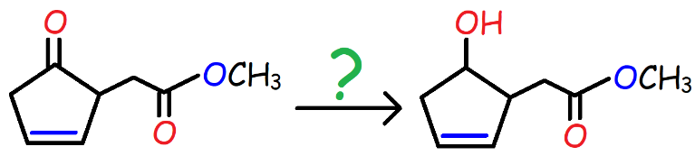

A. H2 / Pd

B. LiAlH4, then H3O+

C. NaBH4, then H3O+

D. C6H5MgBr, then H3O+

99. Which compound is most stable given the heat of combustion in kJ per CH2 group?

|  |  |
| --- | --- |
| **Compound** | **Heat of Combustion** |
| 1 | -674 |
| 2 | -663 |
| 3 | -658 |
| 4 | -691 |

A. Compound 1 B. Compound 2

C. Compound 3 D. Compound 4

100. An unknown molecule with the molecular formula C7H12O undergoes hydrogenation to give an optically active compound that is resistant to Chromic Acid oxidation. Which of the following compounds could it be?

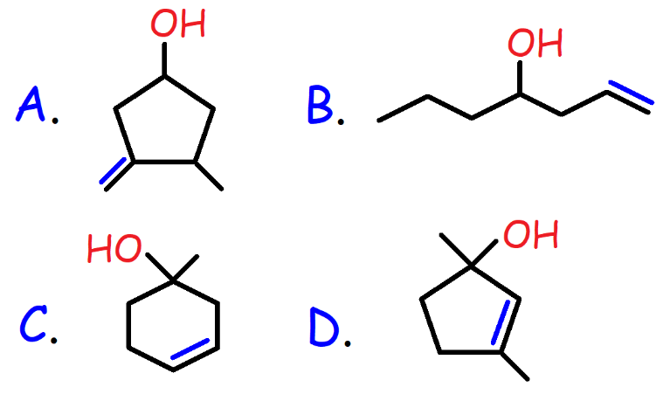

**Answers:**

1. B

2. B

3. A

4. C

5. D

6. A

7. B

8. D

9. E

10. A

11. C

12. A

13. C

14. A

15. D

16. C

17. D

18. C

19. B

20. D

21. B

22. C

23. B

24. C

25. D

26. C

27. A

28. B

29. C

30. D

31. C

32. D

33. C

34. C

35. C

36. D

37. D

38. B

39. A

40. D

41. C

42. C

43. D

44. D

45. A

46. A

47. C

48. C

49. C

50. D

51. A

52. A

53. D

54. C

55. D

56. C

57. B

58. A

59. D

60. D

61. D

62. C

63. A

64. B

65. C

66. C

67. A

68. B

69. C

70. A

71. A

72. A

73. C

74. C

75. C

76. C

77. D

78. A

79. B

80. B

81. D

82. D

83. C

84. C

85. D

86. A

87. B

88. D

89. C

90. B

91. D

92. C

93. A

94. A

95. A

96. D

97. A

98. C

99. C

100. D